Colleagues,
Q2, Corporate Safety and Environment Message 2014
Here is an update of the Corporate HSE Business Plan during Q2 of 2014.
The plan has a total of 30 high-level actions. Each action requires a lot of work for the action to be fully realised.
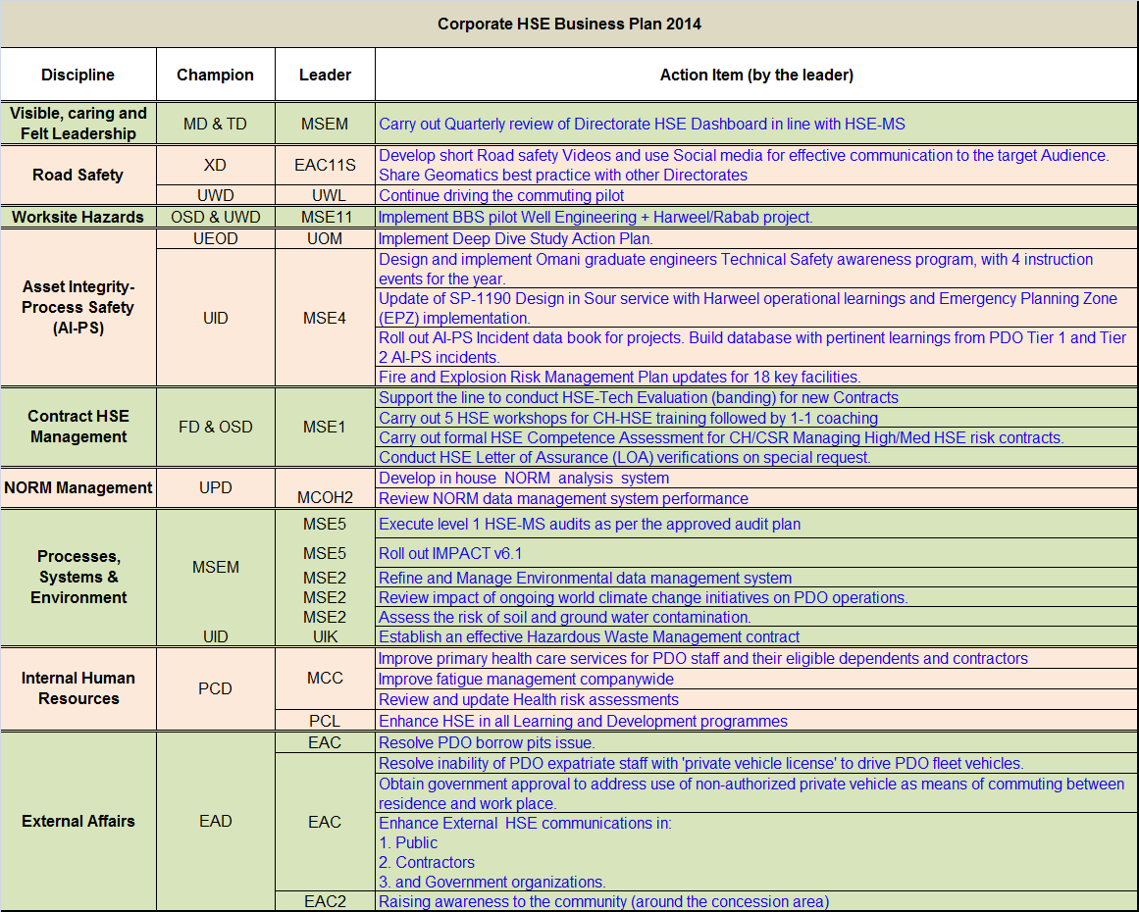
Visible, Caring and Felt Leadership: A quarterly HSE dashboard was shared with all MDC members. A monthly HSE action status is downloaded from PIM and shared with concerned directors. Joint Management Inspection (JMI) visits being carried out as per plan to demonstrate management visibility.
Road Safety: Four videos were launched on YouTube & PDO Tube in May. They were viewed more than 2,000 times. They focused on tail-gating, using seatbelts, avoiding mobile phone usage and school bus driver awareness). The videos were also launched on the ROP traffic website and Twitter account where they reached 57.8K followers.
Phase 3 of the pilot commuting project is progressing and so far:
- Utilisation has increased in Q2 by approximately 2% over the 18% increase in Q1
- Bussing to the South started but further deployment there is currently on hold. A discussion with Oman Air was held on the availability of extra aircraft to accommodate all southern travellers (both PDO and contractor)
- Discussion with contractor CEOs to increase utilisation is ongoing and improvements on the uptake have been noticed. However this still needs more engagement
- A campaign with banners, posters and pop-up massages to publish the project further is to cover to all permanent camps in the concession area and followed by road shows involving both PDO and contractor staff.

Worksite Hazards: The BBS Project was launched in June 2013 and the BBS implementation is ongoing supported by BST (PDO and contractors internal consultants). The completion pilot project will be in Q4 2014. The progress so far:
- Building Blocks: 6 of 7 Solook Foundational activities completed for all pilot sites, except Harweel. Observations commenced at these locations, and were tracked into the data-management tool - RINCON
- Stakeholder engagement of contractor management continues
- While the site has given positive feedback on the effectiveness of the Solook implementation and the application of the observation data sheets, there are challenges with supervisor and crew engagement at several sites. Actions to improve the engagements are underway
- The second and final round of external sustainability reviews by BSTI is scheduled to commence in the second week of September.
Asset Integrity - Process Safety: The action plan from the last MDC workshop in July 2013 was followed up in the monthly TDG meeting. More than 75% of the actions defined after the July 2013 workshop have been completed.
Proposed new actions from the March 2014 MDC workshop have been submitted and progress has already started in some of the working groups on the action plan.
The EMPDS graduate TSE program has run two sessions to date and two more are planned for this year. Over 60 non-TSE have attended. Consider action implemented and up and running.
Eight mini workshops have been conducted to date, to cover specific chapters in the new SP-1190. Data is being consolidated over the summer, and a draft update is to be issued by the start of Q4 2014.
A software interface tool has been indentified for the databook. A delay in further execution has been due to transfer of key staff to other section. Replacement identified via Shell MOR and expected to arrive early in Q4 2014.
FERM updates:
- Prepare for DRB1 discussion on impact on the business. DRB1 presentation on 8 July 2014
- Issued request for bid for UIPT1 – tank farm Concept Select project to five vendors
- Issued request for bid to review nine facilities, expected to start August 2014.
- Budget verified for activity (allocated in PB14)
- Line requested to book funds for PB15; all agreed.
Contract HSE: HSE evaluations: C212581 Marine Diving with evaluation of six companies, C311637 Land Drilling seven companies, C311576 Coil Tubing three companies. ODC review >40 bidders, Chemical Waste Management >30 Bidders.
LoA: Completed three LoAs to date including Shivani, Hi-Tech and 4PL Bahwan. The remainder of the 2014 LoAs are based on line requests with four identified for the Q3 and Q4 period.
Competency: The Omnicom List of Contracts was acquired from FPB updated June 2014. MSE will mount competency campaign in Q3 and Q4 to attract the CH staff to complete their personal assessments in relation to HSE. The list will provide the immediate target. Currently, records show 11 of the 168 have completed the HSE workshop.
HSE Workshops: MSE has completed one HSE workshop session per month since February 2014. Seventy eight staff have completed the workshop. MSE is now running coaching sessions for directorates ensuring that individuals are informed and assisted to complete the self assessment and ultimately line assessment.
NORM Management: Risk assessment for the installation of the Gamma spectrometer performed by a visiting consultant and agreed with UIK3.
NORM data management system development completed. User Testing Approval scheduled for August.
Processes, Systems & Environment: GD HSE MS, ISO 14001 and Occupational Health Audits completed as planned.
Impact v6.1 (PIM) rolled-out on 31/3/2014.
Environmental data management system: Proof of concept workshop (SAP) on going from 29 June until 10 July. A system will be modelled using the PDO structure and business model, and it will provide an opportunity for users to have a ‘hands-on’ experience of the system for three weeks.
World climate change: Scope of work was tendered in the first week of June 2014. Bids are under an evaluation/clarification process and there was a target date to award the contract is by the end of July.
The tender for the hazardous waste contract was floated on 5th of May, followed by a hazardous waste sites visit on 27th of May. Clarifications have been finalised and a technical bids submission was set for 6th of July.
Internal Human Resources: In an effort to improve fitness to work, two new doctors have been recruited, clinic consultation time has been rescheduled, and primary health care has been made available at private health care centers to all PDO eligible staff and their dependents in their catchment areas across the country. Plans are underway to centralise and improve primary health care in Interior hubs.
Drafted fatigue management guidelines, which will be finalised by Q4 2014; a discussion regarding the inclusion of those guidelines in the HSE training matrix is underway and will be discussed further with PCL8.
OH team performed and reviewed more than 30 health risk assessments.
Two workshops held:
- 15 May with TAs, HSE TLs,& ATP training managers and
- 25 May with contractor HSE managers.
These generated a number of actions for which a timeline has been produced, and a draft strategy for implementing the changes in HSE training has been done. Next is to review course material with TAs.
External Affairs: The EAS team had a follow-up meeting at the Ministry of Commerce and Industry. A PDO request to get a single borrow pit permit and be exempted from financial obligations until the Ministry of Legal Affairs issues its final decision on this matter has been put to the committee (a committee from different ministries) and minutes of the meeting have been circulated to all members. We are expecting to receive the decision soon.
A letter has been obtained from the Ministry of Manpower stating that engineers, surveyors and technicians are exempted from the ministerial decision. A meeting with the ROP will be arranged shortly to finalise ROP-related issues.
The Ministry of Manpower (MoM) was contacted to discuss the subject of non-authorised private vehicle usage. The recommendation is to engage the MoM in writing in advance on PDO’s proposal to add an obligatory clause in the Company’s occupational health and safety rules. The consequences of breaching such a rule will be embedded in PDO’s EPM. Both regulations and policy require the MoM’s endorsement.
The Tell A Friend campaign conducted an awareness session in Nizwa on 19 June and is planning four more sessions in Ibri, Sohar, Salalah and Musandam from August to December.

The Quarter Lowlights:
There were 11 LTIs during Q2, with three non-accidental deaths.

