Petroleum Development Oman LLC
Q2 2014 Incident analysis LTI study
PDO’s LTIF performance for Q2 2014 was 0.33 comparing to 0.30 in Q2 2013. PDO suffered 11 LTIs in this quarter, two less than in Q2 2013 and with more man-hours worked. The following analysis of the incidents is designed to identify trends and points of statistical interest to target future focus.
- Directorate
Directorate | Q2 |  | % of 2013
 | 2014 | 2013
UWD | 4 | 6 | -33
OSD | 1 | 1 | 0
GD | 1 | 1 | 0
OND | 1 | 0 | +100
UID | 4 | 2 | +100
HD | 0 | 2 | -100
CPDM | 0 | 1 | -100
Total | 11 | 13 | -15

- Teams

Sr. No | Directorate | Teams | No of LTIs
1 | UWD | UWS | 2
 |  | UWI/1 | 1
 |  | OSPTW | 1
2 | OSD | OSE | 1
3 | GD | GGO4Q | 1
4 | OND | ONO4L | 1
5 | UID | UIPT/45N | 1
 |  | UIB14X | 1
 |  | UIR | 2

- PDO v Contractor
  - 1 – PDO employee.
  - 10 – PDO contractors.

- Contractor information
  - There were 8 contractors involved in Q2 LTIs, of which 2 contractors had 2 LTIs. The breakdown is as follows:-
Sr. No | LTI No | Date | Company
1 | LTI#18 | 02-Apr-14 | Dalma
2 | LTI#19 | 06-Apr-14
3 | LTI#20 | 06-Apr-14 | WG-CCC
4 | LTI#21 | 26-Apr-14 | Weatherford
5 | LTI#22 | 07-May-14 | STST
6 | LTI#23 | 07-Jun-14 | Al Ghalbi
7 | LTI#24 | 25-May-14 | Al Hajiry
8 | LTI#26 | 08-Jun-14
9 | LTI#25 | 09-Jun-14 | Carillion Alawi LLC
10 | LTI#27 | 16-Jun-14 | PDO
11 | LTI#28 | 08-Jun-14 | Schlumberger

- Incident description – Action and Injury:-
  - Fall 1.5m from Crane cabin caused fracture of left wrist and forearm.
  - Slipped in the rig floor caused fracture of right lower leg.
  - Crushed by a hammer caused fracture of distal phalanx right index finger.
  - Crushed by a scraper caused fracture of left lower leg.
  - Trapped between the belts and the pulley caused amputation and fracture of three fingers.
  - Struck violently by a launcher door caused multiple fracture to left arm and fracture of right wrist.
  - Fall down heavily caused left elbow fracture.
  - Trapped between a pipe and the lorry tail gate caused right thumb distal amputation and fracture.
  - Cut the back of the hand while grinding caused a deep cut to his hand. (see if we change the wording, otherwise keep it as the same)
  - Trapped between motor pulley and belt caused a fracture of the tip of the finger.
  - Slipped whilst descending the stairs caused a fracture of wrist and bruised knee.

- Parts of body injured
- Hands/fingers – 4
- Wrist – 3
- Elbow/arm – 3
- Knee/Leg – 3
- Thumb – 1

- Incident classification

Type of Incident causing LTI | No of LTIs  Q2 2014 | No of LTIs  Q2 2013 | % change from  2013
Crush/Trapped | 5 | 3 | +67
Slip, Trip, Fall | 4 | 6 | -33
Struck By Object | 1 | 4 | -75
Portable tools | 1 | 0 | +100

- Actual Severity
- Severity 3 (major injury) 11

- Potential Severity

C3 major injury, has happened in the company 9
D3 major injury, has happened more than once a year in the company 2
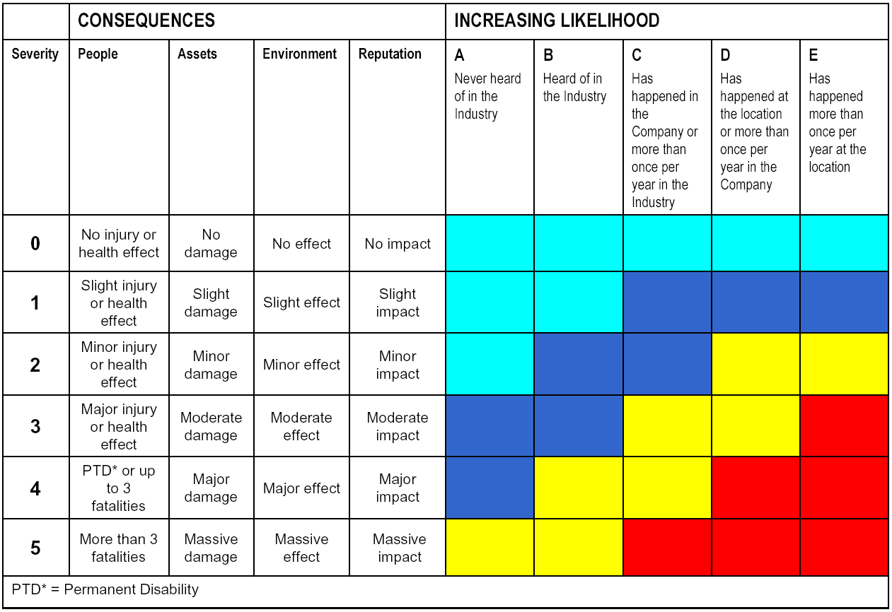

- Underlying causes
There were 56 identified underlying causes out of 11 LTIs of which 17 were repeated underlying causes i.e. failing to learn from LTIs. Details are in the below table:-

Sr No | Underlying causes | Repeated causation
1 | Poor judgment | 4
2 | Inadequate enforcement of PSP | 3
3 | Inadequate reinforcement of critical behaviors | 3
4 | Lack of PSP for the task | 3
5 | Improper supervisory example | 2
6 | Inadequate vertical communication between supervisor and person | 2

- Latent management failures

There were 29 identified latent management failures of 11 LTIs of which 11 were repeated latent management failures i.e. failing to learn from LTIs. Details are in the below table:-

Sr No | Latent management failures | Repeated failure
1 | Inadequate processes for communication of HEMP in TBTs, Safety briefings | 6
2 | Inadequate planning for crisis management | 3
3 | Inappropriate safeguards and management checks to avoid shortfalls. | 2

- Time of incidents

    - 04:00 – 08:00 1
    - 08:00 – 12:00 4
    - 12:00 – 16:00 2
    - 16:00 – 20:00 3
    - 20:00 – 00:00 1

- Age of IP

- 21 – 26 1
- 26 – 30 0
- 30 – 35 4
- 35 – 40 0
- 40 – 45 3
- 45 – 50 1
- 50 – 60 2
- Over 60 0

End of Analysis

