Petroleum Development Oman LLC
Q3 2014 Incident analysis LTI study
PDO’s LTIF performance for Q3 2014 was 0.34 comparing to 0.26 in Q3 2013. PDO suffered 18 LTIs in this quarter, 7 more than in Q3 2013 and with more man-hours worked. The following analysis of the incidents is designed to identify trends and points of statistical interest to target future focus.
- Directorate
Directorate | Q3 |  | % of 2013 | YTD |  | %of 2013
 | 2014 | 2013 |  | 2014 | 2013
UWD | 9 | 5 | 180 | 26 | 16 | 163
OSD | 5 | 4 | 125 | 8 | 9
OND | 1 | 1 |  | 2 | 3
XD | 1 | 0 | 100 | 1 | 1
UID | 2 | 0 | 200 | 8 | 2 | 400
HD | 0 | 0 |  | 0 | 1
GD | 0 | 0 |  | 1 | 1
CPDM | 0 | 1 |  | 0 | 1
Total | 18 | 11 | 164 | 46 | 34 | 135

- LTIs per Operational Teams YTD:-

Sr. No | Directorate | No of LTIs -Team
1 | UWD | 1-OSPTW, 1-UWI/1, 2-UWS, 1-UWCI/3, 1-UWN, 1-UWB/6, 2-UWI,2-UWL,1-UWSN,1-UWSI,1-UWXD3,5-UWCI, 1-UWNF, 1-UWLC/1, 1-UWNY4, 1-UWNA, 1-UWSN, 1-OSPTW, 1 -UWLN
2 | OSD | 2-OSE, 1-OSEG, 3-OSET, 1-OSET5,1-OSC
3 | XD | 1-XGO/1
4 | OND | 1-ONO4L, 1-ONET
5 | UID | 1-UIB14X, 1-UIPT/45N, 1-UIK, 1-UIB, 4-UIR
6 | GD | 1-GGO4Q

- PDO v Contractor
  - 45 - PDO contractors
  - 1 - PDO employee

- Contractor information

There are 28 contractors who suffered LTI incidents, 10 of these contractors experienced more than one LTI incident.
The breakdown is as follows:-
- 5 incidents – Al Turki
- 4 incidents – Dalma Energy
- 3 incidents – Sea & Land ,Bahwan Exel
- 2 incidents – AL Hajiry, Abraj, Ba Omar, Midwesco, WGCCC, Weatherford.
- 1 incident – MBPS, Shivani, Arabian Drilling Services, STST, Desert Byrne, Shaleem Petroleum, Vanguard, Cactus Drilling, KCA Deutag, SOS, Ofsat, Schlumberger, Ardiseis, Carillion Alawi, Al Ghalbi, Saxon Energy, ODC/EMC, Medco, PDO

- Incident description – Action and Injury:-

  - Trapped between 6 ½“pipe and rig mast leg caused left hand fracture.
  - Slipped of temporary mouse hole cover caused deep laceration to groin area.
  - Trapped between tow flanges caused deep cut wound at the hand.
  - MVI rollover caused 1 fatality.
  - MVI rollover caused collar bone fracture and dislocating of left shoulder.
  - Chest Trapped between bucket track guard rail and a pipe rack caused ribs fracture.
  - Lost balance and fell 1.5 m down slop caused right ankle fracture.
  - Trapped between a wire drum and the steel frame caused right foot multi-fracture.
  - Falling from two floors building (10m height) and sustained multiple fractures.
  - Struck by falling object resulted in foot fracture.
  - Trapped between truck support stanchion and a rolling pipe during pips downloading caused middle finger fracture.
  - Fell from the trailer bed (1.8 m height) caused forearm fracture and dislocation of the right elbow joint.
  - Truck slipped out of the road due to sand dunes caused fracture of L1 vertebra and canal compromise due to fragments into the spinal canal.
  - Chemical contents blew out and splashed causing burns on IP eyes.
  - MVI collision caused both legs fracture to a canter driver.
  - Rotating metal bar struck the IP caused right leg fracture and injuries to left hand.
  - Slipped in the truck bed and caused left wrist fracture.
  - MVI head collision caused 3 fatalities.
  - Crushed by a falling pipe in the rig floor caused fracture of 2nd left toe.
  - Burned by radiator water caused 2nd degree burns.
  - MVI rollover caused a fracture to the left elbow.
  - Crushed between tow pips caused a fracture to a finger.
  - Slipped on uneven ground caused a fracture to left knee cap.
  - Trapped between tow pips caused a fracture to the third finger.
  - Trapped between a pipe and a structure column caused a deep cut of middle & ring finger and a fracture to the little finger.
  - Struck by equipment caused displaced fracture of left thumb and index finger.
  - MVI crash and rollover caused a fracture of the left foot.
  - Trapped between a pin and a structure caused amputation of the tip of the middle finger.
  - Struck by vibrator dashboard caused a fracture to the left thigh bone.
  - Struck by a fan blade caused a tip amputation of the left thumb.
  - Trapped between drill bit and steel bracket caused end of ring finger amputation.
  - Fall from Crane cabin 1.5m caused fracture of left wrist and forearm.
  - Slipped in the rig floor caused fracture of right lower leg.
  - Crushed by a hammer caused fracture of distal phalanx right index finger.
  - Crushed by a scraper caused fracture of left lower leg.
  - Trapped between the belts and the pulley caused amputation and fracture of three fingers.
  - Struck violently by a launcher door caused multiple fracture to left arm and fracture of right wrist.
  - Fall down heavily caused left elbow fracture.
  - Trapped between a pipe and the lorry tail gate caused right thumb distal amputation and fracture.
  - Cut the back of the hand while grinding caused a deep cut to his hand. (see if we change the wording, otherwise keep it as the same)
  - Trapped between motor pulley and belt caused a fracture of the tip of the finger.
  - Slipped whilst descending the stairs caused a fracture of wrist and bruised knee.
  - Trapped between the sling and the crane hook block caused a fracture and a cut to the middle finger.
  - Trapped between the slips and the elevator caused a fracture for two fingers.

- Parts of body injured YTD:-
Hands/fingers | 15 | Ankle | 5
Head/Neck | 3 | Wrist | 4
Elbow/arm | 6 | Chest/Rib | 1
Knee/Leg | 7 | Back | 1
Thumb | 2 | Collar Bone | 1
Body | 2 | Pelvis | 1

- Incident classification

Type of Incident causing LTI | No of LTIs  YTD 2014 | No of LTIs  YTD 2013 | % change from  2013
Crush/Trapped | 18 | 13 | 38
Slip, Trip, Fall | 6 | 4 | 50
Struck By Object | 6 | 4 | 5
MVI | 9 | 4 | 125
Burn | 2 | 1 | 100
Fall from height | 4 | 7 | (43)
Portable Tools | 1 | 0 | 100
Rotating equip | 0 | 1 | (100)

- Actual Severity
- Severity 2 (minor injury) 1
- Severity 3 (major injury) 41
- Severity 4 (fatality) 4
- Potential Severity

B3 major injury, Heard of in the industry 0
C3 major injury, has happened in the company 32
C4 fatal injury, has happened in the company 2
D2 minor injury, has happened in the company 1
D3 major injury, has happened more than once a year in the company 6
D4 PTD or up to 3 fatality, has happened more than once in the industry 5
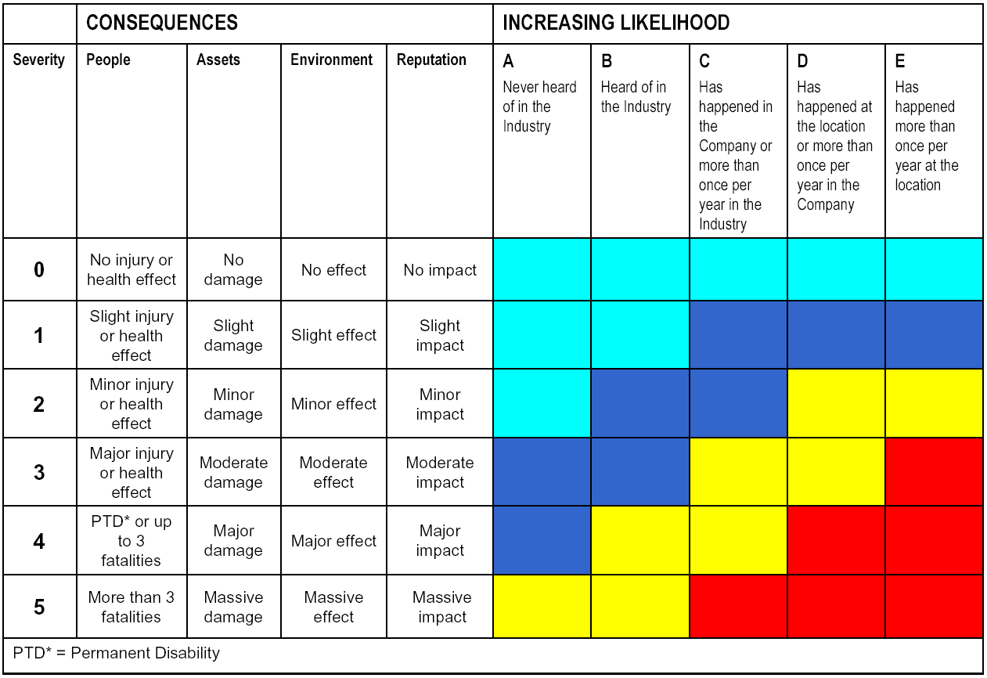

- Q3 Types of underlying causes

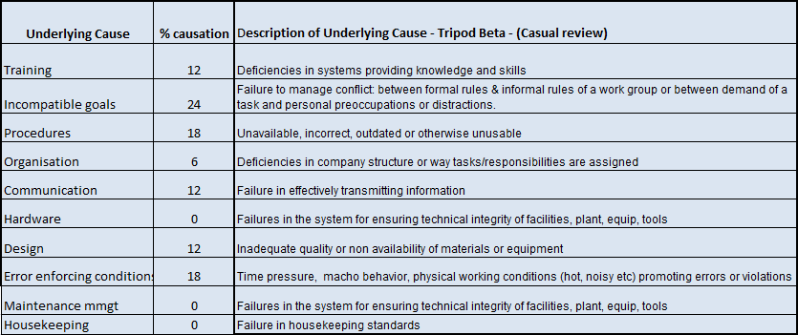

- Time of incidents YTD:
00:00-04:00 | 1
04:00 -08:00 | 3
08:00 -12:00 | 15
12:00 - 04:00 | 15
04:00 - 08:00 | 8
08:00 - 12:00 | 4

- Age of IP YTD:

21-25 | 10
26-30 | 7
30-35 | 9
40-45 | 8
46-50 | 9
51-60 | 3

End of Analysis

