EVENT LEADERS’ GUIDE

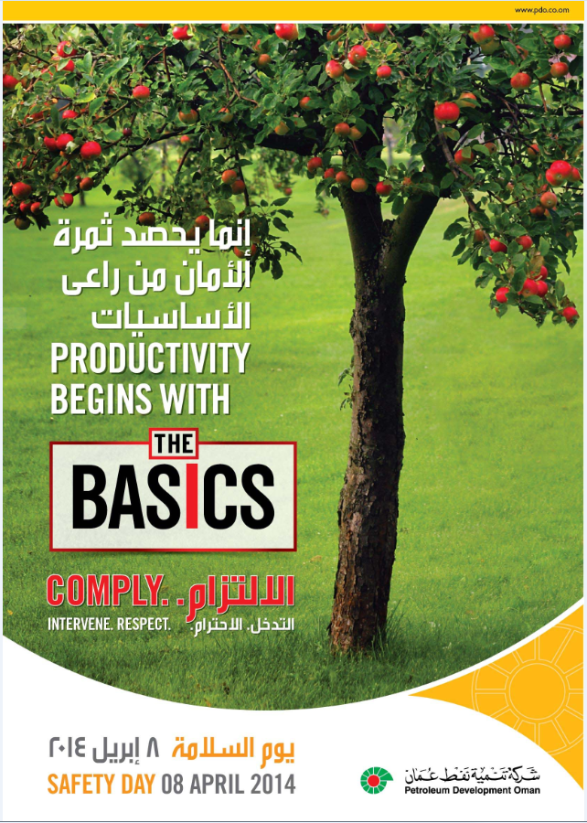

This guide is designed to help you to plan and conduct your team’s Safety Day event. It is divided into clear and specific sections, and contains a number of hints and tips about how to get the most out of your engagement session. It should only take about 20 minutes to read and help to planning a successful Safety Day.

Safety Day is a key engagement for your team. These engagements should generate understanding and, more importantly, drive long-term behavioural change and contribute to performance improvement. It is a great way to challenge assumptions and check if everyone is working in a safe manner and supporting the Goal Zero journey.

To help you plan and design your Safety Day event, we have provided a few ideas. You may choose to use them, modify them, or create a unique engagement programme that addresses the specific needs for your team or site.

This year, Safety Day will be on April 8, 2014 and the theme is “The Basics”. All guidance provided here is to support this theme.

Message from Raoul Restucci 4

Background 5
Safety Day: What is it? 5
Theme: The Basics 5
Involving contractors 6
The Role of Event Leader 7
Timeline 8
Preparing your event 9
Preparation checklist 9
Designing your event 10
Session template 10
Safety Day session outcomes 10
Safety Day resources and materials 11
Safety Day website 11
Engagement materials 11
Promotional materials 11

Dear Safety Day leaders,
Congratulations on being a part of the team that will make Safety Day 2014 yet another success!
Safety Day is a key event on our journey to Goal Zero. Every year I am proud to see the energy and enthusiasm among our employees and contractors during Safety Day. As event leaders, you play a pivotal role in making sure that Safety Day engagements are focused and meaningful. I encourage you to look for new ways to maintain the energy around Safety Day and make sure all of your community, employees and contractors alike, take the time to consider the role they play in achieving Goal Zero.
We have made significant progress in improving our personal safety performance and that is a great accomplishment. In 2013, we achieved our best year ever in safety performance. Our continued efforts are leading to a safer work environment. However, we still do not get it right all the time. We all need to step up as safety leaders and take collective responsibility for each other. Do this by taking the time to understand how your actions and behaviors can impact the safety of yourself and others, in particular of those that are working on the front line.
This guide contains tips and suggestions for how to optimise the engagements with your teams. As event leaders, I challenge you to look for ways to make sure that the time spent on Safety Day has a lasting impact and moves us all closer to Goal Zero.
Thank you and I wish you all a successful engagement and a great day of Safety, full of pride and commitment for what we can and must achieve together and continuously replicate.
I look forward to another successful Safety Day!

Kind regards
Raoul Restucci
Managing Director
Safety Day – what is it?
2014 is the eighth year that we are celebrating Safety Day. The purpose of Safety Day is to bring all employees, contractors and sub contractors together to engage and focus on safety.
It should not be viewed as an isolated event – it’s a significant milestone in our journey to build a stronger safety culture in our pursuit of Goal Zero: No Harm to People and Environment
This year we want to encourage teams to specifically “take time to understand complying to “The Basics” and how our actions/behaviours can impact the safety of others” and provide an opportunity to reaffirm our commitment to building a Goal Zero organisation. We would also like your teams to put particular emphasis on involving contractors and sub contractors, and where applicable, on process safety risk.
Theme: The Basics
The theme “The Basics” throughout our journey in PDO, we have had several initiatives that helped us in improving our overall HSE performance.
This year we have decided to pause, reflect back and refresh our memories of the HSE pillars we rely on to sustain HSE performance, the 3 Golden Rules; Comply, Intervene and Respect.
This year we will focus on the first pillar “Comply” followed by “Intervene” in 2015 and “Respect” in 2016.
Get creative and think about what “Comply” means to your team. It is important to realize that our actions and our behaviors can impact the safety of ourselves, our colleagues and our facilities. We are all connected and therefore need to take collective responsibility to keep each other safe.
Example Theme | What does this mean?
Time to understand | - Understand what ‘Comply’ means to individuals  - Develop understanding of why people break rules.  - Reflect on your role in keeping yourself and others safe
Time to Commit | - Making a personal commitment to put the safety of yourself and your colleagues first  - Making a personal commitment to comply at all times.
Time to Listen | - Taking part in the conversation about non compliance with colleagues.
Time to Lead | - Taking responsibility for existing and future non compliances
Time for Barriers | - Preventing incidents through design, technical and operating integrity  - Conducting our business with respect for others and the integrity of our assets.
Time for Others | - Ensuring we preserve the safety of our colleagues, neighbours and the environment.

Deepening Discussions in the offices
It is important to realize that decisions and behaviors in the office can have unintended consequences and impact the safety of others, including (future) staff at the frontline who can be relatively far away. We encourage office-based teams to reflect on these connections.
Involving Contractors
Our Contracting community plays a significant role in delivering our operations. You are encouraged to partner with your Contractors to design and deliver Safety Day together.
For example:
- Invite local Contractor leaders (counterparts) to jointly lead safety engagements.
- Identify opportunities for Contractors in your operations to partner with Safety Day focal points to plan Safety Day.
- Ensure that your area Safety Day activities and engagements include the Contractor’s views and needs.

The role of event leader on Safety Day
The leader of a team can take on the role of Safety Day event leader, but he/she can also opt to nominate someone in the team as event leader (as a development opportunity, for example). Safety Day provides an opportunity for all to demonstrate effective and visible safety leadership.

Your role as event leader is to:
- Inspire and encourage employees and contractors to have the confidence to always take “Time for Comply”.
- Demonstrate that the conditions and culture in your part of the business are being built so that the team feels empowered to take “Time to Comply”.
Leaders can support Goal Zero by eliminating the barriers which prevent your people from “Compliance” and doing the right thing. This way the team can move beyond compliance to a culture of commitment where people do the right thing even when no one is looking and because they want to. It is a unique opportunity to communicate to every member of the team that:
- If you stop a job for a safety reason – we will back you up.
- If you have a safety concern – we will listen and address it promptly.
- (Remember: you have the support of your Leadership Team).
- If there is an injury – we will provide support to the people that are impacted, fully investigate, share our learning and treat everyone involved fairly.
- We will support you in taking time to Comply with the basic rules.

Timeline
Safety Day 2014 will be held on Tuesday, April 8th or any other day as is convenient for operations as we have to ensure that both shifts are covered in the interior operations. Visit the Safety Day website for helpful materials, including the Safety Day videos. As an event leader you should:
- Start to identify the needs of your teams and lead the design of an event that will enable everyone to focus on “The Basics - Comply”.
- On Safety Day itself, lead and host a team event and enable everyone to make the commitments that will ensure the learnings of the day are converted into actions.
- Request staff to complete Safety Day online Survey and submit any suggestions
- Post Safety Day, look for opportunities to check with your teams on the commitments that were made, and individuals should hold themselves accountable for delivering on their “The Basics - Comply” promises.
- Send your photos for the events to MSE/51 with a short write-up to upload onto the Corporate HSE website.

Preparing your event
It is important to tailor an engagement that is relevant to the team’s risks, needs and culture.
The Corporate Safety & Environment Department (MSE) will provide various materials and engagement activity suggestions to help you with this. You may also choose to develop your own ideas that best meet the needs of your teams.
Preparation of checklist
When preparing your event, we recommend you consider the following steps:
- Make sure everyone in your organisation knows about Safety Day well in advance, and has it in their calendar and/or work plans to participate.
- Understand the risks and needs for the team and design the engagement content with support from your Directorate HSE Team Leader or HSE focal point.
- Put a plan in place to involve everyone in your team. Think about a meeting location and organise engagement.
- It is recommended that the session will last at least one hour and ideally takes place face-to-face.
- Try to hold sessions in groups of no more than 30.
- Sessions can be held as part of other meetings/events.
- Watch the Safety Day videos and test it before you use it for your session.
- Think through personal examples so you can really personalise the session.
- Have means to record or capture event highlights (e.g. camera)

Session template
In order to keep Safety Day fresh and exciting for your team, consider looking at new ways to engage your team. As a guideline, you may outline your event into sections such as:
- Opening
- Engagement activity
- Reflection
- Commitment
The following provides a suggested structure for Safety Day engagements. Depending on the needs of the team/site, the structure and duration may differ.
Opening:
The opening segment is to welcome the team, set the stage and create a safe and open environment. Your team should feel they can engage, share and internalise the key messages into their own behaviour and attitudes.
For 2014 Safety Day, 2 videos will be provided; one with a message from Raoul Restucci – PDO MD and another on Know about Compliance. We recommend that both these videos be part of your Safety Day event.
Reflection and commitment:
To gain commitment from your team and agree to follow up, which may be the single most important session on the day. The commitment should be specific and include actions that will be taken to support Comply.
- Reflection of key messages from the day and your personal commitment.
- Affirm “Comply” commitments and follow-up plans.
- Closing words from the event leader.
- Recognise and thank your team.
The recommended timing for the closing segment is 15 minutes.
Safety Day session outcomes
Every individual should:
- Understand their role in the pursuit of Goal Zero and comply.
- Agree tangible actions which will support Comply.
- Know what they can do to help build a stronger safety culture.
- Review and reaffirm their focus and commitment to safety by complying with all HSE basic rules.
- Submit online survey for Safety Day engagement session.
Event leaders should capture team commitments and ensure follow through after Safety Day. You should agree the plans for follow-up after Safety Day with the team.
A webpage will be provided by MSE Department to capture and monitor commitments.

Safety Day Website
You can find a range of support material on our Safety Day website to help you prepare, design and promote your Safety Day event, and to use on the day:
http://pdointernet/hseforcontractors/SitePages/safetyday2014.aspx
Engagement Materials
Several materials to support your Safety Day engagement are available on the Safety Day website.
Safety Day video
A video will be made available for event leaders to use on the day. It will help you to set the scene for “The Basics - Comply”.
Email template
The email template can be used to brand communications. There is an area for your message plus an embedded link to the Safety Day site.

