
Petroleum Development Oman

Gas Directorate

GD 2008 HSE Plan

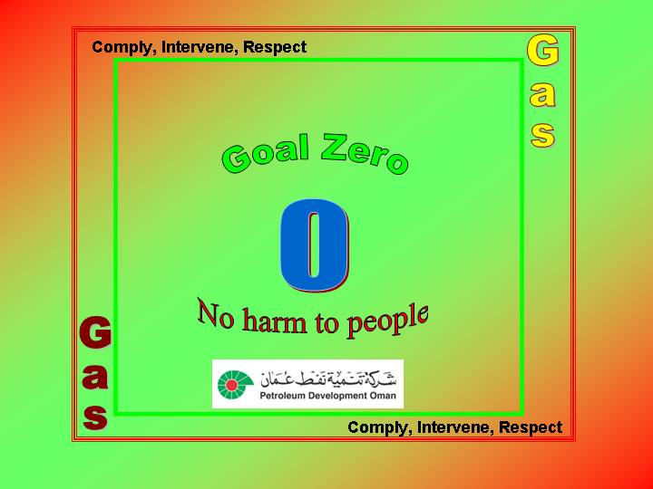
Authors: Fareed Al Hinai GGS
 |  | Signature | Date
Reviewed and Endorsed by | GGO  Muthir Al Karusi
Reviewed and Endorsed by | GGE  Abdallah Al Aufi
Reviewed and Endorsed by | GGP  Sultan Al Shidhani
Reviewed and Endorsed by | GGF  Nadir Al Maskary
Reviewed and Endorsed by | GGB  Rene
Approved by | GD  Abla Al Riyami
Document Authority: GD

Summary: 3
Performance- 2007 4
1. Targets-2008 5
2. HSE Inspections, Emergency Plan 6
3. Activity Plan-2008. 7
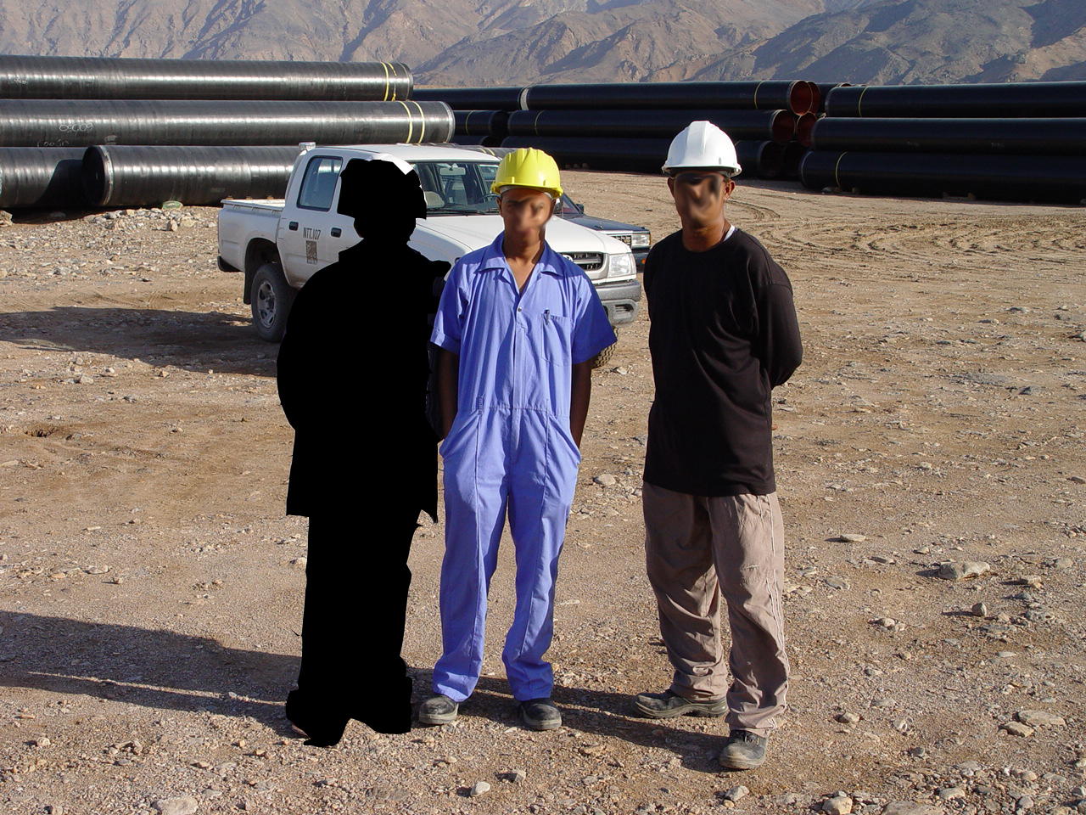

Summary:

HSE-2008 activity plan is driven from PDO and Gas learning from Shell HSE-MS audit conducted, incidents, STOP observation, and compliance checks during 2007. The HSE plan has been developed inline with PDO implementation of the Goal Zero (no harm to people) for the 2008 plan. The target areas are road safety, process safety, HSE management of contracts and worksite hazards.
The process to achieve the goal zero will continue to be Comply, Intervene and Respect. The plan has been changed to have easy monitoring and implementation in the areas of management walkabout, inspection, audit, emergency exercise, and follow-ups. The actions are combined from top management to the operations and projects team.
Best project in compliance to HSE competition has been added to the plan, to promote the competition between the projects to achieve the goal of no harm to people during the executions.
Installation of In-Vehicle Monitoring Systems (IVMS) in the projects vehicle will continue, excluding ODC& EMC projects. PDO vehicles will follow company directions.
Re-introduction to STOP training in the gas team, will continue during 2008 to train 200 staff of gas and 100% of site project staff. The introduction to STOP will help staff to differentiate between normal observation and non-compliance, which require the use of consequence management system to ensure discipline by individuals are maintained.
Operation HSE case workshop conducted during Jan-08 GGO team with support of MSEM group. Rolling out of the HSE case is planned during Q4-08.
Commitment and communication from all individuals during the meetings and during the day are required to ensure the risk of the business is adequately controlled to ensure safe workplace at all time.
In the document you will find:
- Performance-2007
- Targets-2008
- HSE inspection by the management team to support the HSE at site.
- HSE monitoring list of activity plan.

Performance- 2007

The objective of improving HSE performance in 2007 was achieved with unfortunate of having 6 lost time incidents during the year (LTI). During 2007, the gas team including contractors, worked 14 million man-hours and drove 12 million km, the team had total of 67 incidents and six of them were lost time incidents (LTI), higher than 2006 which was 4 LTI. The LTI were two industry-related, 2 road traffic accident related, one at office site and one back injury. The asset had two potential fires one when QA workshop burnt down due to electrical fault and at CPP when E-4106 re-boiler caught fire due to self ignition of leaking condensate, during gasket replacement. Improvements in road safety achieved by the installation of In-Vehicle Monitoring Systems (IVMS) in the pipeline, Haban, SN-Shuiba projects, SRDC project been implemented. Total of 250 vehicles had the IVMS installed on them. System been evaluated to ensure the sustainability of achievement on changing the driver behaviours.

Actual flaring was higher than the target due to additional WTU activity and the tested wells had higher potential than estimated when the targets was set at the end of 2006.

During the year, Yibal project achieved 1 million man-hours, Kauther 3 million man-hours and Haban 2 million man-hours without lost time injury. The SN- Shuiba compressor was transported safely from port Sohar to Qarn Alam.

Management has continually visited the sites as planed for inspection, communicate and coach staff on the need to continue improving our HSE performance. Goal zero (no harm to people) was addressed to most staff during 2007 and communication will continue during 2008. STOP (Safety Training Observation Program) has started and coachers trained to cascade to interior staff. PDO health walk-2007 sponsored by the directorate for the fist time as part of health promotion for work life balance.

Closeout of fountain actions has been followed aggressively with the action party to ensure proper closeouts are documented and maintained. By end 2007 total of 86, was pending and in 2008 this will be part of the monthly monitoring plan.

1. Targets-2008

Reactive:

 | Performance  Indicator | GD 2007  Target | GD 2007  Actual | 2008 target
Days without LTI |  | Na | 359* | 365
Environment | GWP  (K Ton/month CO2 equiv.) | 79 | 96 | 104  Flaring 59  Combustion 45
Environment | Flaring K m3/d | 500 | 850 | 763
Environment | WTU K m3/d | 352 | 620 | 500
Environment | CPP K m3/d | 120 | 206 | 227
Environment | BARIK K m3/d | 4 | 7.2 | 7
Environment | SNGP K m3/d | 16 | 4 | 4
Environment | Kauther K m3/d | n/a | n/a | 15
Environment | GGP K m3/d | 8 | 12 | 10

Proactive:

Pro active targets- 2008
STOP cards | 1500 | Projects HSE compliance audits |  | 4
GLT HSE-MS inspections | 4 | Staff trained in STOP |  | 200
GGO and GGE HSE-MS inspections | 6+6 | Staff trained in STOP, projects |  | 100%
PTW Audits level-2 | 2 | Vehicles with IVMS in projects |  | 100%
PTW Audits level-1 | 1 | Meeting HSE managers |  | 2 times/ year

*As advised from MSE/54

2. HSE Inspections, Emergency Plan

Inspection by GD, GGE, GGO, GLT:

Total of 4 HSE dedicated HSE-MS inspections will be done by the gas management as team and 6 HSE-MS inspections will be done by the individual managers GGO and GGE to cover operations and projects sites.

Camp inspections:

The aim is to improve the compliance to camp standards and during the visits, contractors camps will be one of the areas for inspection by the management.

Emergency plan:
Operations need to conduct evacuation drills at agreed intervals and to join the area team for conducting an exercise as agreed with Yibal and QA OND team. Once per area as joint exercise.

Projects to be done following the agreed monitoring plan, minimum once per month.

Coast office one evacuation exercise is planned during the 2008.

3. Activity Plan-2008.

Note:
- The actual matrix will be issued to all for easy update.
- The document will be placed to the HSE web site.

