
Petroleum Development Oman L.L.C.

Document Title:
Lift Planning/- Execution Procedure

Document ID | PR-1709
Document Type | Procedure
Security | Unrestricted
Discipline | UEQ
Owner | UEQ/3
Issue Date | 29 June 2015
Version | 1.2
This page was intentionally left blank
Keywords: This document is the property of Petroleum Development Oman, LLC. Neither the whole nor any part of this document may be disclosed to others or reproduced, stored in a retrieval system, or transmitted in any form by any means (electronic, mechanical, reprographic recording or otherwise) without prior written consent of the owner.
- Document Authorisation
Authorised For Issue

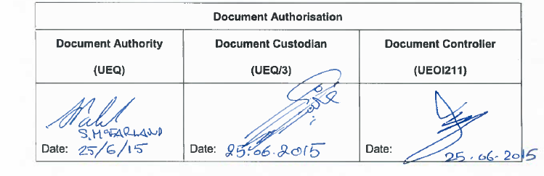
- Revision History
The following is a brief summary of the 4 most recent revisions to this document. Details of all revisions prior to these are held on file by the issuing department.

Version No. | Date | Author | Scope / Remarks
Version 0 | 1.9.07 | Hugo den Boogert, UEC/14 | New Lift Planning /- Execution procedure – Initial Issue
Version 1 | 1.9.11 | Hugo den Boogert UEQ/3 | Amendments reflecting input users
Version 1.1 | May-12 | Robin Norman UOP6 | Added Interim Amendment 1709_0412_01
Version 1.2 | June-15 | Hugo den Boogert UEQ/31 | Added Interim Amendment 1709_0615_02

- Related Business Processes
Code | Business Process (EPBM 4.0)
- Related Corporate Management Frame Work (CMF) Documents
The related CMF Documents can be retrieved from the Corporate Business Control Documentation Register TAXI.
Design: CP117 Project engineering
Procurement: CP129 Contracting and Procurement CoP
PR1233 Contracting and Procurement Procedures
Lifting and Hoisting: PR1708 Lifting and Hoisting, Inspection, Testing and Certification
Maintenance: CP114 Maintenance Code of Practice
HSE: PL04 HSE Policy
SP2000 Road Transport
SP1143 Specification for Earthmoving and Construction Equipment
SP1257 HSE Specification - Scaffolding, Working at Heights or Over Water, Lifting Operations and Earthworks
CP-122 HSE Management System
SP-1242 Activities Within Vicinity of Overhead Power Lines
Well Engineering: PR1312 Equipment Inspection and Certification Procedure
TABLE OF CONTENTS

1. Introduction 7
1.1 Purpose 7
1.2 Scope 7
1.3 Terminology 7
2. Roles and Responsibilities 9
3. Lift Planning and Execution 10
3.1 Defining the lift 10
3.2 Planning 10
3.3 Execution 13
3.4 Reacting to changing conditions 14
3.5 Learn and Record 14
4. Application & Step-Out Aproval 15
4.1 Application 15
4.2 Step-out and Approval 15
Appendixes 16
Appendix 1, Risk Matrix 16
Appendix 2, Sample Lift Plan 18
Appendix 3, Specific Requirements for Execution of Lifting Operations 19
Appendix 4, Sample of JHA form 30
Appendix 5, 10 Questions for a safe lift 31
Interim Amendment 1709_0412_01 32

Introduction

Purpose
This document provides the procedure to be used for crane operational practices.
The key to safe crane operation is having qualified personnel using the correct equipment in a safe manner. This procedure will outline the issues relating to the selection of the correct people for the task. It will describe the operational practices to be used by these people as part of a safe and effective crane and rigging program.

Scope
This procedure applies to all lifting operations.The lift planning process describes the systematic assessment of important load factors and site factors. It is as applicable to “simple” routine lifts as well as ”heavy” non-routine lifts. Planning a non-routine lift requires considerable effort. In a lift determined to be non-critical, many of the elements can be determined "by inspection"; and the depth involved in a non-routine lift will not be required. Nevertheless, the planning process must be followed.
This procedure prohibits a person from riding or travelling on the load, lifting hook, sling, platform or other lifting medium.

Terminology
Terminology specific to this document is given in the table below:
Abbreviation/Term | Meaning
Net Capacity | The net capacity is the gross crane capacity minus deductions. The deductions differ from manufacturer to manufacturer as well as between crane types.  Deductions normally are:  Weight of main hook block  Weight of slings and rigging  Weight of auxiliary hook block  Weight of all wire rope from boom tip and the block  Weight of any stowed jib
Gross Capacity | The gross capacity is the capacity shown in the crane’s load or capacity charts.
Lift Planner | A person who has appropriate practical and theoretical knowledge and experience of the lifting operations to enable him to prepare a full working lift plan and who is approved by the lifting equipment engineer.
CAP | Competent Authorised Person is a person who is appointed by the production co-ordinator (site-manager) to undertake the day-to-day control of lifting equipment.
Equipment Tag Number | A unique number given to an item of lifting equipment for registration purposes and to facilitate traceability.
Bilingual Text | English and Arabic
Lifting Inspector | A person from a third party certification authority who has the appropriate practical and theoretical knowledge and experience of the lifting accessories to be thoroughly inspected against the applicable lifting equipment standards in relation to the safety and continued use of the lifting tackle and who is approved by the lifting equipment engineer.

Lifting Engineer (surveyor) | A person from a third party certification company who has the appropriate practical and theoretical knowledge and experience of the lifting equipment to be thoroughly inspected as will enable him to detect defects or weaknesses and to assess their importance in relation to the safety and continued use of the lifting equipment.
NDT Inspector | The term NDT inspector is used to describe any person carrying out NDT inspection on lifting equipment. In all cases, the inspector shall have experience and training suitable to the NDT inspection being performed. (min level 2 as per ASNT Tc 1a or equivalent)

Roles and Responsibilities
WHO | WHAT
Project Manager | To identify the need for a crane based on his/her workscope requirement.
Executing Dept. | To identify lifting parameters needed to execute the work.  To ensure that a risk assessment is carried out and a liftplan is prepared/approved.  To source a certified mobile crane from registered contractor/operator under their current contract.  To constantly monitor the approved plan and identify improvement for future work.
Contractor/Crane supplier | To establish crane capacity and boom length in order to carry out the given workscope safely and in accordance with this procedure.
PDO’s Lifting Engineer  UEQ3 | To review and approve lifting plan and operation submitted by contractor/crane supplier via the Executing Department as and when required.  To constantly monitor the approved plan and identify improvement for future.
Crane Operator | To control the crane operations as per approved liftplan.  To participate in JHA/risk assessment/toolbox talk for the lift.  To perform pre-use crane inspections.  To maintain crane operation logbook comprising manuals, pre-use inspection lists, crane/lifting gear certificates, wire rope certificate and hook block certificate.
Banksman | To co-ordinate the lifting movements and maintains radio- and/or visual communication with crane operator and persons close to the load.  To participate in JHA/risk assessment/ toolbox talk for the lift.  Should not get involved as Rigger when also performing the role of a Banksman.
Slinger/Rigger | To inspect the rigging, select rigging to suit the load, install the equipment.  To participate in JHA/risk assessment/toolbox talk for the lift.  To connect/disconnect the load.
Person in charge of the lift (PIC) | To co-ordinate and control all aspects of lifting operations on site.  Liaise with the lifting equipment engineer.

Lift Planning and Execution

Defining the lift
When a lifting operation has to be carried out, it has to be checked if this particular lifting operation has been carried out before on that site. A risk assessment and Lift Plan might already exist.
If a risk assessment and Lift Plan do exist then they shall be assessed to confirm that they are still applicable (e.g. changes to personnel, equipment, site layout or work environment could all result in the need for re-assessment of hazards). Assuming that significant changes have not taken place then lifting operations may proceed under the requirements of the Lift Plan subject to approval by the lifting engineer.
If the lifting operations have not been carried out before, a competent person will prepare a Lift Plan. This has to be initiated by the executing department.
To define the lift the following parameters are established:
- Load weight, shape, centre of gravity and availability of adequate lifting points
- Initial and final load positions and how it will get there
- The environment in which the Lifting Equipment will be used

Planning
Risk Assessment
For every lifting operation the risks have to be assessed and controlled.
As part of the Hazard Effect Management Process (HEMP), a risk assessment is carried out prior to any lifting operation to identify associated hazards, their severity and likelihood of occurrence. The Group (YG) ‘Risk Assessment Matrix’ (RAM) for determining risk is shown in App.1 and is the basis of the risk assessment process, with the objective of ensuring that all tasks have Low Risk through elimination or adequate control. All risk assessments are formally to be documented. A sample form is attached under App.4
The risk assessment addresses a.o. the following aspects and activities:
- Cultural, communication and language difficulties
- Weight, size, shape and centre of gravity of load
- Availability of approved lifting points on load
- Method of slinging/attaching/detaching the load
- Overturning/load integrity/need for tag lines
- Suitability and condition of Lifting Equipment to be used
- Initial and final load positions and how it will get there
- Ground and underground considerations
- Lifting over live equipment
- Number and duration of lift(s)
- Conflicting tasks in area
- Environmental conditions including weather and permissible limits
- Lighting in the pick-up and lay-down areas
- Proximity hazards, obstructions, path of load (e.g. potentially live electrical, hydraulic or pneumatic lines, underground conduits, bridges and overhead structures)
- Working under suspended loads
- Access and emergency escape routes for the Lifting Appliance Operator and load handlers (e.g. Banksman, Slinger)
- Experience, competence and training of personnel
- Number of personnel required for task
- Pre-Use Inspection of equipment by Operator
- Visibility of the load at all times by either the Lifting Appliance Operator
or the person guiding the load (Banksman). He must maintain communication
with the Operator at all times either via hand signals, radio or a relay Signal Banksman.

Categorising Lifting Operations
As an aid to identifying risks and suitable controls, lifting operations are categorised to reflect increasing risk and increasing level of control required as per categorisation scheme as given below:

Routine Lifts
This classification comprises:
- Routine crane operations
- Repetitive lifting operations using the same equipment (eg drilling activities), and
- Routine lifting operations with Loose Lifting Equipment

A generic risk assessment and Lift Plan may be used for Routine Lifts. However, classifying a lifting operation as ‘routine’ does not automatically make it a ‘safe’ lifting operation – most incidents associated with lifting occur during routine operations. The risk assessments and Lift Plans shall always be reviewed during the Toolbox Talk for continued applicability.
NOTE: Refer to Interim Amendment 1709_0412_01 for Generic Lift Plan, HEMP (Risk Assessment) and Lifting Calculation Sheet. These may be used for all generic Lifts and this Interim Amendment will be incorporated when the procedure is reviewed and validated at the next due date.
The control requirements for each category of lift are as follows:

Category of Lift | Documentation/Controls | Competent Personnel
Routine Crane Operations  when:  − Gross load is less than 5 tonnes, or  − Gross load represents less than 50% of the load chart at working radius  − Within the normal operating parameters of the crane  − Lifting over non-sensitive areas  − Suitable environmental conditions  − Familiar, competent Crane Operators  − Load has known and evaluated weight, shape and centre of gravity  − Standard rigging arrangements  − Repetitive functions with same equipment and with same operators (eg repeat rig moves) | − Risk Assessment (generic)  − Lift Plan (generic) (initiated by executing department and approved by PDO’s lifting engineer)  − Job Hazard Analysis  − Work Permit  − Toolbox Talk  − Safety checklist  − 10 questions for a safe lift | − Crane Operator  − Banksman and / or Slinger/ Rigger  − Drilling Crew

Non-Routine Lifts
Non-routine lifting operations can be further sub-divided to reflect increasing risk:
- Simple lifting operations using Loose Lifting Equipment
- Complicated lifting operations eg tandem lifting
- Complex / Critical / Heavy lifting operations requiring a Lift Plan with engineering input

The control requirements for each category of lift are as follows:

Category of Lift | Documentation/Controls | Competent Personnel
Non-Routine – Simple  when:  − Gross load is less than 25 tonnes, or  − Gross load is greater than 50%, but less than 75% of the load chart at working radius  − Equipment specifically installed by a competent operator  − Load has known and evaluated weight  − Centre of gravity below the lifting point  − Use of a certified lifting point directly above the load  − Ample headroom  − Outwith sensitive, difficult or restricted areas  − Single lifting appliance  − Unlikely to be affected by changing environmental conditions  − Experienced and competent Lifting Appliance Operator  − Standard rigging arrangements  − Suitable laydown area available | − Risk assessment  − Lift Plan initiated by executing department/ prepared by contractor (approved by PDO’s lifting engineer)  − Job Hazard Analysis  − Work Permit  − Safety checklist  − Toolbox Talk  − 10 questions for a  safe lift | − Maintenance Technicians  − Riggers
Non-Routine – Complicated  when:  − Gross load is greater than 25 tonnes, or  − Gross load represents more than 75% of the load chart at working radius, or  − Gross load is greater than 30 tonnes and is also greater than 80% of the manufacturer’s load chart  − Continuation of a lifting operation with different equipment (due to malfunction, inadequacy or unsuitability)  − Use of two or more Lifting Appliances (tandem lifting)  − Within sensitive, difficult or restricted areas | − Risk assessment  − Specific Lift Plan initiated by executing department/prepared by contractor (approved by PDO’s lifting engineer)  − Job Safety Analysis  − Work Permit  − Safety checklist  − Toolbox Talk  − 10 questions for a  safe lift | − Crane Operator  − Banksman (Signaller)  − Slinger / Rigger
Non-Routine – Complex / Critical / Heavy Lift  when:  − Gross load is greater than 75 tonnes, or  − Gross load represents more than 90% of the load chart at working radius, or  − Gross load is greater than 50 tonnes and is also greater than 80% of the load chart.  − Continuation of a lifting operation with different personnel; for example, shift changeover  − Lifting of personnel, including drill floor Man Riding operations  − Over or in sensitive areas – active or energized hydrocarbon-containing process equipment, near overhead electrical power lines  − Use of two or more cranes (tandem lifting)  − Lifting with a helicopter  − Transferring the load from one lifting appliance to another (tailing lift)  − In environmental conditions likely to affect  equipment performance  − Load with unknown / difficult to estimate weight and / or centre of gravity  − Load is special and / or expensive whose loss would have a serious impact on production operations  − Non-standard rigging arrangements  − Load lowered into or lifted from a confined space | − Formal work pack with method statement, including calculations  − Lift Plan prepared and  reviewed by a qualified engineer (approved by PDO’s lifting engineer)  − Risk assessment  − Job Hazard Analysis  − Work Permit  − Safety checklist  − Toolbox Talk  − 10 questions for a safe lift | − Crane Operator  − Banksman (Signaller)  − Slinger/Rigger

Lift Plan
A Lift Plan is prepared or identified for every lift. The Lift Plan comprises ao:
- The competent person planning the lift
- Calculations
- Equipment required
- Personnel required and their particular roles
- Step-by-step instructions
- Communication methods to be used
- Contingency and rescue plans

All Lift Plans – generic, specific or engineered – are developed, reviewed and approved by persons competent to do so. This shall be initiated by the executing department.
A sample Lift Plan is included in App.2 showing the elements required.

Execution
Communication of Lift Plan
Prior to starting of lifting operations a competent person shall hold a Toolbox Talk with all personnel assigned to carry out the lift. Application of the ‘10 questions for a safe lift’ to the lift shall be covered during the Toolbox Talk (Appendix 5).
The Person-in-Charge (PIC) shall be clearly identified and made known to all members of the lift team and personnel in the proximity.
All personnel involved in the lifting operation shall have their individual responsibilities clearly allocated.
All personnel should have the opportunity to review the findings of the risk assessment and the details of the Lift Plan to ensure that everyone clearly understands and agrees with the methods and control measures to be used.

Conducting the Lifting Operation
Lifting operations shall be conducted in strict accordance with the approved Lift Plan. Any variation from the agreed Lift Plan shall result in the job being stopped and reassessed to ensure continued safe operation.
The Lifting Appliance Operator shall obey an emergency stop signal at all times, no matter who gives it.
When lifting operations need to be controlled by signals, a designated signal person shall be assigned. Signals between the Lifting Appliance Operator and the designated signal person (Banksman / Signaller) shall be audible or visible at all times.
The appropriate load-radius chart for the Lifting Appliance configuration in use shall be visible to the operator.
Load to be lifted shall be confirmed to be within the rated capacity of the Lifting Equipment and attached by means of suitable Lifting Accessories.
The Operator of the Lifting Appliance shall not leave the operating controls while the load is suspended.

Moving the Load
- Prior to lifting the PIC shall be satisfied that the load is secure and properly balanced and that the load path is clear of obstructions and personnel
- At commencement of the first lift the Lifting Appliance Operator shall carefully check the operation of the hoist brake to ensure no slippage occurs
- Take up sling slack to confirm that the Lifting Appliance hook has been positioned centrally over the load lifting point, adjust the Lifting Equipment as necessary to minimise any ‘drift’ of the load as it is lifted
- No external forces shall be applied to the load that create significant side loading of the Lifting Equipment
- For crane operations appropriate tag lines shall be used to control the load– large or long loads with flat sides that could act as a ‘sail’ are particularly prone to spinning and tag lines shall be used – tag lines shall be secured to the load and not to the rigging slings
- Cranes shall not be used for dragging a load
- No fewer than five (5) full wraps of rope must remain on the winch drum in any operating conditions.

Additional requirements, specific to particular equipment or operations, are detailed in App.3.

Reacting to changing conditions
All critical lifting parameters (e.g. weather, sea state, visibility, terrain stability and slope, surrounding operations and installations, site access and egress, Lifting Equipment, personnel) shall be identified during the risk assessment and preparation of the Lift Plan.
The PIC shall ensure that these conditions are monitored as lifting operations proceed to ensure continued safety.
If, as part of the operation and maintenance of equipment, the computer system shuts down the operation, the load must be placed on the ground and a new lift plan must be developed, eliminating the condition that caused the shut down.
Procedures for recovering and landing the load in the event of the lift being aborted shall be clearly identified.

Learn and Record
After completing the lifting operation, everyone involved in the lift should have the opportunity to discuss and make improvements to the Lift Plan. Any learning points noted on the plan must be reviewed by a competent person and, where appropriate, action taken. Learning points may include feedback on equipment effectiveness, lifting techniques, personnel, etc.

Application & Step-Out Aproval

Application
This Lift planning procedure is applicable to all lifting operations / lifting equipment in PDO. As such, this document is mandatory and shall be adhered to by all parties, involved in lifting operations.

Step-out and Approval
Any step-out from this procedure shall be addressed to the lifting equipment engineer in writing. He will review and authorise the deviation in exceptional circumstances.

Appendixes

Appendix 1, Risk Matrix
The RAM provides one means of determining the level of risk associated with any task
through consideration of the potential severity of any incident and the likelihood of such an
incident occurring.

For different applications different overlays of the Risk Assessment Matrix can be used.
Severity | Consequences |  |  |  | Increasing likelihood
Severity | People | Assets | Environment | Reputation | A | B | C | D | E
 |  |  |  |  | Never  heard of in  E&P  Industry | Heard of in  E&P  Industry | Incident has occurred in PDO | Happens several times per year in PDO | Happens several times per year in a location
0 | No injury or health effect | No damage | No effect | No impact
1 | Slight injury or health effect | Slight damage | Slight effect | Slight impact
2 | Minor injury or health effect | Minor damage | Minor effect | Limited impact
3 | Major injury or health effect | Localised damage | Localised effect | Considerable impact
4 | PTD* or 1 fatality | Major damage | Major effect | National impact
5 | Multiple fatalities | Extensive damage | Massive effect | International impact
*PTD = Permanent Total Disability

Risk Assessment
…A scale of consequences from “0” to “5” is used to indicate increasing severity…
The potential consequences, rather than the actual ones, are used….

…After assessing the potential outcome, the likelihood on the horizontal axis is estimated on the
basis of historical evidence or experience that such consequences have materialised within the
industry, the company or a smaller unit. Note that this should not be confused with the likelihood
that the hazard is released: it is the likelihood of the estimated consequences occurring.

…In Operating Units or new ventures where experience is limited, it is recommended that the
probability be assessed on the basis of knowledge from similar operations in other Operating
Units….

The following interpretations may assist in determining likelihood when assessing risks
specific to lifting and hoisting operations:

Low Risk May be acceptable but review task to see if risk can be reduced further.

Medium Risk Task should only be undertaken with appropriate management
authorisation after consultation with specialist personnel and assessment team. Where possible, the task should be redefined to take account of the hazards involved or the risk should be reduced further prior to task commencement.

High Risk Task shall not proceed. It should be redefined or further control measures put in place to reduce risk. The controls should be reassessed for adequacy prior to task commencement.

Appendix 2, Sample Lift Plan
LIFTING OPERATION PLAN |  |  | PAGE 1 of
Location: |  | Area:
Permit Number: |  | Risk Assessment Number:
Generic Lifting Plan No: |  | Method Statement Number:
Is Diagram/Sketch/Calculations Of Lifting Operation Enclosed? YES/NO nr.:
Description Of Lifting Operation:

Lift Category: Routine: Non-Routine:

Weight Of Load: Actual / Assessed (delete as appropriate)

Lifting Equipment & Accessories to be used (specify type ,SWL and colour code)

All Lifting Operations Require The Following To Be Considered But This List Is Not Exhaustive.

□ Cultural, communication and language difficulties  □ Weight, size, shape and centre of gravity of load    □ Availability of approved lifting points on load  □ Method of slinging/attaching/detaching the load  □ Overturning/load integrity/need for tag lines  □ Suitability and condition of lifting equipment to be used  □ Initial and final load positions and how it will get there  □ Ground and underground considerations  □ Lifting over live equipment  □ Number and duration of lift(s)  □  □ |  | □ Conflicting tasks in area  □  Environmental conditions including weather and  permissible limits  □ Lighting in the pick-up and lay-down areas;   □ Proximity hazards, obstructions, path of load   □ Working under suspended loads   □ Access and emergency escape routes   □ Experience, competence and training of personnel   □ Number of personnel required for task   □ Pre-Use Inspection of equipment by operator   □ Visibility of the load  □  □  □
Task Details (Step By Step)
Method(s) Of Communication To Be Used Radio □     Verbal □     Hand Signals □
Steps Taken To Eliminate Danger To Personnel Involved and Others (including barriers where appropriate):

De-brief and learning points:

Prepared By/Name: Signature: Date:

Reviewed By/Name: Signature: Date:

Approved By/Name: Signature: Date:

Appendix 3, Specific Requirements for Execution of Lifting Operations

1. Handling of tubulars

2. Mobile Crane Operation

3. Overhead Gantry Crane Operation

4. Operating Near Overhead Electric Power Lines and Cables

5. Tandem Lifting

6. Operating Powered Industrial Trucks including Fork Lift Trucks (FLTs)

7. Operating Personnel Lifting Devices/Mobile Aerial Platforms

1. Handling of tubulars

1.1 Slinging of Tubulars
Key elements and practices for the safe operation of slinging tubulars or tubular bundles are
described in this section.

1.2 Handling

- Only tubulars of the same diameter or size and about the same length should be bundled together
- The number of tubes in each bundle should be such that the middle tubes are gripped and will not slip out of the bundle. Whenever practicable tubulars over 5.5” in diameter should be bundled in ‘odd’ numbers
- Tubulars should always be slung with two slings, each of the same length and of the same SWL
- Slings should be placed positioned at equaldistance (approximately 25% of total length) from the ends of the load. They should be double wrapped and choked around the tubular either when using steel slings or nylon webbing
- The sling should be of sufficient length to ensure that the choke is on the sling body, never on the sling splice, fittings, tag, eye or at the base of the sling eye or fitting
- Excessive long tubular bundles may have a tag line attached. This shall be subject to a JHA
- Care should be taken on removing slings due to stowage movement
- Whilst loading, consideration should be given to the installation discharging sequence
- Ensure thread protectors and endcaps are securely fastened
- Due care and attention should be taken when loading tubulars to avoid damage to slings
- Slings shall not cross under the load to avoid damage to the sling
- Prior to making any lifts, the release of rigging should be considered. Precautions are
required to prevent personnel from being trapped between tubulars during release of rigging

1.3 Transportation
- Certified transportation frames are considered best practice for chrome casings to
avoid/reduce body to body contact
- In preparing tubulars for transportation it is good practice to pick up the tubing bundle for a second time to see if more slack can be taken out using clamps or bulldog clips

1.4 Storage
- Tubular ‘stacks’ should be segregated by pipe posts
- The bottom stow of tubulars should be individually ‘chocked’ or secured by other mechanical means to stop movement

2. Mobile Crane Operations
Persons shall not be permitted to board or leave the crane without first obtaining the Crane
Operator’s permission.

The crane shall not be left unattended.

The PIC shall obtain information on wind conditions prior to starting a lifting operation. The lifting
operation shall be stopped, or the mobile crane secured in an out-of-service condition, as
appropriate, when the wind speed limits, as indicated by the manufacturer, are exceeded.

The PIC shall ensure that the ground (soil test), or any means of support, can sustain loads imposed by the crane and is suitable for the crane to operate within the levels and other parameters specified by the crane manufacturer. Side loads shall be avoided.

When siting a crane, point loads through the outrigger / stabiliser beams and jack pads shall be
spread over a sufficient area to support the outrigger pad and to prevent the crane overturning or becoming unstable. The PIC shall ensure that the siting can accommodate the crane with the
outriggers extended and set as specified in the load chart. The mobile crane shall only be operated in level position.

Danger to and from underground services (gas, electricity, water) shall be taken into
consideration and precautions taken to ensure that the crane foundation is clear of such services or that they are adequately protected.

On-site travel of fully rigged wheeled cranes, whether loaded or unloaded, shall not be allowed.

While in transit the boom shall be retracted and carried in line with the direction of motion and the superstructure secured against rotation (or the boom placed in a boom rack mounted on the
carrier). The empty hook shall be lashed or otherwise restrained so that it cannot swing freely. If
the crane has a telescopic boom it shall be set to the fully closed position.

Counterweights shall be properly secured and under no circumstances counterweights shall be used heavier than the manufacturer's recommended weight.

3. Overhead Gantry Crane Operation
Operators of overhead gantry cranes shall carry out daily checks on the cranes and use shall be
prohibited if the limit switches, wire ropes, chains or other components are severely worn or in
disrepair.

Personnel working in the vicinity of the crane shall:
- Be clear of a lifted load at all times
- Not work or move under a suspended load
- Not ride on the hook or load
- Directional movement shall be made smoothly and deliberately; avoid rapid movements in any direction

Do not exceed the rated capacity of the crane, hoist, chain, sling or any other component.
Slings, load chains and other accessories shall be fully and securely seated in the hook before
moving a load. Remove slack from the sling, chain or cable before lifting a load.

Use the following practices to avoid a swinging load:
- Locate the hoist directly above the lifting point of the load before lifting
- Lower loads directly below the hoist – do not allow the load to be pulled to one side while suspended
- Maintain a minimum of five (5) full wraps of cable on the hoisting drum at all times

When lifting loads at or near the crane rated capacity test the hoist brakes by returning the master switch or push button to the “OFF” position after raising the load a few centimetres off the floor. If the brakes do not hold, lower the load to the floor slowly and do not continue with the lifting operation. Report the situation immediately and DO NOT USE the crane until repairs have been carried out.

Ensure that all loads are lifted high enough to clear obstructions before moving the bridge or trolley. Whenever possible, maintain a minimum clearance of 300mm above obstacles and to the sides of the load. Raise the load only to the height necessary to clear lower objects.

Never pull a hoist by the pendant cable. Never leave the controls unattended while a load is suspended. If it becomes necessary to leave the controls, lower the load to the floor.

Familiarise yourself with the location of the disconnect/isolation switch.

If loss of power occurs, place controls in the “OFF” position to prevent unexpected start-up upon restoration of power. Disconnect power to a hoist that is unsafe or in need of repair – follow the ‘Lock-Out’ procedure.

The daily inspection shall include:
- Check for any loose or missing parts
- Check end-stops, which prevent the trolley from running off the beam
- Know the location of the disconnect/isolation switch that will cut power off only to the hoist or crane. Be sure that it is readily accessible and not blocked.
- Make sure all control buttons are clearly labelled to indicate their function. Operate each
button to make sure it functions properly, releases immediately and does not stick
- Check upper hoist limit switch by slowly raising the block to trip the switch
- Lower the hoist block to activate the lower limit switch if the hoist is so equipped, leaving at least five turns of rope on the hoist drum
- Make sure wire rope is properly seated in its drum and sheave grooves without any slack or overlapping
- Operate the crane or hoist a short distance (300-600mm) in each direction that it travels.
Listen for any unusual noises and look for any jerky movements
- When moving an A-frame hoist, take care to ensure that the wheels on each side stay on the track
- Check all hooks – hooks shall not be cracked, stretched, bent or twisted. Each hook shall have a safety latch that automatically closes the throat of the hook. If the latch is bent, spring is broken or is otherwise damaged the latch shall be repaired before use. Hooks shall rotate freely in a block assembly
- Check the block assembly for structural damage or cracks in any components. Sheaves
shall rotate freely. The sheave guard shall be unbroken and intact. No part of the sheave
guard shall be in contact with the wire rope or sheave
- Lower the block to the lowest level and check the wire rope for the following:
- Reduced diameter of the rope – this may indicate that the rope has been stretched, has lost its inner core support or has worn wires
- Any number of broken strands or wire
- Kinked, crushed, cut, heat damaged or “bird-caged” wire rope
- Check the load chain for damage, wear at contact points, cracks or distorted (bent, twisted or stretched) links. Inspect all mechanical coupling links to ensure linking pins are secured and in good condition
- Check the condition and capacity of all accessories – nylon or synthetic web sling, wire rope slings, shackles. Capacity ratings shall be legible. The capacity of the sling being used shall be adequate for the load and attachment method

The following shutdown procedure shall be followed:
- Position the crane so that it will not cause an obstruction
- Remove the load and Lifting Accessories from the hook
- Raise the hook block clear of obstructions, personnel and plant
- Apply brakes
- Ensure that the controller is in neutral and apply the “STOP” button
- Turn off the auxiliary isolating switch
- Turn off the main isolating switch

4. Operating Near Overhead Electric Power Lines and Cables
If any part of a crane, including rope, slings or load, touches or even approaches overhead electric lines or cables there is a serious risk of fatal accident. The work shall be performed so there is no possibility of the crane, load line or load becoming a conductive path.
In general, the PIC shall ensure that the crane does not operate within:
15 metres (50 feet) plus the maximum achievable boom length, measured horizontally, for overhead lines on steel towers; or 9 metres (30 feet) plus the maximum achievable boom length, measured horizontally, for overhead lines on wood, concrete or steel poles.

Additionally, the PIC shall consider:
- Isolation of electricity if possible
- Contacting the electricity provider
- Weather – effect on the safe working zone
- Use of physical barriers e.g. goal posts

Cranes shall not be used to handle materials stored under electric power lines unless any combination of boom, load, load line or machine component cannot enter the prohibited zone. Overhead lines and other electrical apparatus shall be considered live unless declared ‘dead’ and ‘safe’ by the Line Operator. Crane Operators shall not rely on the coverings of wires for their protection.
Where the possibility of contact with energised power lines exists then durable signs shall be installed at the operator’s station and on the outside of the crane warning that electrocution or serious bodily injury may occur unless minimum clearances are maintained between the crane or the load being handled and energised power lines.
See also SP-1242 Activities within vicinity of overhead powerlines, which have to be strictly adhered to.

5. Tandem Lifting
Tandem lifts for weight reasons alone (because a load is too heavy for a single crane) shall only be considered as a last option.
All tandem lifts shall only be authorised by the lifting engineer and Site Manager and, based on a risk assessment demonstrating that other alternatives are not technically feasible.
Tandem lifts shall only be carried out with lifting devices equipped with a load indicator.
Tandem lifts shall always be classified as Non-Routine Lift and should at least follow the preparations outlined for this type of lift.
In addition, the following controls shall always be in place:
- Positions of cranes and loads to be carefully assessed in the Lift Plan, documented in drawings, and verified by the PIC prior to commencing the lift
- Loads for both cranes to be calculated, including the range of permitted tolerances, and documented. Speeds of raising / lowering the load and slewing of the cranes shall be documented in the Lift Plan
- The lift area to be fenced off and a permit-to-work system in operation, the load shall not be transferred over personnel at any time
- A full function test of all power, transmission, control, and safety systems to be carried out prior to the commencement of the lift, by competent personnel
- Only one person giving signals to be appointed for both cranes and shall have direct sight vision (and permanent radio contact) to the Crane Operators
- Prior to the lift, the PIC to ascertain that both load lines are vertical without side / off loading of the boom
- Upon signal, both cranes to lift slowly, to either the calculated weight tolerance limit or until the load is free, and STOP
- The PIC to confirm that the full load has been transmitted prior to authorizing the lift to continue. The safe load indicator accuracy and the integrity of the braking mechanism to be verified before the lift continues
- Raising or lowering the lift, or slewing of the crane, to only be undertaken at the signal from the signalman and at the previously agreed speeds
- Be aware that if the load is moved from horizontal to vertical the weight on each crane will change significantly

6 Powered Industrial Trucks including Fork Lift Trucks (FLTs)

6.1 Daily / Pre-Use Inspections
These inspections must be performed and documented by the qualified operator prior to first
use each day or shift the truck is used. These checks ensure that audible and visual
warning equipment is working correctly by carrying out function tests prior to any lifting
operations.

6.2 Operations
Key elements and practices for the safe operation of powered industrial trucks shall include,
but may not be limited too, dependent on local legislation and conditions, the following:
- Before each operation or series of operations, the Operator shall:
- Perform a pre-operational check to demonstrate operational readiness of the truck. If controls do not operate properly, the Operator is responsible for notifying the supervisor. Repairs and adjustments are made before operations begin
- Ensure the equipment is within inspection and testing intervals by examination of the periodic re-certification tags and/or documentation
- Adhere to all tags on the controls
- Ensure, if fitted, that seat belts are worn when operating a powered industrial truck equipped with a roll over protection device
- During operations, the Operator shall:
  - Drive at speeds appropriate for the existing conditions (space, load, lighting, surface conditions, etc.) and at or below posted limits
  - Keep all parts of the body inside the Operator compartment during operations
  - Not start or operate the truck or any of its attachments from any place other than from the Operators position
  - Ensure other personnel are not in the swing radius prior to performing turning manoeuvres
  - Sound the horn when approaching cross aisles, doorways and other locations where pedestrians may step into the path of truck travel
  - Verify sufficient headroom under overhead installations, lights, wiring, pipes, sprinkler systems etc
  - Ensure they are driven on suitable surfaces. Road humps and rough or soft surfaces are to be avoided
  - Movement with loads in excessively raised positions shall not be carried out to avoid the danger of toppling, especially on uneven surfaces and while cornering
  - Shall only be used for loads, which can be carried safely on the forks or attachments fitted. Non-standard, unpackaged and excessively wide loads shall be avoided wherever possible. In particular, long tubes shall be carried using appropriate attachments
  - They are not to be operated on excessive gradients or across gradients (In general they should be driven forwards up a slope, backwards down a slope and in line with the incline. It may be necessary to raise the forks slightly at the bottom of a slope to avoid grounding)
- No personnel shall:
  - Put any part of the body into the mast structure or between the mast and truck
  - Be allowed to stand or pass under the elevated portion of any truck, empty or loaded
- Unauthorised personnel shall not be permitted to ride on powered industrial trucks
A safe place to ride (i.e. another seat) should be provided where riding of trucks is
authorised
- Equipment shall not be loaded beyond its rated load (capacity) except for required testing
- Trucks should not be driven up to anyone standing in front of an object
- Only approved industrial trucks shall be used in areas classified as hazardous locations
- When parked:
  - The engine shall be switched off, the key removed and the hand-brake applied
  - The keys shall be kept in a secure place and only issued to authorised operators for the duration of the duty period or task
  - They shall be parked in secure areas to deter access by unauthorised personnel
  - They do not block access to fire aisles, stairways, or fire equipment
- While refueling, the engine shall be stopped and the Operator shall not be on the truck
- Lifting personnel with a powered industrial truck is not allowed, and alternative methods have to be used (e.g. mobile aerial platform)

6.3 Rough Terrain Operations for FLTs
The operation of rough terrain FLTs involves special hazards, which require additional care and
consideration:
- Care shall be taken at all times to ensure that traction is retained. Loss of traction due to the nature of the terrain or weight transfer taking load off the driving wheels is to be avoided
- Care shall be taken and speeds minimised to reduce the risk of load toppling caused by the imbalance induced when operating on rough terrain
- Operators shall ensure that the parking brake is capable of holding the FLT stationary on an incline (some rough terrain vehicles are capable of climbing inclines steeper than those on which the parking brake will hold the vehicle)
- Checks for overhead obstructions shall be made before lifting and transporting loads
- Special care shall be taken near power lines and other materials handling vehicles such as mobile cranes
- Driving rough terrain FLTs on public roads shall be kept to a minimum. When public roadtravel is necessary, fork arms shall be removed, folded or protected in some way so that they do not present a hazard to other road users. Where this is not possible, forks shall be painted or otherwise made highly visible
- Rough terrain FLT Operators shall wear seat belts while operating their vehicles.

6.3 Repairs
If repairs or part replacement is required then the following guidelines shall be followed:
- Immediately take the truck out of service if an unsafe condition is identified or restrict its
operation to eliminate the unsafe condition
- Repair or replace all critical components promptly by or under supervision of a qualified
mechanic
- An original equipment manufacturer or other approved vendor should supply spare parts or components
- Document in writing all repairs or replacements as per the PM program

7. Personnel Lifting Devices / Mobile Aerial Platforms

7.1 Daily / Pre-Use Inspections
These inspections shall be performed and documented by the qualified operator prior to first
use, each day or shift the equipment is used.

7.2 Operations
Personnel lifting devices and mobile aerial platforms shall be operated according to applicable
government requirements, and manufacturers’ instructions. The following practices shall be followed:
- Determine through JHA process that the proposed personnel lifting operation is either the least hazardous method or the only method available to position personnel so that an operation can be accomplished

- Before use, the Operator shall:
  - Have read and understood the manufacturer’s operating instructions and safety rules, have been trained and licensed according to SP-1251 Training Requirements for Lifting Operations Personnel and have read and understood all decals and warnings on the device
  - Inspect the personnel lifting device or mobile aerial platforms per the daily/Pre-Use Inspection requirements
  - Perform a pre-operational check to demonstrate operational readiness. If controls do not operate properly, the Operator is responsible for notifying the supervisor. Repairs and adjustments shall be made before operations begin. The Operator shall adhere to all tags placed on the controls
  - Ensure that the personnel lifting device is within inspection and testing intervals by examination of the periodic re-certification tags and documentation
  - Test the agreed communication system. Operation shall stop immediately upon communication loss and should not continue until communication is restored
  - Before operating the machine, make sure all safety gates are closed and fastened in their proper position

- Personnel shall:
  - Keep all parts of the body, tools, and equipment inside the work platform periphery during raising, lowering, and travelling operations
  - Hold onto a moving platform using both hands
  - Secure tools and other objects in canvas bags or by other methods so that both hands are free and do not present a snagging hazard. Alternate methods of tool delivery beside personnel lifting devices should be investigated
  - Wear fall protection with a lanyard attached to an authorised lanyard anchorage point. Attach only one (1) lanyard per lanyard anchorage point
  - Detailed technical operating procedures describing personnel lifting device operation, emergency steps, communication requirements, and special requirements should be prepared
  - Personnel lifting device or mobile aerial platforms shall not be loaded beyond its rated load (capacity) except for required testing
  - Consideration shall be given to prevailing environmental conditions (e.g. wind max. 12.5 m/s or as indicated by manufacturer), as well as aspects of the device (e.g. sail area) before commencing operations
- The following additional requirements shall be followed for mobile aerial platform operations:
  - Check all limit switches and outrigger drift switches, if applicable
  - Survey the area for applicable hazards such as:
    - Overhead obstructions and high-voltage conductors;
    - Debris, bumps and loose obstructions, drop-offs, holes, ditches, open earth fills, obstructed path of travel, unstable footing, and other possible hazardous conditions.

- Electrocution Hazards
  - For work on or near electrical distribution and transmission lines, mobile aerial platforms shall be operated in accordance with the applicable national and or local standard e.g. ANSI/SIA ASME standard
Note: for non-insulated platforms it is recommended that the following sign is posted: ‘This machine is not insulated and does not provide protection from contact or proximity to electrical current’
  - Maintain safe distance from electrical lines, apparatus, or any energized (exposed or insulated) parts according to the Minimum Safe Approach Distance (MSAD) as shown in Table 1-1;

  - Insulated mobile aerial platforms shall be tested and inspected in accordance with the applicable standard e.g. BS EN 61057 or ANSI/SIA ASME standard;
  - Stow boom and shut off all power before leaving machine
  - When two or more persons are in the platform, the Operator shall be responsible for all machine operations
  - Do not place boom or platform against any structure to steady the platform or to support the structure
  - Keep both feet firmly positioned on the platform floor at al times. Never use ladders, boxes, steps, planks, or similar items on platform to provide additional reach
  - Never use the boom assembly to enter or leave the platform
  - Do not use machine as a ground for welding
  - When performing welding or metal cutting operations, precautions shall be taken to protect the chassis from direct exposure to weld and metal cutting spatter
  - Do not refuel the machine with the engine running
  - Charge batteries only in a well ventilated area

- Tipping Hazards:
  - The user shall be familiar with the surface before driving. Do not exceed the allowable side slope and grade while driving
  - Personnel Platforms/Carriers should not be elevated whilst on a sloping, uneven, or soft surface. Personnel shall not be driven with the platform elevated
  - Before driving on floors, bridges, trucks, and other surfaces, check allowable capacity of the surfaces
  - Never exceed the maximum platform capacity. Distribute loads evenly on platform floor
  - Do not raise the platform or drive from an elevated position unless the machine is on firm, level surfaces and evenly supported
  - Keep the chassis of the machine at least 2 ft. (0.6m) from holes, bumps, drop-offs, obstructions, debris, concealed holes, and other potential hazards on the floor/surface
  - Do not push or pull any object with the boom
  - Never attempt to use the machine as a crane. Do not tie-off machine to any adjacent structure
  - Do not operate the machine when wind conditions exceed 12.5 m/s or as prescribed by manufacturer, local legislation and or procedures
  - Do not increase the surface area of the platform or the load. Increase of the area exposed to the wind will decrease stability
  - Do not increase the platform size with unauthorised deck extensions or attachments
  - If boom assembly or platform is in a position that one or more wheels are off the ground, all persons shall be removed before attempting to stabilize the machine. Use cranes, forklift trucks, or other appropriate equipment to stabilize machine and remove personnel

- Crushing and Collision Hazards
  - All operating and ground personnel shall wear approved headgear
  - Check work area for clearances overhead, on sides, and bottom of platform when lifting or lowering platform, and driving
  - During operation, keep all body parts inside platform railing
  - Use the boom functions, not the drive function, to position the platform close to obstacles
  - Always post a lookout when driving in areas where vision is obstructed
  - Keep non-operating personnel at least 6 ft. (1.8m) away from machine during all driving and swing operations
  - Limit travel speed according to conditions of ground surface, congestion, visibility, slope, location of personnel, and other factors, which may cause collision or injury to personnel
  - Be aware of stopping distances in all drive speeds. When driving in high speed, switch to low speed before stopping
  - Travel grades in low speed only
  - Do not use high-speed drive in restricted or close quarters or when driving in reverse
  - Exercise extreme caution at all times to prevent obstacles from striking or interfering with operating controls and persons in the platform
  - Be sure that operators of other overhead and floor level machines are aware of the aerial work platform’s presence
  - Disconnect power to overhead cranes
  - Warn personnel not to work, stand, or walk under a raised boom or platform
  - Position barricades on floor if necessary

- Towing, Lifting and Hauling
  - Never allow personnel in platform while towing, lifting, or hauling, unless so designed that the operator has to be on the platform to drive it

- The following additional requirements shall be followed for man riding baskets operations:
  - Man baskets are only to be used in exceptional circumstances, when there are no alternatives and has to be approved by the site manager in writing.
  - The suitability of the mobile crane has to be checked carefully. Use check list from NSL Aberdeen (Link: http://www.nsl-aberdeen.com/downloads.php )
  - The lifting and supporting to be made under controlled conditions and under the direction of one appointed person
  - A crane driver always to be present at the normal crane control station when the basket is occupied
  - Visible and audible communication is there to be between the persons in the basket and the crane driver at all times during the lifting operation
  - The required equipment necessary to perform an emergency rescue to be available throughout the lifting operation
  - During operation the crane driver and signaller are not to do other work at the same time, or direct a second crane and/or basket
  - Lifting slings for suspended baskets not to be used for any other purpose
  - People in the basket shall wear a harness with lanyard. A safety lanyard to be attached to crane hook or basket anchoring point
  - Suspended baskets not to be used in wind in excess of 7m/s, or other adverse weather conditions that could affect the safety of personnel
  - Machines which can be operated simultaneously in the same place with risks of collision have to be stopped
  - Unintended movement of the basket should, where possible, to be prevented e.g. by means of guide ropes or anchoring
  - The crane, suspended baskets, hook, catch, and fixed load lifting attachment to be inspected prior to each use
  - The hook must have a safety catch
  - The lifting capacity of the crane employed is reduced to 10% at any given radius
  - The basket to be positioned on a firm surface when entering or exiting
  - Before employees exit or enter a suspended basket that is not landed, it is to be secured to the structure where the work is to be performed
  - Stay away from power lines unless all necessary precautions have been taken. See also here above.

Interim Amendment 1709_0615_02

Man baskets (work platforms) on fork lift trucks, telehandlers and wheel loaders with fork lift attachment are only allowed to be used as per par. 4.5 of PR-1708 and then only, (based ao on Puwer/Loler and WAH Regulations as per HSE UK PM28 4th rev 2013), when following additional requirements are complied with:
  - Man baskets are only to be used in exceptional circumstances, where not using them creates a bigger risk than using them.
  - Under these circumstances the equipment needs to fully meet the following safety requirements that are: holding down valves in case of hydraulic failure and hose rupture valves in case of bursting hoses, to prevent falling down.
  - Telehandlers and wheel loaders, whereby the fork lift accessory is handled by a hydraulically operated quick hitch system, shall be fitted with a securing system. In case the securing system is manual, then the Lift Supervisor, as part of the pre-work activities, must check that the securing device is engaged.
  - If a hydraulic system of handling the fork lift accessory is not available, then the Lift Supervisor must ensure as part of the pre-work check that the manual pins are in place and correct.
  - All machines must be provided with a locking mechanism to prevent unintended release.
  - Attachments and the following functions shall not be capable of movement whilst the working basket is elevated: tilt or side shift/chassis or mast leveling/reach (telehandler).
  - Only OEM approved and 3rd party certified man baskets to be used (attention especially for securing man basket to truck).
  - Telehandlers in rough terrain are not to be used with man baskets above 6m.
  - Lift to be categorized as the highest level (critical lift PR-1709 par. 3.2), to be planned, risk assessed and approved by PDO’s lifting engineers. This shall include a check list, which is to be provided to the lift supervisor, to complete pre-work checks.
  - Only for occasional use (for instance non-routine maintenance).
  - The truck/man basket combination must have adequate stability under all circumstances in which it is intended to be used.
  - People in the basket must not be able to reach hazardous moving parts or controls on the truck. Screens or guards must be fitted to prevent the risk of trapping or crushing.
  - The weight of the basket together with its load of people, tools, materials etc. shall be not more than half of the actual capacity of the truck (ie actual capacity for materials handling) with which it is intended to be used.
  - If the basket is fork mounted then the fork arms on the truck shall extend fully into the fork pockets and spaced at the widest practicable distance apart without excessive clearance between the pockets and forks.
  - Pre-work checks shall be carried out by an authorized (qualified, trained and competent) person to ensure that the man basket is properly located and secured to the truck each time and before it is used.
  - Lifting operations involving man baskets shall be supervised at all times by an authorized person.
  - A toolbox talk to be held by means of a check sheet, which must be signed by all involved in the lift operation, to state they understand the method statement and risk assessment.
  - The truck operator shall remain at the controls of the truck while the platform is in an elevated position.
  - Truck/man basket combination shall only be used on firm, well maintained and level surfaces.
  - The truck should not be moved while the working platform is elevated
  - The parking brake shall be applied whenever the basket is elevated
  - Where applicable, the transmission shall be placed in neutral before elevating the platform
  - If the truck/working platform combination is rated for use with truck stabilizers and/or axle locking deployed then they must be deployed before the platform is elevated.
  - Visible and when necessary audible communication is there to be between the persons in the basket and the truck operator at all times during the operation
  - Personnel shall not stand on guard rails, nor lean out of the basket.
  - People shall wear a harness with work restraint lanyard, which is to be attached to the basket anchoring point.
  - Stay away from power lines unless all necessary precautions have been taken.
  - Machines which can be operated simultaneously in the same place with risks of collision have to be stopped.
  - Overhead protection is required if the basket is being used where there are risks from falling objects or other overhead hazards.
  - People working in baskets and truck operators shall be made aware of the restrictions in its use and be properly trained, including the action to be taken in the event of an emergency.
  - The working area shall be cordoned off.
  - The working platform manufacturer/supplier shall provide instructions how to fit and secure the platform.
  - The design of the basket shall conform to the requirements of HSE UK PM28
  - An identification plate shall be attached to the platform giving the following information: manufacturer, tare weight and the position of the centre of gravity, max. allowable load and max. number of persons allowed. In addition truck/man basket combinations have to be indicated.

  - Appendix 4, Sample of JHA form

Appendix 5, 10 Questions for a safe lift

10 Questions for a Safe Lift
1. Is everyone aware of and do they fully understand the lifting and hoisting
procedures applicable to the lift?
2. Has everyone attended the toolbox talk?
3. Has a pre-use inspection of the Lifting Equipment been carried out and are the
Lifting Accessories tagged or marked with:
- Safe Working Load
- A unique identification number
- A valid certification date
4. Are all safety devices working?
5. Does everyone know the Person-in-Charge of the lift?
6. Is everyone competent and aware of his or her tasks?
7. Is there a current Lift Plan and JHA and does everybody understand the job and
precautions?
8. Does everyone know the environmental limits (e.g. maximum permissible wind
speed) for the lift?
9. Is the lift area controlled and is everyone clear if the load falls or swings?
10. Are signalling methods and communication agreed and clear to you?

Interim Amendment 1709_0412_01
The following embedded documents can be used for submission for Routine (Generic) Lifts as detailed in Section 3.2.
The documents shall be printed and the correct information added where applicable. The document shall then be approved / authorised at the correct level before the lift(s) can be executed.
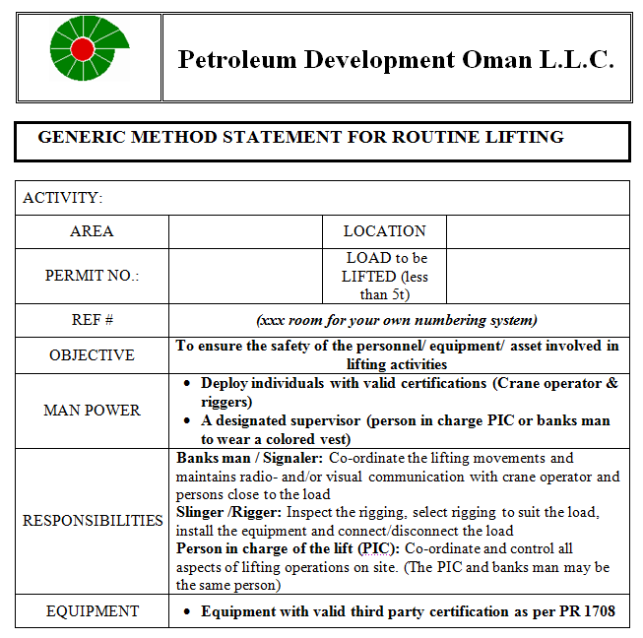
To access this document “Ctrl Click” on the icon
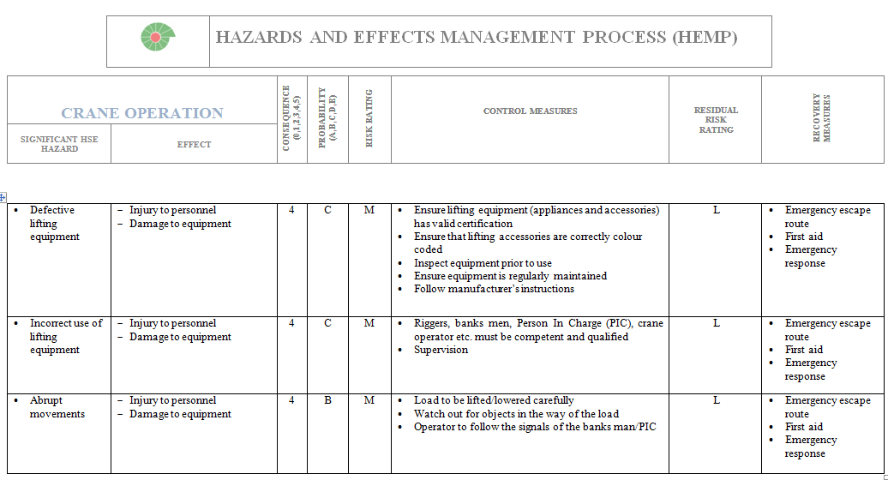
To access this document “Ctrl Click” on the icon
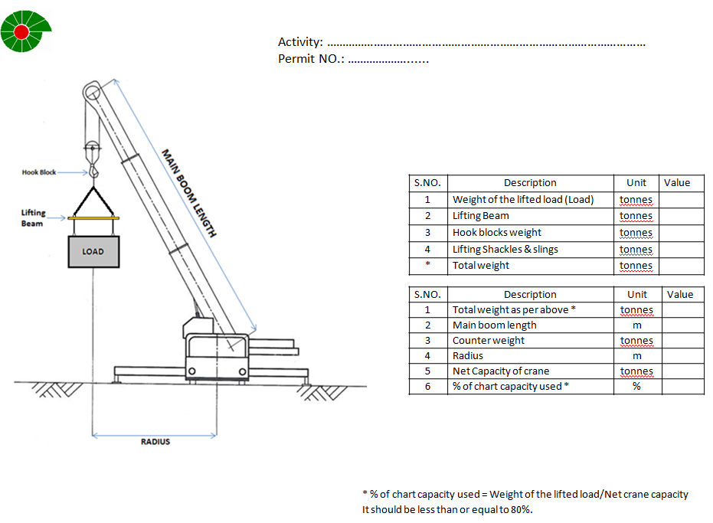
To access this document “Ctrl Click” on the icon

This page was intentionally left blank

