
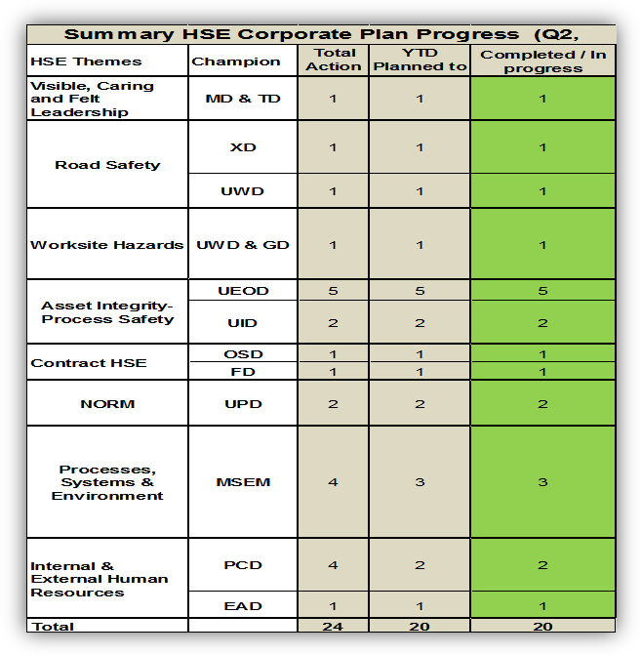
Colleagues, I would like to share with you the progress of your Corporate HSE plan during Q2 2013 As you can see the plan has a total of 24 actions, of which 20 actions have either started and been completed or are progressing..
Q2, Corporate Safety and Environment Update 2013
Overall I am pleased to report nearly all the 20 actions are progressing as-planned which is an excellent achievement, thanks to your continuous efforts. The details of these actions can be found below under their respective schemes.
Visible, Caring and Felt Leadership: Quarterly review for Q22013 will be presented to the MDC in August. OSD will present element 8 (Review) and GD will present element 3 (Organisation and responsibilities)
Road Safety: A team from MSE1 & EAC prepared a comprehensive plan for 2013- 2014 with a number of major milestones (Khareef Salalah, Traffic Expo , MoE & MoHE plans & Women Associations participations). The campaign includes radio Ads in August and representation at the Khareef Salalah festival for 12 days (weekends from 15th August to 6th September). A well organised program to attract tourists, families and festival visitors has been planned. Three new videos will be launched by end of July.
The 1st phase of the Commuting Pilot in the North commenced on 15th of June and the utilisation is being monitored, trended and teething issues addressed. A full time Commuting pilot project manager is now on ground and Contractor data is being collected and analysed before the second phase is implemented.
Worksite Hazards: The Behavior Based Safety (BBS) Project by BSTI has commenced as planned on the 5th June with an MDC launch on the 16th June 2013. The MDC visioning workshop (abridged) was concluded on the 1st July and was dove-tailed into the Deep-dive Learning Workshop conducted by UEOD. Stake-holdering sessions were conducted with participants, both from PDO, Abraj & Shaleem. The Leadership workshops and coaching sessions are planned from September onwards and will cover all MDC members, + 75 sr./mid managers and 300 supervisors. The nominations for the PDO Internal Consultants - INCONs are ongoing and INCON assessments are scheduled to be confirmed on the 30th & 31st July.
Asset Integrity - Process Safety: There are 5 main actions relating to the scorecard and each action stretches over the year. The actual progress are on and exceeding the set target date.
Fire fighting Code of practice has been drafted, in circulation and expected to be formalized by 30th Nov 2013
Fire and Explosion Risk management Single source contract developed with detailed scope which is being finalised by FPR staff (Tebodin contract with EEE consultant). Expected start of work by early May 2013 and completion by 31st Oct 2013
Contract HSE: Two workshops were held by end of Q2 (one in each quarter) 35% critical HSE CHs have been covered. We expect to meet the 85% target set.
Total 4 LoAs out of 7 planned for the year were completed by end Q2 as per plan. Three contractors are expected to be covered within Q3.
NORM Management: Scope of work for the consultant reviewed and agreed. Awaiting for a consultant quotation. The progress indicates that the target date (Q4, 13) will be met.
The requirements for establishing central system for NORM data management has been provided to various vendors with a targeted demonstration and selection of the best available by September 13.
Processes, Systems & Environment: Level HSE-MS audits are going as per plan with some ahead of the plan. Asset Integrity Process safety (AI-PS) audit was carried out by independent party to verify quality and quantity of reported actions taken. The audit concluded positive with one high finding.
Level 2 and 3 audit check lists have been completed and communicated to all HSE team leaders for use and feedback for continuous improvements.
The development of a new Environmental management system is now in strategy development stage and tender board approval for the evaluation of the capabilities of various vendors/systems including SAP and IMPACT ERM.
Technical pre-qualification of interested companies for the management of hazardous waste has been completed and a list of potential tenderers has been established and is awaiting tender board approval. The tender documentation is in preparation. Based on progress so far the contract award is expected to be in March 2014.
Internal & External Human Resources: HSE functional Learning Ladder has been constructed for all the functions in PDO. It needs to be formalised with PSC. Full formalization expected to be in Q3 13
Having established and embedded all learning from the initial kick off of the Tell A Friend campaign on road safety at Muscat festival, the campaign has been aligned to further role on In Salalah Khareef Festival. PDO and Royal Oman police are the key players behind the campaign.
The Quarter Lowlights: In Q2, PDO suffered 13 Lost Time Injuries compared to 11 in the first quarter of the year. Seven were injured due to crushing; two people slipped/fell; three fell from height and one was struck by an object. There were no work-related fatalities recorded but PDO suffered four non-work related commuting fatalities and three Non-Accidental Deaths in the quarter.

