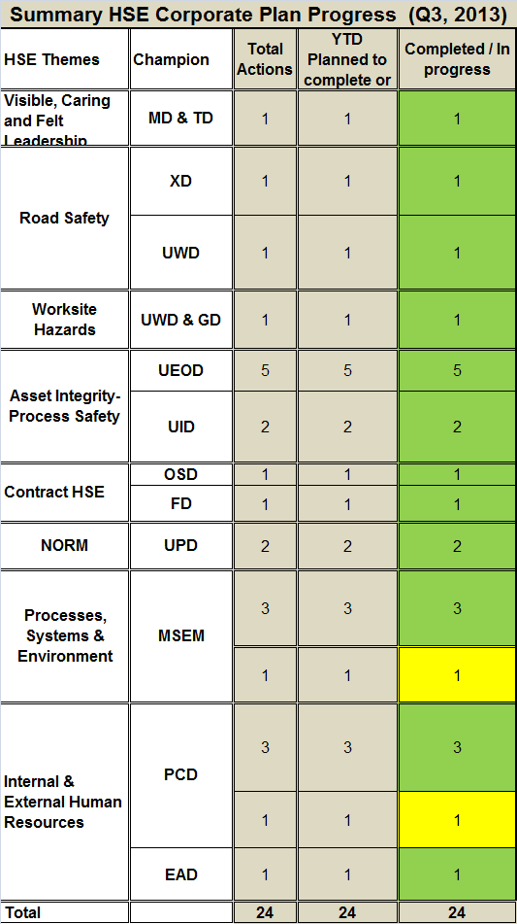
Colleagues,
Q3, Corporate Safety and Environment Message 2013
It is time to share with you the progress of the Corporate HSE plan during Q3 of 2013.
The plan has a total of 24 actions, of which 22 actions have either been completed or are progressing on time. This is an excellent achievement and it gets us closer in our continuous efforts towards achieving Goal Zero.
Only two have fallen behind target due to underestimated resources and time required to get them done.

Visible, Caring and Felt Leadership: Quarterly review for Q3 of 2013 will be presented to the MDC in November. UEOD will present Element 5 “Planning and Procedure” and OND will present Element 6 “Implementations and Operations”.
Road Safety: As a continuation to the work already done on the “Tell A Friend” road safety campaign, planning has taken place to introduce road safety messages on the radio in the second week of November. Work has also taken place for PDO to once again participate in the Oman Traffic Expo from 11th to 14th November at the Oman Exhibition Centre.
Phases one and two of the commuting pilot have been successfully introduced resulting in a 44% increase in the number of PDO employees travelling on the buses (increasing from 641 passengers pre-pilot to 923 passengers at the end of September). Road exposure has additionally been reduced by 50,000 km by using the new system. The system has been opened up to the contractor community and new routes are being quickly introduced in the fast-tracked plan.
Worksite Hazards: Four sessions of ELT/Mid manager Safety Leadership Workshop completed, 49 attendees with 49 coaching sessions completed. Planning for the last and final session scheduled for 3 November has taken place. (2) Additional INCONs (Internal Consultants) assessed and found suitable for training.
Asset Integrity - Process Safety: The five main items relating to the scorecard which stretch over the year are progressing as planned. The Firefighting Code of Practice is now in draft and is expected to be formalised by the end of November.
The Fire & Explosion Risk Management (FERM) review is almost complete and is in final consultation before being distributed.
Contract HSE: Four Contract Holder competency workshops were held during Q3 and one more is in planning in Q4 as per the plan.
Letter of Assurance: Eight ‘letter of assurance’ audits have been completed so far with only two more to complete by the end of the year.
NORM Management: The scope of work has now been agreed and quotations are awaited by the end of November. The vendor has developed the system and planning for a final demonstration tentatively planned for 14th November 2013.
Processes, Systems & Environment: Level 1 HSE-MS audits are progressing ahead of plan. The Al Noor MGI Phase 3A project HSE-MS audit has been conducted and no serious findings were identified.
A project to develop a new environmental IT management system is ongoing with vendor evaluations having taken place for SAP, IHS and ERM, including visits to existing customers.
Technical pre-qualification has been revisited following a steer from the Tender Board. The list of potential companies is now finalised, the tender documents are being developed and the expected award date of March/April 2014 remains on target.
Internal & External Human Resources: In an effort to improve fitness to work, the medical team has been working on the revision to the medical specification SP1230 to be launched by the end of this year. Clinics have been approved and the list has been issued to HSE leaders, contract holders and contractors. Ten training sessions relating to conducting fitness-to-work medical examinations have been provided to all doctors in Interior clinics and the main private clinics at the Coast.
The HSE functional Learning Ladder has been constructed for all the PDO functions but further work is required for completion and is expected to be ready in 2014.

The Quarter Lowlights:
Ten more people were injured in the three months of Q3, four in falls from height. We were lucky not to have a fatality when a driller, who was working at height unprotected, fell 9m to the ground from a rig which was rigging up. . He survived the fall with a fractured pelvis.

