**Petroleum Development Oman LLC**

**End of Year 2013 LTI Incident Analysis**

**Summary**

PDO’s Lost time incident frequency (LTIF) performance to the end of the year 2013 was 0.26, an encouraging 10% lower than the rate achieved in 2012 (0.29). PDO suffered 10 lost time injuries in the quarter, 4 less that in 2012 which brought the total to 44 LTIs which is 3 lower than in 2012. The following analysis of the incidents is designed to identify trends and points of statistical interest to target future resource.

**Analysis**

1. **PDO LTI performance by directorate**

|  |  |  |  |  |  |  |
| --- | --- | --- | --- | --- | --- | --- |
| **Directorate** | **Q4** | | **% of 2012** | **End of Year** | | **% of 2012** |
|  | **2013** | **2012** |  | **2013** | **2012** |  |
| **UWD** | **5** | **11** | **(55)** | **21** | **30** | **(30)** |
| **OSD** | **4** | **2** | **100** | **10** | **9** | **11** |
| **GD** |  |  |  | **1** | **2** | **(50)** |
| **OND** | **1** | **1** | **0** | **4** | **6** | **(33)** |
| **UID** |  |  |  | **3** | **0** | **100** |
| **UEOD** |  |  |  | **2** | **0** | **100** |
| **XD** |  |  |  |  |  |  |
| **CPDM** |  |  |  | **2** | **0** | **100** |
| **MD** |  |  |  | **1** | **0** | **100** |
| **Total** | **10** | **14** | **(28)** | **44** | **47** | **(6)** |

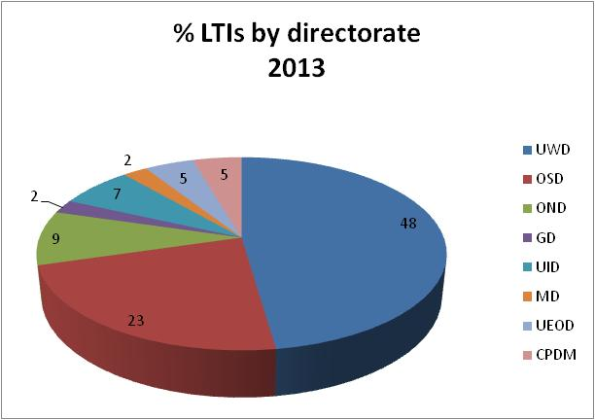

1. **Number of LTIs per Operational Team - YTD**
   1. UWD – 21 – (6 - UWN, 4 – UWS, 5 –UWX, 1- UWI, 4- UWC, 1- OSPTW)
   2. OSD – 10 – (7 – OSE, 2- OSET, 1- OSHOH)
   3. OND – 4 – (3- ONET, 1 – ONO)
   4. UID – 3 – (2- UIPT, 1- UIR)
   5. UEOD – 2 – (2-UEO)
   6. GD – 1 – (1- GGE)
   7. CPDM – 2 – (1- OSHE, 1 - CGS)
   8. MD – 1 - (1- MSEM)
2. **PDO v Contractor** 
   1. 41 - PDO contractors,
   2. 3 - PDO employee
3. **Contractor information**
   1. There are 22 contractors who have suffered LTI incidents, nine of these contractors experienced more than one LTI incident.  
      1. 4 incidents – Dalma, KCAD
      2. 3 incidents – Al Turki, Galfar, Weatherford
      3. 2 incidents – Abraj, Petrogas, STST, Arabian Drilling Services
      4. 1 incident – MBPS, Shivani, Attila Dogan, Haimo Technologies, Tawoos, IPC, WIPRO, Haliburton, Sea and Land, Majan Shipping, Mix Telematics, Petrozone, Larsen Turbo,
4. **Incident description – injury and action**
   1. Scald injury when light fitting filled with hot water from leaking pipe
   2. Fractured finger tightening shackle and caught it between two bowls
   3. Fractured arm, falling two meters from the mixing hopper
   4. Rollover: fatality (1), fractured foot (1), abdominal trauma (1) & chest pains (1)
   5. Fractured finger, in the pinch point on roughneck assembly he was reconnecting
   6. Fractured arm when he fell down the utility hole on the rig floor
   7. Fractured foot when hit by foundation slipper JCB was swinging into place
   8. Fractured finger when caught in pulley wheel on portable lighting rig
   9. Fractured elbow when stumbled backwards over flow-line.
   10. Fractured finger when hit by a lubricator which was being lifted from the BOP
   11. Fractured leg when he fell from access stairs of a FBU unit after feeling faint.
   12. Fracture of his spine after falling 2.5 metres from wooden scaffolding
   13. Fractured finger when stack of steel brackets collapsed he was restacking
   14. Fractured finger when caught in the tongs on the rig
   15. Fractured thumb when caught between excavator arm and bracket being changed.
   16. Fractured leg when fell from platform outside the workshop at the hoist
   17. Fractured toe when drill pipe was lowered on to his foot
   18. Fractured leg when reinforced glass in pallet box fell over whilst being unloaded.
   19. Fractured finger when hit by a hammer
   20. Broken leg when fell off a ladder
   21. Fractured leg when fell through loose grating on platform
   22. Amputated finger on a rotary saw
   23. Fractured leg falling off a ladder
   24. Fractured toe getting out of lorry
   25. Fractured finger hammering a safety clamp
   26. Multiple fractures when he fell 9m from rig
   27. Fractured pelvis when crushed by pipe
   28. Fractured wrist when stairway fell down
   29. Fractured arm when the tong unlatched and struck him
   30. Fractured foot when a beam pump guard fell on him
   31. Fractured finger when it was caught in a rotary wheel
   32. Fractured left arm when tong slipped and struck him
   33. Fractured foot when beam pump guard fell over on him
   34. Fractured finger when trapped finger in rotary wheel
   35. Fractured finger when he dropped a spool on it.
   36. Serious eye injury when metal he had hammered flew into it
   37. Dislocated knee when he slipped on floor being cleaned
   38. Fractured bone in face following an motor vehicle incident
   39. Fractured finger when hand trapped under mud bucket
   40. Fractured wrist when he fell over when fainting
   41. Fractured bone in foot when he slipped on stairs
   42. Fractured bone in hand when struck by power tong
   43. Fractured finger when trapped by the cavin slips when winch wire moved
   44. 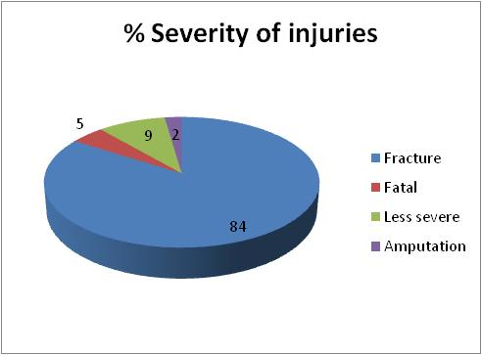Fatality following head on crash with public vehicle

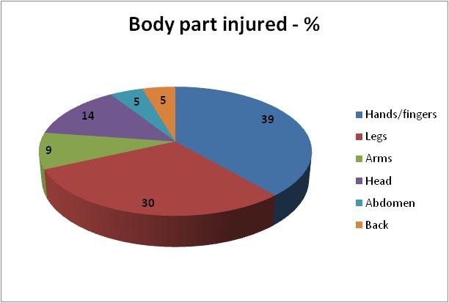

1. **Parts of body injured**
2. Hands/fingers - 17
3. Leg/foot - 13
4. Arms - 4
5. Head - 6
6. Back - 2
7. Abdomen - 2

**Incident classification**



1. **Actual Severity**
2. Severity 2 (minor injury) = 2
3. Severity 3 (major injury) = 40
4. Severity 4 (single fatality) = 2
5. **Potential Severity**
6. **15** – C3 – major injury – has happened in the company
7. **15** – D3 – major injury – happened more than once a year in company
8. **4** – B5 – multiple fatal injury – heard of in the industry
9. **3** – B3 - major injury – heard of in the industry
10. **6** – C4 – fatal injury – has happened in the company
11. **1** – D2 – minor injury – happened more than once a year in company
12. **Underlying causes – numbers of**
13. **6** separate causes- 4
14. **5** separate causes – 3
15. **4** separate causes – 11
16. **3** separate causes - 7
17. **2** separate causes – 5
18. **1** separate cause – 1
19. **Types of underlying causes**
20. Training 23
21. Incompatible goals 20
22. Procedures 19
23. Organisation 16
24. Communication 14
25. Hardware 7
26. Design 7
27. Error enforcing conditions 5
28. Maintenance management 4
29. Housekeeping 1





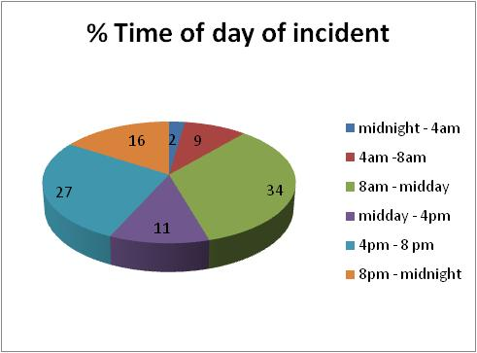

1. **Time of incidents**
   1. 00:00-04:00 - 1
   2. 04:00 – 08:00 - 4
   3. 08:00 – 12:00 - 15
   4. 12:00 – 16:00 - 5
   5. 16:00 – 20:00 - 12
   6. 20:00 - 00:00 – 7
2. **Age of IP**

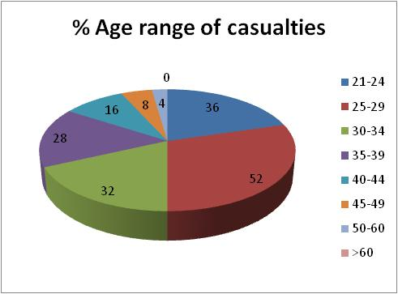

1. 20-24 - 9
2. 25- 29 - 13
3. 30 – 34 - 8
4. 35 – 39 - 7
5. 40 – 44 - 4
6. 45 - 49 - 2
7. 50 – 54 - 1
8. 55- 59 - 0
9. 60 – 64 - 0

1. **Observations**

Well Engineering had a memorable year with a 30% reduction in their LTI performance, reducing 30 down to 21 LTIs. The Gas directorate also decreased by 50% as did Oil North by 33%. Oil South increased by 11%. UID, UEOD, CPDM and MD who had not experienced LTIs in 2012 also added 8 LTIs to the total. XD remains the only LTI free directorate for the year.

The LTI severity trend continues to involve an abnormally high instance of major injuries with only 9% involving an injury less severe than a fracture. This suggests a significant under-reporting of less severe lost time injuries.

The competency of people remains the top causational factor followed by people’s inappropriate behavior. Poor procedures, organization and communication then come next.

The most common time of incidents is still between 08:00 and 12:00 (34%) with the later time between 16:00 and 20:00 coming second (27%).

The most common age of person injured is between 25 and 29 years old (52%) with people younger coming second (36%).

1. **Glossary**
2. **Incompatible goals**

Failure to manage conflict between different goals, such as safety v production, formal v informal rules, company directives v personal goals

1. **Communication**

Failure to effectively transmit information

1. **Error enforcing conditions**

Factors such as time pressure, changes in work patterns, physical working conditions (hot, cold, noisy) etc that promote human error

1. **Procedure**

Unclear, unavailable, incorrect or otherwise ineffective work instructions

1. **Training**

Deficiencies in the system for providing the necessary knowledge or skills

1. **Design**

Deficiencies in the layout or design of facilities, plant or equipment

1. **Maintenance management**

Failures in the system for ensuring the technical integrity of facilities, plant, equipment and tools

1. **Hardware**

Failures due to inadequate quality or non availability of materials or equipment

1. **Organisation**

Deficiencies in either the structure of a company or the way tasks, responsibilities and authorities are assigned

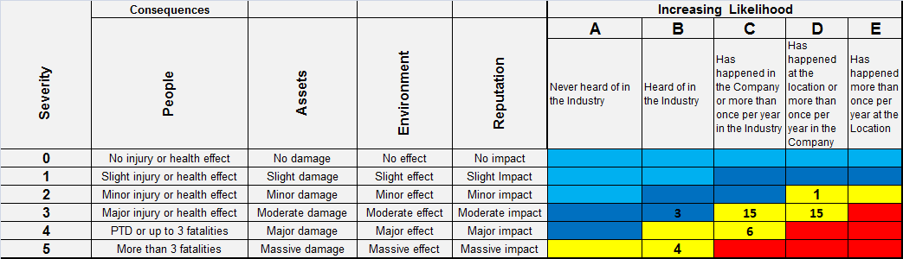

**RAM matrix**

**End of analysis**