Dear Colleagues,
Q1, Corporate Safety and Environment Message 2014
Here is an update of the Corporate HSE plan during Q1 of 2014.
The plan has a total of 30 high-level actions. Each action requires a lot of work for the action to be fully realised.
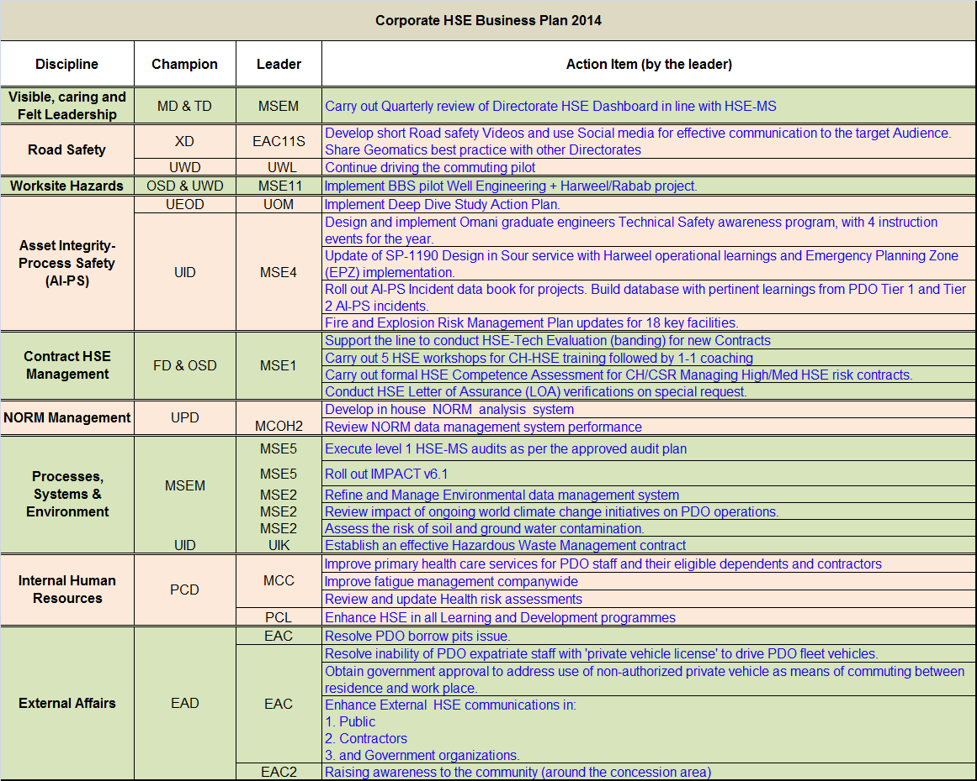
Visible, Caring and Felt Leadership: A quarterly HSE Dashboard was shared with all MDC members. A monthly HSE actions status is downloaded from PIM and shared with concerned directors. Joint Management Inspection (JMI) visits being carried out as per plan to demonstrate management visibility.
Road Safety: The videos are in progress and will be communicated by early May. They will focus on tail-gating, using seatbelts, avoiding mobile phone usages and school bus driver awareness.
Phase 3 of the pilot commuting project was implemented on 10 November 2014 by connecting Qarn Alam camp with villages in the North. So far:
- Utilisation has increased by 18% from 1-31 March
- Bussing to the South has started but further deployment there is currently on hold. We are in discussion with Oman Air to assess the availability of extra aircraft to accommodate all southern travelers (PDO and Contractor)
- Discussion with the CEOs to increase use
- A campaign with banners and posters to publish the project further is to start soon
- A meeting with directors is being organised to discuss way forward.
Worksite Hazards: The Behaviour Based Safety (BBS) project was launched in June 2013 and the BBS implementation is ongoing supported by BST (PDO & contractors internal consultants). The completion pilot project will be in Q4 2014.
Asset Integrity - Process Safety: The action plan from the last MDC workshop in July 2013 was followed up in the monthly TDG meeting. In the March 2014 MDC workshop actions were briefly discussed. The focus was on the next step and way forward. We have completed about 70% of the actions defined after the July 2013 workshop.
Minutes from the March 2014 MDC workshop with proposed new actions have been submitted and work has already started in one of the working groups (pattern 1) to develop the next action plan.
A programme was developed to address the 10 topics on tech safety for non-TS engineers. It was delivered by Omani TSE staff & Expat TSE staff.
The work to update SP-1190 included the following:
- A gap assessment identified an urgent need to upgrade company H₂S awareness training
- EPZ continued implementation and roll out. Engagement with YK team to review impact
- Workshop to collect feedback from SP-1190 users and stakeholders. New sections identified: SO2, EPZ, ADMS, sampling and field measurement.
AI-PS incidents data book project is ongoing and so far:
- There has been intensive PIM data mining to extract all AI-PS incidents. Data completed back to 2009.
- We are engaging line and incident owners on older events to find data going back to 2000 (+/- 100 incidents)
- A data book example presented to TD in January. Each project to be able to go through the incidents and sign off so that “these can be prevented at the project.”
- Software tool options investigated (IHS team – PIM, Excel, web-based)
- PB-15 budget requested for further development
- Test of tool planned end April with YK team.
Work on FERM included:
- TDG presentation of updated FERM strategy on 19 January
- Prepare for DRB1 discussion on impact on business. Planned for 7 May
- Issued request for bid for UIPT1 – tank farm concept select project to five vendors
- Selection of another 17 facilities
- Budget verified for activity (allocated in PB14)
- Preparation ongoing to present to MiTB
- Line to be requested to book funds for PB15.
Contract HSE: HSE evaluations: New contracts undergoing ‘banding’ exercise as requested by the line. Current workload includes the marine business.
Meeting with the minor TB considered the stance taken on the model (Contract Conditioning – Amber Adders) was accepted.
LoA: List established for 2014 to date, Hi-Tech/4PL/Al Haditha/ABB.
Competency: Segmentation update completed. The model was received from FPM and this is the database model that is being used to add the CHCS and HSE competency details.
HSE Workshops: MSEM invited the champions to attend the kick-off to present a leadership message/or safety moment to the candidates. MSE12 will provide the upcoming dates. Champions will also attempt to attend the CHCS or CH HSE workshop.
NORM Management: Gamma spectrometer unit quotation is under review. UIK staff identified for training on the Gamma spectrometer.
NORM data management system modification in progress, demo presented and tested on 10/04/2014, and next update scheduled for end of May. Expected go live by end of June.
Processes, Systems & Environment: GD HSE-MS audit was completed on 6/5/2014 as planned with no serious findings.
Impact v6.1 (PIM) rolled-out on 31/3/2014.
Technical pre-qualification has been revisited following tender board steering. The list of potential companies has been finalised and the tender document is being developed. The revised date of expectation to award in September 2014 remains valid.
To assess potential impact, a project has been initiated to carry out GHG emissions survey across the concession area covering all facilities. Scope of work for the survey developed including definition of the methodology and required deliverables. Proposals will be requested from consultants by end of April 2014.
Desktop study (initial screening) including sensitivity map was completed by March 2014. Scope of work for site verification is being prepared. The site verification will include assessment of the actual physical condition and there will be permeability tests on each cluster. This will be done by an external party. The scope of work will be revised to have a generic risk assessment of the entire concession area.
Slight delay in floating the tender of waste management. Review of the tender documents are still being finalised with CE/Legal team and it is now planned to be floated before the end of April
Internal Human Resources: In an effort to improve fitness to work, two new doctors were recruited, clinic consultation time was rescheduled, and primary health care has been made available at private health care centres to all PDO-eligible staff and their dependents in their catchment areas across the country. Plans are underway to centralise and improve primary health care in Interior hubs.
Drafted fatigue management guidelines, which will be finalised by the end of next month (May 2014). A discussion regarding inclusion of those guidelines in HSE training matrix is underway and will be discussed further with PCL8.
OH team performed and reviewed more than 20 Health Risk Assessments(HRAs).
Learning ladders draft is ready. Next step is to schedule a workshop with MSE team and the TA. Workshop will be done in May.
External Affairs: Discussion is ongoing between the Company and concerned government authorities to resolve PDO borrow pits issue. Letters have been exchanged, and the last of which was from EAD to the Undersecretary of the Ministry Of Commerce and Industry on PDO’s stance on the legal advice.
A letter has been obtained from the Ministry of Manpower stating that engineers, surveyors and technicians are exempted from the ministerial decision. A meeting with ROP will be arranged shortly to finalise ROP-related issues.
The Ministry of Manpower was contacted to discuss the subject of non-authorised private vehicle usage. The recommendation is to engage the ministry in writing in advance on PDO’s proposal of adding an obligatory clause in PDO’s occupational health and safety rules. The consequences of breaching such a rule will be embedded in PDO’s EPM. Both regulations/policy require the ministry’s endorsement.
The “Tell A Friend” campaign is planning five awareness sessions starting in Dakhylia - Nizwa and Ibri - in the last week of May. The three other sessions will take place between September to December in Salalah, Musandam and Batinah.

Quarter Lowlights:
There were 17 LTIs during Q1, including a fatal road incident; seven Non Accidental Deaths and 5 Tier-1 AIPS incidents.

