Petroleum Development Oman LLC
Quarter One 2014 Incident analysis LTI study
PDO’s LTIF performance for 2014 Q1 was 0.40 which was extremely shocking comparing to 0.26 in Q1 in 2013. PDO suffered 17 LTIs in the quarter, six more than in 2013 but with more man-hours worked. The following analysis of the incidents is designed to identify trends and points of statistical interest to target future focus.
- Directorate
Directorate | Q1 |  | % of 2013
 | 2014 | 2013
UWD | 13 | 5 | +160
OSD | 2 | 4 | -50
GD | 0 | 0 | 0
OND | 0 | 2 | -100
UID | 2 | 0 | 100
HD | 0 | 0 | 0
UEOD | 0 | 0 | 0
XD | 0 | 0 | 0
Total | 17 | 11 | +55

- Teams
  - UWXD3 - 1
  - UWSI - 1
  - UWSN - 1
  - UWL - 2
  - UWI - 2
  - UWCI - 3
  - UWB6 - 1
  - UWN - 1 (1 in Q1 2013)
  - UWCI3 - 1
  - UIR - 1
  - UIK - 1
  - OSEG - 1
  - OSE - 1 (4 in Q1 2013)
- PDO v Contractor
  - All incidents involved PDO contractors.
- Contractor information
  - There were 16 contractors involved in Q1 LTIs, of which one contactor had 2 LTIs. The breakdown is as follows:-
Sr. No | LTI No | Date | Company
1 | LTI#01 | 01/01/2014 | Sea and Land
2 | LTI#02 | 09/01/2014 | Sea and Land
3 | LTI#03 | 18/01/2014 | Dalma Energy
4 | LTI#04 | 24/01/2014 | Shiv-Vani
5 | LTI#05 | 25/01/2014 | Desert Byrne Drilling
6 | LTI#06 | 04/03/2014 | Arabian Industries Projects
7 | LTI#07 | 22/01/2014 | Shaleem Petroleum
8 | LTI#08 | 22/02/2014 | Vanguard
9 | LTI#09 | 26/02/2014 | Al Turki
10 | LTI#10 | 26/02/2014 | Midwesco
11 | LTI#11 | 25/02/2014 | Bahwan Excel
12 | LTI#12 | 13/03/2014 | Cactus Premier Drilling
13 | LTI#13 | 13/03/2014 | KCA Deutag
14 | LTI#14 | 23/03/2014 | SOS
15 | LTI#15 | 26/03/2014 | OFSAT
16 | LTI#16 | 31/03/2014 | Abraj Energy
17 | LTI#17 | 30/03/2014 | MB Petroleum Services

- Incident description – Action and Injury:-
  - Trapped between 6 ½“pipe and rig mast leg caused left hand fracture.
  - Slipped of temporary mouse hole cover caused deep laceration to groin area.
  - Trapped between tow flanges caused deep cut wound at the hand.
  - MVI rollover caused 1 fatality.
  - MVI rollover caused collar bone fracture and dislocating of left shoulder.
  - Chest Trapped between bucket track guard rail and a pipe rack caused ribs fracture.
  - Lost balance and fell 1.5 m down slop caused right ankle fracture.
  - Trapped between a wire drum and the steel frame caused right foot multi-fracture.
  - Falling from two floors building (10m height) and sustained multiple fractures.
  - Struck by falling object resulted in foot fracture.
  - Trapped between truck support stanchion and a rolling pipe during pips downloading caused middle finger fracture.
  - Fell from the trailer bed (1.8 m height) caused forearm fracture and dislocation of the right elbow joint.
  - Truck slipped out of the road due to sand dunes caused fracture of L1 vertebra and canal compromise due to fragments into the spinal canal.
  - Chemical contents blew out and splashed causing burns on IP eyes.
  - MVI collision caused both legs fracture to a canter driver.
  - Rotating metal bar struck the IP caused right leg fracture and injuries to left hand.
  - Slipped in the truck bed and caused left wrist fracture.

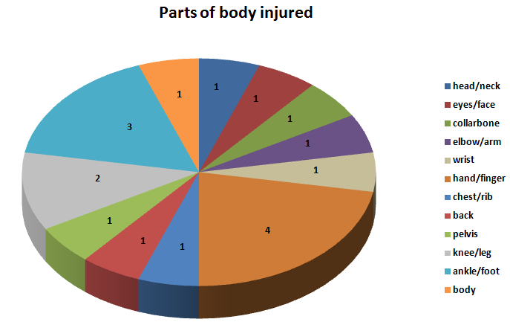
- Parts of body injured
- Hands/fingers – 4
- Head/neck – 1
- Foot/ankle – 3
- Chest/rib – 1
- Back – 1
- Body – 1
- eyes/face – 1
- Wrist –1
- collar bone –1
- Elbow –1
- Knee/Leg –2
- Pelvis –1

- Incident classification

Type of Incident causing LTI | No of LTIs  2014 | No of LTIs  2013 | % change from  2013
Crush/Trapped | 6 | 3 | +100
Slip, Trip, Fall | 4 | 1 | +300
MVI | 2 | 4 | -50
Fall from height | 2 | 1 | +100
Struck By Object | 2 | 1 | +100
Chemical/Heat Burn | 1 | 1 | 0

- Actual Severity
- Severity 2 (minor injury) 1
- Severity 3 (major injury) 15
- Severity 4 (single fatality) 1
- Potential Severity

B3 major injury, Heard of in the industry 2
C3 major injury, has happened in the company 10
C4 fatal injury, has happened in the company 0
D2 minor injury, has happened in the company 1
D3 major injury, has happened more than once a year in the company 2
D4 PTD or up to 3 fatality, has happened more than once in the industry 2
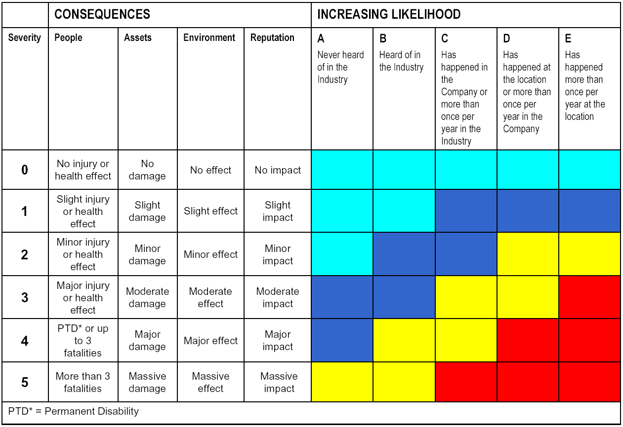

- Underlying causes
There were 52 identified underlying causes out of 17 LTIs of which 23 were repeated underlying causes i.e. failing to learn from LTIs. Details are in the below table:-
Sr No | Underlying causes | Repeated causation
1 | Inadequate leadership or supervision | 7
2 | Inadequate assessment of needs and risks | 4
3 | Inadequate vertical communication between supervisor and IP | 3
4 | Inadequate work planning. | 3
5 | Inadequate ergonomic design | 3
6 | Poor Judgment | 3
7 | Inadequate identification of critical safe behaviors | 2
8 | Inadequate correction of worksite or job hazards | 2
9 | Inadequate risk assessment. | 2
10 | Inadequate standards, specification and or design criteria. | 2
11 | Employee perceived haste | 2

- Latent management failures
There were 29 identified latent management failures of 17 LTIs of which 12 were repeated latent management failures i.e. failing to learn from LTIs. Details are in the below table:-

Sr No | Latent management failures | Repeated failure
1 | Management failed to show leadership in HSE | 3
2 | Crisis and Emergency Response | 3
3 | Inappropriate audit and assurance process | 2
4 | Inappropriate safeguards and management checks to avoid shortcuts/ shortfalls. | 2
5 | Inadequate focus on maintaining procedures up to date | 2

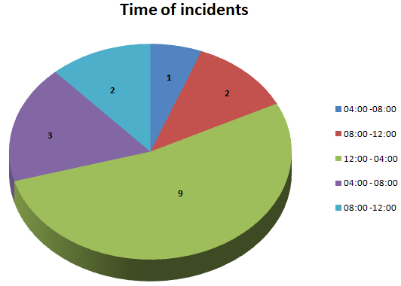
- Time of incidents

    - 00:00 – 04:00 0
    - 04:00 – 08:00 1
    - 08:00 – 12:00 2
    - 12:00 – 16:00 9
    - 16:00 – 20:00 3
    - 20:00 – 00:00 2

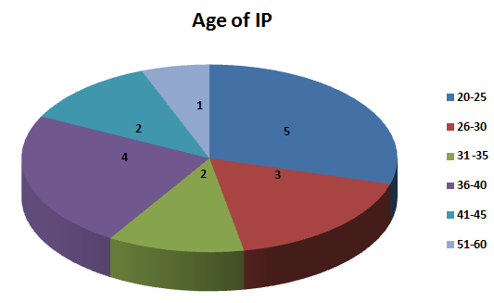
- Age of IP
- 21 – 26 5
- 26 – 30 3
- 30 – 35 2
- 35 – 40 4
- 40 – 45 2
- 45 – 50 0
- 50 – 60 1
- Over 60 0

End of Analysis

