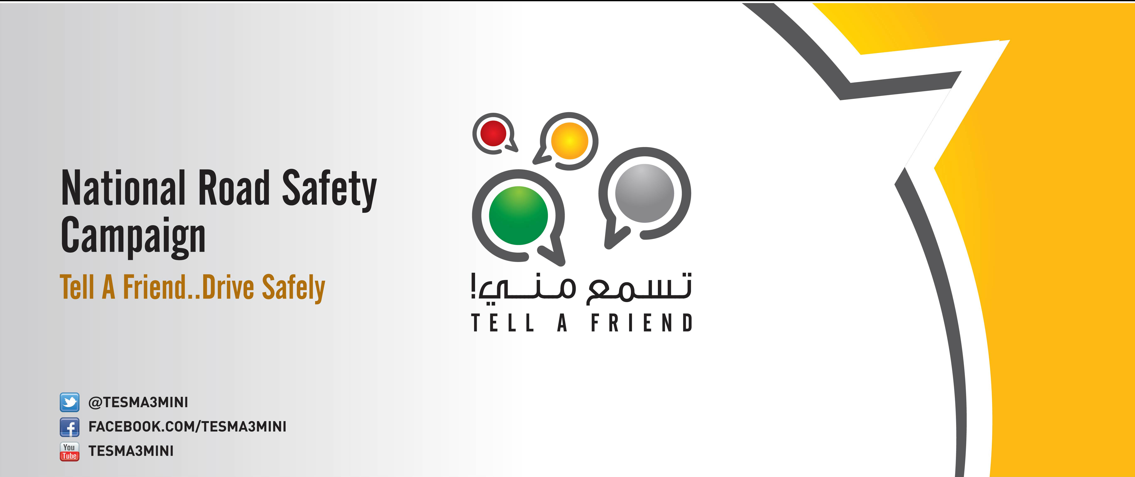

**Tell A Friend Campaign on Road Safety Launches its New Films**

The Tell A Friend campaign on road safety was launched in 2013 to the Omani public. The campaign featured at the Muscat and Khareef Salalah festivals where volunteers engaged more than 5,000 people and raised their awareness on safe driving. The campaign’s positive strategy helped to send out the safe driving message in an easy and clear way so people grasped the need to change dangerous driving behaviours. The campaign’s positive strategy is reflected in its engaging publicity material including videos, radio ads and posters. In 2013 , we produced three films and 16 radio messages that were published on our social media sites and broadcasted on national radio channels.

This year , we are pleased to launch four new videos , which include key messages to remember while driving. To view the videos please visit the below links and **share them with your family , friends and colleagues.**

[Mobile Phones – Stop then call](http://pdotube.pdo.shell.om/pdotube/?v=573)

[Children Safety – Use child car seat for their safety (Arabic)](http://pdotube.pdo.shell.om/pdotube/?v=575)

[Children Safety – Use a child car seat (English)](http://pdotube.pdo.shell.om/pdotube/avc-view.aspx?v=576)

[Tailgating- You don’t walk like this then why you drive like this? (Arabic)](http://pdotube.pdo.shell.om/pdotube/?v=577)

[Tailgating – You don’t walk like this then why you drive like this? (English)](http://pdotube.pdo.shell.om/pdotube/avc-view.aspx?v=578)

[Mobile Phones – Imagine if it is true (Arabic)](http://pdotube.pdo.shell.om/pdotube/?v=572)

[Mobile Phones – Imagine if it is true (English)](http://pdotube.pdo.shell.om/pdotube/avc-view.aspx?v=574)

To read about the Tell A Friend profile please click  [here](http://sww.pdo.shell.om/Newslistdocs/TAF%20excel%20day%20middle%20no3%20who%20we.pdf) . You may take your copy of the radio ads here

For more information, please contact Munira al Balushi, Tell A Friend Team Leader , EAC11S.

**Intisar al Kindy – Exploration Director**

**Road Safety Champion**