Colleagues,
Q3, Corporate Safety and Environment Message 2014
Here is an update of the Corporate HSE Business Plan during Q3 of 2014.
The plan has a total of 30 high-level actions. Each action requires a lot of work for the action to be fully realised.
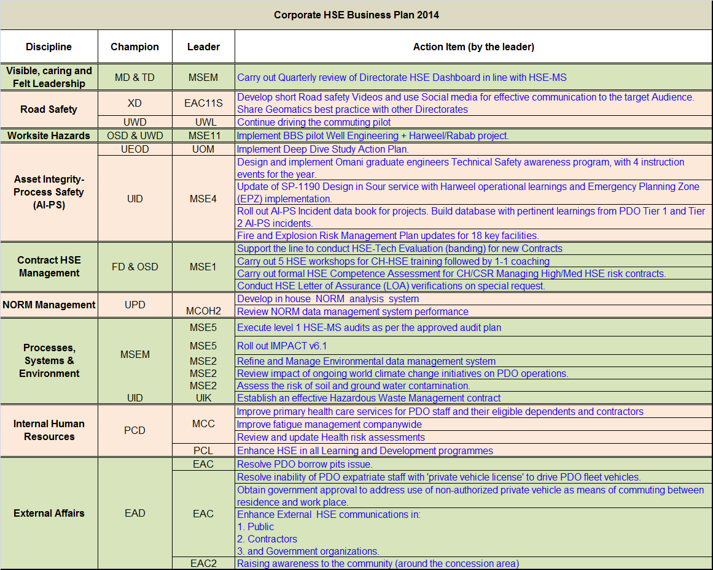
Visible, Caring and Felt Leadership: A quarterly HSE dashboard was shared with all MDC members. A monthly HSE action status is downloaded from PIM and shared with concerned directors. Joint Management Inspection (JMI) visits being carried out as per plan to demonstrate management visibility.
Road Safety: 4 videos were launched on YouTube & PDO Tube in May. They were viewed more than 2000 times. They focused on (Tail-gating, using seatbelts, avoiding mobile phone usages & school bus driver awareness). The videos were also launched on ROP Traffic website and Twitter account where they reached 57.8K followers.
Phase 3 of the pilot commuting project is progressing and so far:
- Slow but steady progress over the year.
- A different way to steer the project forward to achieve greater success was proposed following the work stoppage.
- A steering Committee has been formed consisting of OND, OSD and UWD to support the project team in accelerating the implementation progress. The first steering committee meeting is scheduled for October 2014.

Worksite Hazards: The BBS Project was launched in June 2013 and the BBS implementation is ongoing supported by BST (PDO and contractors internal consultants). The completion pilot project will be in Q1 2015. The progress so far:
- Building Blocks: Solook Foundational activities completed for all Pilot sites.
- Abraj observation data sheets have been uploaded on RINCON by BSTI and Shaleem and Abraj Process index and dashboards completed until Sept.
- The BBS contract extension endorsed by MiTB on the 2nd Oct.
- Sustainability reviews for Abraj and Shaleem starting 9th Nov to 20th. (10-day plan to be shared shortly)
  - All INCONs will be coached in the process.
  - Sustainability reviews for Harweel and Logistics/Commuting scheduled in April 2015 and to be conducted by BSTI and INCONS. This will give equitable advantage of learning from the Abraj and Shaleem reviews.
- Three INCONs (Internal Consultants) participated in the "Safety in Action" conference organized by BSTI.
Asset Integrity - Process Safety: Proposed new actions from the March 2014 MDC workshop have been submitted and progress have already started in some of the working groups on the action plan.
A second MDC deep-dive workshop is scheduled for November.
A program was developed to address the 10 Topics on Tech safety for non TS engineers, delivered by Omani TSE staff & Expat TSE staff:
- 1st session – 11 Feb - 29 graduates ( very positive feedback)
- 2nd session – 5 May - 31 graduates
- 3rd session – 11 Aug – 39 graduates
- 4rd session – 6 Nov – about 35 graduates
- 5th session (extra) – mid Dec.
Eight mini workshops have been conducted to date, to cover specific chapters in the new SP-1190. Data is being consolidated over the summer, and a draft update is to be issued by the start of Q4 2014.
A software interface tool has been indentified for the databook. A delay in further execution has been due to transfer of key staff to other section. Software tool options investigated (IHS team – PIM, Excel, web-based). Power Point example developed for review and “Soft” launch of tool in October. Interactive database planned for Q1 2015 with IT team.
FERM updates:
- Prepare for DRB1 discussion on impact on the business. DRB1 presentation on 8 July 2014
- Issued request for bid for UIPT1 – tank farm Concept Select project to five vendors
- Issued request for bid to review nine facilities, expected to start August 2014.
- Budget verified for activity (allocated in PB14)
- Line requested to book funds for PB15; all agreed.
- Monthly PCAP feedback to TDG.
- FERM Strategy SP-1075 Rev 3 for official issue 30 Sep 2014.
- Two additional fire safety engineers recruited in June 2014. Expected Nov/Dec 2014.
Contract HSE: HSE evaluations: 68 banded companies (38 green; 24 Amber; 6 Red) Current workload includes 32 bidders including LCC’s for ODC contract.
Amber Adders: Apparently most of suggested adders on Amber rated contractors have not been applied
Business Assessment letter: Reviewed with finance, the ageing review has taken place as part of the overall risk profile for this aspect and the latest risk profile agreed.
HSE Workshops: MSE has completed nine HSE workshop sessions per month since February 2014. Seventy eight staff have completed the workshop. MSE is now running coaching sessions for directorates ensuring that individuals are informed and assisted to complete the self assessment and ultimately line assessment.
Competency: The Omnicom listing has been used for the basis of the Contract Holder review. Based on the current information it is estimated that we currently have 160 High Risk rated contracts. The Contract Holders of these contracts will form the starting point of the HSE competence review with 20 (contract staff and HSE advisors) have been assessed in 2014 YTD.
LoA: 6 Listed for 2014. To date, 3 completed (Hi-Tech, 4PL and Shivani). Al Barka is now in progress. Pending are Al Haditha and ABB spA.

NORM Management: Risk assessment for the installation of the Gamma spectrometer performed by a visiting consultant and agreed with UIK3.
NORM data management system development completed. User Testing Approval scheduled for Q4.
Processes, Systems & Environment: GD HSE MS, ISO 14001, Occupational Health and HSE training Audits completed as planned.
Impact v6.1 (PIM) upgrade was completed in July.
Environmental data management system: Proof of concept workshop (SAP) conducted from 29th June until 10th July. Further verification of SAP solution was carried out through demos and current SAP user’s visits. Awaiting endorsement of proposed solution by the Project steering committee.
World climate change: Project was awarded and project plan developed. Kick off meeting was held on 19 Oct. Final report expected by end of Dec.
The tender for the hazardous waste contract was floated on 5th of May, followed by a hazardous waste sites visit on 27th of May. Technical evaluation was completed in Sep and awaiting tender board approval to proceed to commercial evaluation.
Internal Human Resources: In an effort to improve fitness to work, 4 new doctors have been recruited and one more in the pipeline, we have rescheduled the clinic consultation time. The primary health care has been made available at private health care centers to all PDO eligible staff and their dependents in their catchment areas across the country. Plans are underway to centralize and improve primary health care in interior hubs.
Fatigue risk management procedure is drafted and soon will be disseminated to line management and HSE leaders for their input. Once approved, we are going to conduct road shows to increase awareness and incorporate it into the mandatory HSE trainings. The inclusion of fatigue risk management in HSE training matrix has already been discussed with PCL and PCL8.
Up to the end of Q3, the OH team performed and reviewed more than 40 Health risk assessments.
As a result of HSE Training Audit completed on 4th Sep 2014, HSE Training Delivery and ATP approval is being overhauled. HSE Learning Ladder will be part of this process.
External Affairs: The EAS team had a follow-up meeting at the Ministry of Commerce and Industry. A PDO request to get a single borrow pit permit and be exempted from financial obligations until the Ministry of Legal Affairs issues its final decision on this matter has been put to the committee (a committee from different ministries) and minutes of the meeting have been circulated to all members. We are expecting to receive the decision soon.
A letter has been obtained from the Ministry of Manpower stating that engineers, surveyors and technicians are exempted from the ministerial decision. A meeting with the ROP will be arranged shortly to finalise ROP-related issues.
The Ministry of Manpower (MoM) was contacted to discuss the subject of non-authorised private vehicle usage. The recommendation is to engage the MOM in writing in advance on PDO’s proposal to add an obligatory clause in the Company’s occupational health and safety rules. The consequences of breaching such a rule will be embedded in PDO’s EPM. Both regulations and policy require the MOM’s endorsement.
The Tell A Friend campaign conducted an awareness session in Nizwa and in Ibri. Planning four more sessions in Sohar, Salalah and Musandam from August to December.

The Quarter Lowlights:
There were 17 LTIs during Q3 with 4 Tier 1 incidents.

