Colleagues,
Q4, Corporate Safety and Environment Message 2014
Here is an update of the Corporate HSE Business Plan during Q4 of 2014.
The plan has a total of 30 high-level actions with aim to manage our HSE risks efficiently and effectively.
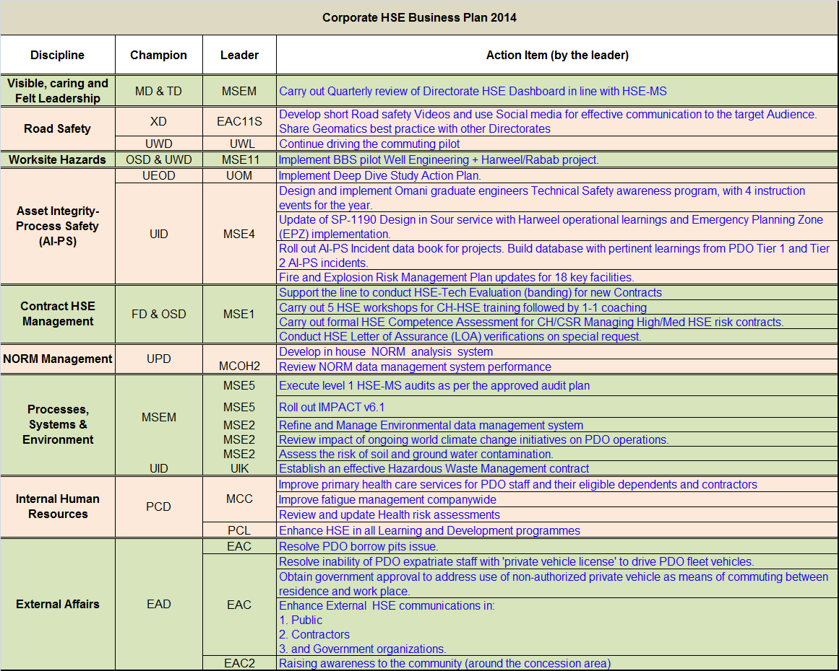
Visible, Caring and Felt Leadership: A quarterly HSE dashboard was shared with all MDC members. A monthly HSE action status is downloaded from PIM and shared with concerned directors. Joint Management Inspection (JMI) visits being carried out as per plan to demonstrate management visibility.
Road Safety: Tell a Friend campaigns were organized in Nizwa, Ibri and Khasab sharing the 4 developed videos. These sessions were attended by more than 600 and were run in association with Governmental and NGOs. Social media such as Facebook, Twitter and YouTube are used to further reach out the nation.
Phase 3 of the pilot commuting project is progressing and so far:
- Total of 3,318 (1730 PDO and 1,588 contractor’s) passengers were transported in December 2014 putting the total to 43143 passengers since project started.
- 26 HUBs covered + 65 villages (pick up for PDO staff)
- Reduction in the number of private vehicles in North by 24% (Nov 2014 compared to Nov 2013).
- Project steering committee and the working teams are formed for the further project development which will attract more users.
- 50 Contractor companies enrolled in the Project.
- Friday operation started to cater commuting demand by Galfar & STST staff.
- WiFi system installed and operates in 5 buses as a trial to determine quality of the service.
- Improvements are made in the booking support with two additional Al Sumri staff in place.
- Commuting declaration launched on PDO network.
- Commuting survey launched on PDO network.
- Project was awarded with UWD Special mention Non-Technical Director’s Award 2014.
- Commuting posters and banners are placed in PDO camps and PACs.
- Several engagement sessions held in interior camps by project team.
- Commuting road shows by UWL & MSE were held in all camps.

Worksite Hazards: The BBS Project was launched in June 2013 and the BBS implementation is ongoing supported by BST (PDO and contractors internal consultants). The following has been achieved within the pilot group of 2 contractors in WE and Harweel:
- MDC members have been engaged in a 2 day Visioning Workshop. Leadership Diagnostic Survey (360 deg).
- A Workforce BBS Culture Survey called the OCDI was conducted. The Survey results were presented to MDC.
- A Deep dive analysis of specific parameters was conducted and results presented to the HSE MDC on the 6th Feb 2014.
- Implementation of Solook (BBS) has commenced in the Pilot sites and is ongoing.
- RINCON, the BBS software has been installed and customized with access to contractors.
- 77 ELT/Sr. Mid Managers participated in the Leadership workshops. 75 of them have also engaged in a one-on-one coaching session.
- Many sessions of Supervisory Leadership Workshops were completed followed by one-on-one coaching sessions.
- Number of Solook training session for site working team members including Solook observers were conducted.
- Sustainability review conducted for Shaleem and Abraj.
- Workshop was organized to review and put action plan on Sustainability outcome from phase 2.
Asset Integrity - Process Safety: 2 MDC Deep Dive workshops were conducted in 2014. 95% of the MDC Deep Dive workshops action plan are closed.
A program was developed to address the 10 Topics on Tech safety for non TS engineers, delivered by Omani TSE staff & Expat TSE staff. In total 5 awareness workshops were conducted in which a total of 170 young graduate PDO engineers participated. The workshops will continue for 2015 as they have been received very positively by participants.
Draft SP-1190 issued for review with key stakeholders. Awaiting the results from the H2S remapping on Harweel which is handled by SGS Manchester. EPZ learnings have been included. Issue of next revision planned for end Q1 2015.
PDO Tier 1 incident data collected from 2008 to date. Information and statistics has been posted on shared Livelink site for users to access. Development of suitable IT interface under discussion. Final publication of data -book delayed due to Oman visa delays for recruited Shell LFI expert.
The FERM strategy update was presented to TDG in January 2014, and endorsed by DRB on 8 July 2014. The implementation of the new strategy has progressed according to plan. By end 2014, 3 contracts were in place for the FERM review and hardware verification of 12 facilities in PDO. The contract for the next 9 facilities is under discussion, and is expected by end Q1.
Contract HSE: HSE evaluations: 100 companies banded, 59Green, 33 Amber and 8 Red rated.
HSE Workshops: 6 Workshops held with a total of 118 participants.
Competency: The Omnicom listing has been used for the basis of the Contract Holder review. Based on the current information it is estimated that we currently have 160 High Risk rated contracts. 26 formal assessments done.
LoA: 6 LOA's done 1 Green , 5 Amber and 0 Red.

NORM Management: MD and TD approved the manpower to operate the equipment. The equipment is expected to be in the lab around Q2 2015.
NORM data management system development completed. System developed and reviewed and gone live.
Processes, Systems & Environment: GD HSE MS, ISO 14001, Occupational Health, HSE Training, Small fields and North EMC/ODC Audits completed as planned.
Impact v6.1 (PIM) upgrade was completed in July.
Environmental data management system: The endorsed way forward is SAP based application and TOR was signed by steering committee. The next step is to create a project plan followed by Performa for tender strategy.
World climate change: GHG inventorization for PDO operational facilities has been completed. A Draft report was issued and being finalised.
Soil and ground water contamination: The Risk Assessment study is completed and the report is being finalized.
The tender for the hazardous waste contract was floated on 5th of May, commercial evaluation has been completed but in order to ensure a fail FAIR evaluation, the line & FPR team need to clarify certain assumptions with commercial implications which were made by some bidders.
At the moment, the MTBC proforma to request permission to obtain the clarifications is in circulation.
Internal Human Resources: In an effort to improve fitness to work, 4 new doctors have been recruited and one more in the pipeline, we have rescheduled the clinic consultation time. The primary health care has been made available at private health care centers to all PDO eligible staff and their dependents in their catchment areas across the country. Plans are underway to centralize and improve primary health care in interior hubs.
Fatigue risk management procedure is drafted and disseminated to line management and HSE leaders for their comments. Now it is in the final editing stage, targeting end of January 2015, once approved, road shows will be conducted to increase awareness and incorporate it into the mandatory induction HSE trainings. The inclusion of fatigue risk management in HSE training matrix has already been discussed with MD, MSEM, PCL and PCL8.
Up to the end of Q3 the OH team performed and reviewed more than 40 Health risk assessments.
The review of HSE Training is ongoing, update to MDC was done on 12th January 2015. A new HSE Orientation Program will be introduced in April 2015 and will replace Core Learning Ladder courses: HSE Induction IFR and DHR. The orientation will be categorized into themes: Well Engineering, Logistics, Constructions and Operations. Working groups for all these themes are formed and meet every two weeks to design the orientation course material.
External Affairs: The Ministry of Commerce & Industry will exempt PDO of financial obligations which include bank guarantee and royalty payments in regards to borrow pits permit. However, PDO has to submit a request to the Ministry of Commerce & Industry for a permit. The Ministry will issue it with a “none objection letter” for the purposes “specifying environmental requirements” that the company must adhere to.
It was agreed with all concerned parties (MoMP, ROP and others) to lift the restriction imposed on expats driving Commercially registered vehicles which includes “Technicians”, (the bulk of PDO staff), and it covers all jobs/skills categories. We expect this agreement to be official soon and we are following the issue regularly.
A letter has been obtained from the Ministry of Manpower stating that engineers, surveyors and technicians are exempted from the ministerial decision. A meeting with the ROP will be arranged shortly to finalise ROP-related issues.
In our last meeting with MOM in Q3, we have been advised that to address the bus commuting obligation in the new draft labor law. Hence; PDO is currently addressing this issue in the draft O&G chapter of the new labor law, before the committee established by MD 302/2014.
An awareness session was Held on 1st June for two schools in Al-Jazer (North and South Ghubra) at the end of school year ceremony. The ceremony was sponsored by PDO and had a large attendance from parents, students, local dignitaries and officials from Ministry of Education

The Quarter Lowlights:
There was 1 commuting fatality, 3 non accidental deaths, 12 LTIs during Q3 with 1 Tier 1 incident.

