Petroleum Development Oman LLC
End of year 2014 Incident analysis LTI study

Summary
PDO’s Lost time injuries frequency (LTIF) performance to the end of the year 2014 was 0.32, unfortunately 23% more than the rate achieved in 2013 (0.26). PDO suffered 12 lost time injuries in the quarter, 2 more that in 2013 which brought the total to 58 LTIs which is 14 more than in 2013.The following analysis of the incidents is designed to identify trends and points of statistical interest to target future resource.
Analysis
- Directorate
Directorate | Q4 |  | cf 2013 % | YTD |  | cf 2013 %
 | 2014 | 2013 |  | 2014 | 2013
UWD | 11 | 5 | 120 | 37 | 21 | 76
OSD | 0 | 4 | (100) | 8 | 10 | (20)
OND | 0 | 1 | (100) | 2 | 4 | (50)
XD | 0 | 0 |  | 1 | 0 | 100
UID | 1 | 0 | 100 | 9 | 3 | 300
HD | 0 | 0 |  | 0 | 1 | (100)
GD | 0 | 0 |  | 1 | 1
UEOD | 0 | 0 |  | 0 | 2 | (100)
CPDM | 0 | 0 |  | 0 | 2 | (100)
Total | 12 | 10 | 20 | 58 | 44 | 32

- LTIs per Operational Teams 2014:-

Sr. No | Directorate | No of LTIs -Team
1 | UWD | 1-UWMS,1-UWX,1-OSPTW,1-UWI/1,2-UWS, 1-UWCI/3,2-UWN,1-UWB/6, 2-UWI,3-UWL,3-UWSN,1-UWS/1,1-UWXD3,6-UWCI,2-UWNF, 1-UWLC/1, 1-UWNY4, 1-UWNA, 1-OSPTW3, 1-UWLP,1-UWS/2,1-UWXD,1-UWDG,1-UWLN
2 | OSD | 1-OSE, 1-OSEG, 3-OSET, 1-OSET5,2-OSC
3 | XD | 1-XGO/1
4 | OND | 1-ONO4L, 1-ONET
5 | UID | 1-UIB14X, 1-UIPT/45N, 1-UIK, 1-UIB, 5-UIR
6 | GD | 1-GGO4Q

- PDO v Contractor 2014:-
  - 57 - PDO contractors
  - 1 - PDO employee

There are 33 contractors who suffered LTI incidents, 13 of these contractors experienced more than one LTI incident.
The breakdown is as follows:-
- 6 incidents – Dalma Energy
- 5 incidents – Al Turki
- 4 incidents – Bahwan Exel
- 3 incidents – Sea & Land, AL Hajiry, Abraj, Midwesco
- 2 incidents – Shaleem Petroleum, MBPS, Ba Omar, WGCCC, KCA Deutag, Weatherford.
- 1 incident – Shivani, Arabian Drilling Services, STST, Desert Byrne, Vanguard, Cactus Drilling, SOS, Ofsat, Schlumberger, Ardiseis, Carillion Alawi, Al Ghalbi, Saxon Energy, Medco, Al Haditha Petroleum, NDSC, Ensign, Al Hajri TTC, PDO

- Incident description – Action and Injury 2014:-

  - Trapped between 6 ½“pipe and rig mast leg caused left hand fracture.
  - Slipped of temporary mouse hole cover caused deep laceration to groin area.
  - Trapped between tow flanges caused deep cut wound at the hand.
  - MVI rollover caused 1 fatality.
  - MVI rollover caused collar bone fracture and dislocating of left shoulder.
  - Chest Trapped between bucket track guard rail and a pipe rack caused ribs fracture.
  - Lost balance and fell 1.5 m down slop caused right ankle fracture.
  - Trapped between a wire drum and the steel frame caused right foot multi-fracture.
  - Falling from two floors building (10m height) and sustained multiple fractures.
  - Struck by falling object resulted in foot fracture.
  - Trapped between truck support stanchion and a rolling pipe during pips downloading caused middle finger fracture.
  - Fell from the trailer bed (1.8 m height) caused forearm fracture and dislocation of the right elbow joint.
  - Truck slipped out of the road due to sand dunes caused fracture of L1 vertebra and canal compromise due to fragments into the spinal canal.
  - Chemical contents blew out and splashed causing burns on IP eyes.
  - MVI collision caused both legs fracture to a canter driver.
  - Rotating metal bar struck the IP caused right leg fracture and injuries to left hand.
  - Slipped in the truck bed and caused left wrist fracture.
  - MVI head collision caused 3 fatalities.
  - Crushed by a falling pipe in the rig floor caused fracture of 2nd left toe.
  - Burned by radiator water caused 2nd degree burns.
  - MVI rollover caused a fracture to the left elbow.
  - Crushed between tow pips caused a fracture to a finger.
  - Slipped on uneven ground caused a fracture to left knee cap.
  - Trapped between tow pips caused a fracture to the third finger.
  - Trapped between a pipe and a structure column caused a deep cut of middle & ring finger and a fracture to the little finger.
  - Struck by equipment caused displaced fracture of left thumb and index finger.
  - MVI crash and rollover caused a fracture of the left foot.
  - Trapped between a pin and a structure caused amputation of the tip of the middle finger.
  - Struck by vibrator dashboard caused a fracture to the left thigh bone.
  - Struck by a fan blade caused a tip amputation of the left thumb.
  - Trapped between drill bit and steel bracket caused end of ring finger amputation.
  - Fall from Crane cabin 1.5m caused fracture of left wrist and forearm.
  - Slipped in the rig floor caused fracture of right lower leg.
  - Crushed by a hammer caused fracture of distal phalanx right index finger.
  - Crushed by a scraper caused fracture of left lower leg.
  - Trapped between the belts and the pulley caused amputation and fracture of three fingers.
  - Struck violently by a launcher door caused multiple fracture to left arm and fracture of right wrist.
  - Fall down heavily caused left elbow fracture.
  - Trapped between a pipe and the lorry tail gate caused right thumb distal amputation and fracture.
  - Cut the back of the hand while grinding caused a deep cut to his hand. (see if we change the wording, otherwise keep it as the same)
  - Trapped between motor pulley and belt caused a fracture of the tip of the finger.
  - Slipped whilst descending the stairs caused a fracture of wrist and bruised knee.
  - Trapped between the sling and the crane hook block caused a fracture and a cut to the middle finger.
  - Trapped between the slips and the elevator caused a fracture for two fingers.
  - Crashed by a torque valve caused fracture to the right leg.
  - Struck by a falling stabbing board caused serious injuries to the spinal column, broken ribs and a large laceration to the head.
  - Slipped on a concrete platform caused a fracture to the left elbow.
  - Struck by a rolling pipe caused a fracture to the right leg.
  - Struck by a high pressure water gun caused a deep cut to the left wrist.
  - Fall down from height of 2 m while climbing down a ladder caused a fracture to the leg.
  - Crashed by a curb stone caused a fracture to the right foot.
  - Struck by a falling drill line caused a fracture to the left shoulder and wrist.
  - Trapped between the tubing body and elevator jaws caused a finger fracture.
  - Crashed by a bit breaker caused a fracture to the middle finger.
  - Trapped between a tong jaws caused thumb fracture.
  - Trapped between crane hook block and its lines caused finger tip amputation.
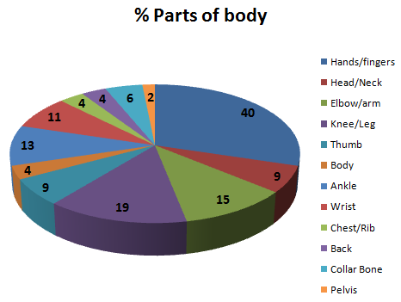

- Parts of body injured 2014:-
Hands/fingers | 19 | Ankle/Foot | 6
Head/Neck | 4 | Wrist | 5
Elbow/arm | 7 | Chest/Rib | 2
Knee/Leg | 9 | Back | 2
Thumb | 4 | Collar Bone/Shoulder | 3
Body | 2 | Eyes/Nose | 1

- Incident classification 2014:

Type of Incident causing LTI | No of LTIs  2014 | No of LTIs  2013 | % change from  2013
Crush/Trapped | 25 | 17 | 47
Slip, Trip, Fall | 9 | 7 | 28
Struck By Object | 8 | 5 | 60
MVI | 9 | 6 | 50
Burn | 2 | 1 | 100
Fall from height | 4 | 7 | (43)
Portable Tools | 1 | 0 | 100
Rotating equip | 0 | 1 | (100)

- Actual Severity 2014:
- Severity 2 (minor injury) 1
- Severity 3 (major injury) 53
- Severity 4 (fatality) 4
- Potential Severity 2014:-

B3 major injury, Heard of in the industry 2
C3 major injury, has happened in the company 48
C4 fatal injury, has happened in the company 1
D2 minor injury, has happened in the company 1
D3 major injury, has happened more than once a year in the company 4
D4 PTD or up to 3 fatality, has happened more than once in the industry 2

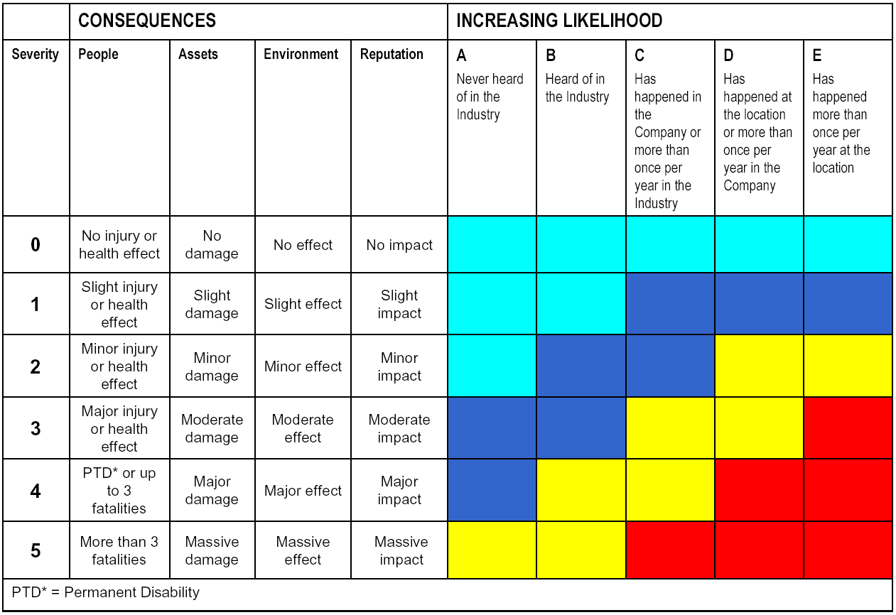
RAM (Risk Assessment Matrix)

- Types of underlying causes 2014:-

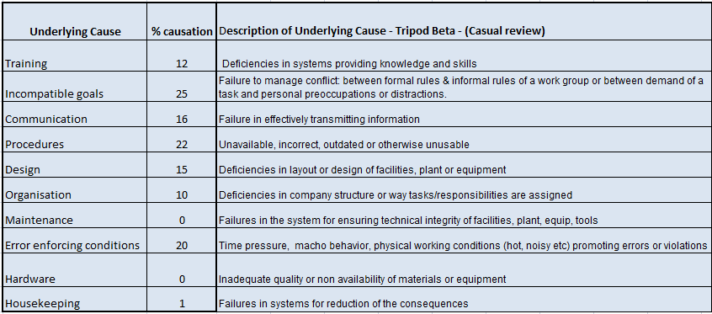

- Time of incidents 2014:-
00:00-04:00 | 3
04:00 -08:00 | 4
08:00 -12:00 | 16
12:00 - 04:00 | 15
04:00 - 08:00 | 14
08:00 - 12:00 | 6

- Age of IP 2014:-

20-25 | 12
26-30 | 13
31 -35 | 13
36-40 | 6
41-45 | 10
46-50 | 1
51-60 | 3

- Observations
- Well Engineering had a bad year performance with a (76%) augmentation in their LTI performance, increasing from 21 up to 37 LTIs. The infrastructure Unit (UID) also increased by (300%) as they increased to 9 LTIs compared with 3 in 2013. XD after 10 years LTIs free added 1 to the total. OSD and OND decreased their incident rate by 20% and 50% respectively, UEOD, CPDM and MD managed the whole year without an LTI.
- The hands & fingers are the most prevalent part of the body injured with (40%) and knee & leg came second with (19%).
- The incompatible goals is the most causational factor with (25%) followed by procedures with (23%) and error enforcing conditions third with (20%).The communication, design, organization and training are next sequentially.
- The most common time of incidents remains between 08:00 and 12:00 (35%) with the later time between 12:00 and 16:00 coming second (33%).
- The most common age of person injured is evenly split between 26-30 year olds (28%), 31-35 year olds (28%) and 20-25 year olds (26%).

End of Analysis

