Ergonomics – Exercises for office workers

This information bulletin was produced to assist office workers with a number of posture reversal exercises which can be undertaken to counteract the effects of repetitive office tasks.

Why exercises are recommended
It is now well accepted that office work has many inherent health risks. This is largely to do with the repetitive nature of many office tasks and the tendency to maintain postures for prolonged periods. These risks are best minimised by good job design.
Good job design should provide the opportunity for people to sit, stand or walk a short distance as a normal part of their duties. It is important to include task variety in the design of work. This means mixing up periods of intensive keyboard use with other activities that involve a change of posture and different mental demands.
When a variety of tasks are not available it is important to take more pauses such that the muscles performing the task have a chance to recover. It is also important to reverse the postures that have been adopted as part of the task. An excellent way of achieving this is by the use of posture reversal exercises. Some simple exercises are listed below.
If you have a pre-existing condition you should consult your health provider to ensure that it is not going to be exacerbated by these exercises.

Stop, s-t-r-e-t-c-h and check!
- • Do a few of these exercises a few times every day.
- • Make sure you relax and perform them.
- • Hold the stretch or repeat as indicated on the diagram.
- • Do not over-stretch.
- • Stop if you feel discomfort when performing an action.
- • Remember to do each side.

While you are exercising, read the notes alongside each instruction and consider whether your work-station is adjusted to suit you.

Neck
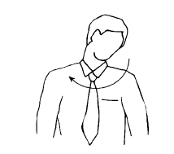
Diagram 1: Head rolls
Gently lower ear to shoulder and hold for 10 seconds.

Slowly roll chin to chest and up to other shoulder and hold for 10 seconds.

Repeat several times and be careful not to extend your neck back too far.

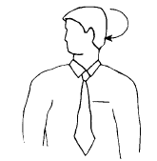
Diagram 2: Head turns

Turn head to look over left shoulder and hold for 10 seconds.

Turn head the other way and hold for 10 seconds.

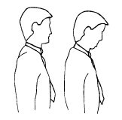
Diagram 3: Chin tucks

Raise the head to straighten the neck. Tuck the chin in and upwards creating a double chin. This also results in a forward tilt of the head. Hold for 10 seconds and repeat several times.

Check neck posture whilst seated
Position the top of your screen at eye level. Use a document holder directly beside or below the screen - it prevents you looking down.
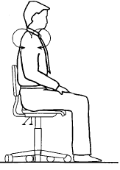

Shoulders

Diagram 4: Shoulder rolls

Circle shoulders forward several times, then backward.

Repeat 3 to 5 times.

Diagram 5: Shoulder stretch

Stretch arm above head, cradle elbow with hand and gently pull elbow behind the head.
Hold for 10 seconds and repeat several times.

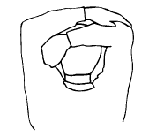
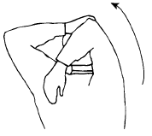

Check shoulder posture whilst seated
Relax your shoulders and rest your hands on your lap. Bend your elbows to 90 degrees and check the height of your finger tips against your current work height. If the work (keyboard or desk) is higher than your hands you may be hunching your shoulders unnecessarily. If so, try and raise your chair height or lower your desk height and try and relax your shoulders while working.

Wrists, hands and arms
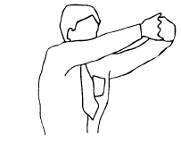

Diagram 6: Wrist stretch

Interlace fingers, palms outward, and straighten arms in front.

Hold for 10 seconds and repeat several times.

Check hand and wrist posture whilst seated
• Keep your fingers suspended over the keyboard.
• Keep elbows at keyboard level. This may mean adjusting the desk or chair height.
• Don’t rest your wrists on the desk or keyboard. Keep hands suspended.

Upper and lower back
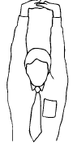

Diagram 7: Upper and lower back stretch

Interlace fingers and turn palms upward above head, straighten arms then slowly lean slightly from side to side.

Repeat movement several times.

Diagram 8: Back arching
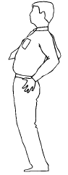

Stand up. Support lower back with hands, gently arch back and hold for 5 to 10 seconds.

Repeat as often as is needed.

Check back support whilst seated

• Sit well back in your chair - if your feet need support, use a foot rest.
• Adjust the back rest on your chair to support your lower back.

Legs
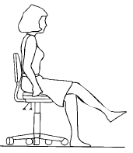

Diagram 9: Foot rotation

Hold onto the chair with hands either side. Straighten leg and lift foot a few centimetres off floor. Rotate foot and ankle both ways (point toes up) and extend (point toes down).

Repeat several times per foot.

Check leg comfort whilst seated

• If the seat of your chair is digging into the back of your thighs check that it is not too high or whether it is tilted backwards.

• If the seat is too high lower the chair and desk or use a foot rest to support your feet.
• Also check the tilt of the seat and if necessary adjust it to a horizontal position.

Eyes
Diagram 10: Eye exercise

Sit up straight, face forward and repeat this sequence several times without moving head.
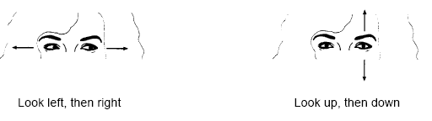

Diagram 11: Visual rest
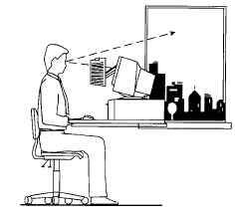

Look up and away from screen.
Focus on a distant object (more than 3 metres).
For example, look out of the window or at a picture on a far wall. Shift vision back to screen and refocus.

Check eye comfort

• Is there enough light falling on your documents?
• Do windows or light fittings cause glare or reflection on the screen? If so, try turning the screen or blocking the path of the light.

• Use a screen with a light background when working with text. Software with a light background for text is more comfortable for the eyes.

