TiReS!
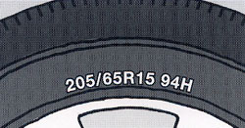
Tire is the unquestionably the most important component of any vehicle!
Tires need a special attention to ensure your safety and that of your family, friends and colleagues who may be riding with you. Do you remember when the last time you checked your tires? How do you know if they are ok or not? As a matter of fact tire check is a critical element of our daily vehicle checklist in PDO operation.
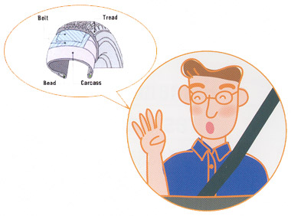
What do you need to check?
Well there is pressure, tread depth, any irregular wear and tears or cracks! How you can find out about your vehicle tire pressure, well, simply it is available on the inside of the driver door; a label containing such important information is fixed there. Check it the next time you ride your vehicle. Also do not forget to check your spare tire as well.
How about the tread depth, do we have the knowledge of checking it? Worn tires require a much longer distance to stop on wet roads, and the tires naturally wear out due to long driving, harsh breaking and wheeling. There are two methods of checking the tread wear, either by seeing the tread wear indicator on the tire or by using the measuring depth gauge. Sometimes we see some irregular wear occurs when the air pressure of the tire is not correct and here we find two types of irregular wear, either the centre wear or the shoulder wear, the first one due to excessive high air pressure and the second one due to low pressure of air in the tire.
If you are planning to buy new tires make sure they are not more than two years old from the day of manufacturing. How do you know how old? On the same line of the tire code you will see a rounded rectangle that contains the week and year of manufacturing, such as 0705 which indicates that the tire we manufactured on the 7th week of 2005.
What does the tire size code tell you? Well, a lot of information are mentioned on the code and it is very simple to read as per the below example, if you notice any differences of codes on each tire then please make sure that they are identical and tire with wrong specs must be changed immediately.
205/65R15 94 H - this is a sample code available on each tire but what does it mean?
205 Indicates the section width in mm of the tire.
65 Indicates the Aspect ratio (%) of the tire, which is the ratio of height to width.
R Indicates the Radial Construction of the tire.
15 Indicates the Rim diameter of the tire in inches.
94 Indicates the load index (LI) and 94 means total weight of 670kgs.
H Indicates the maximum speed of the tire (H means maximum speed is 210).
Do you know why the tires are black? The rubber for tires contains carbon black, a reinforcing material which gives it the color as well. A tire isn’t just a rubber; it is a complicated mixture of metals and fibers.
Do not wait to get a tire explosion due to high speed and wear off, please check your tires regularly and arrange to change them immediately.

