011/94

Personal Jewellery

Background
A worker injured his finger severely when his ring caught on the metal framework of a truck. The tendons of the worker's ring finger were severed in addition to deep lacerations. The worker was evacuated to the coast for micro-surgery.

Recommendations to prevent Recurrence
The HSE Manual prohibits the wearing of personal jewellery and necklaces in the workplace if there is a danger that they may be trapped in rotating or moving machinery.

However, the practice of wearing personal jewellery in other areas is not prohibited. As a result of this injury, area supervisors are asked to review the outcome of this incident and develop practices that will prevent a recurrence.

It is recommended that rings and items of personal jewellery be removed before entering any areas where crush or catch hazards may be present. This includes all areas except offices.

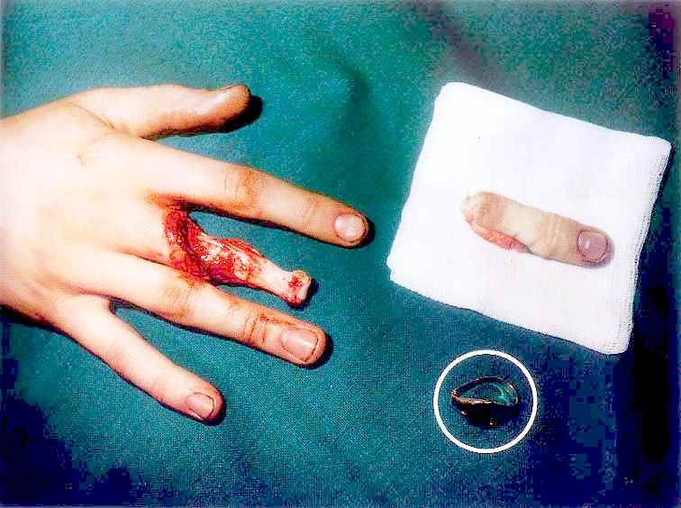

The contents of this Safety Alert should be communicated to all PDO and Contractor employees by Section Heads and Contract Holders. Employees should be encouraged to review this alert with members of their families.
TSEM Please remove from bulletin boards by 30 November 1994

