Safety
Alert
No.1

Feb. 2001

Vacuum-truck Fatality

Background

A 2-man crew of a vacuum truck was carrying out a routine activity of discharging oily sludge at a waste management pit. The inexperienced helper switched the pump to discharge oily waste, and then opened a valve on the discharge line. There was no flow. With the pump still running, the helper tried to unblock the valve by using the stick of a sweeping brush.

Whilst trying to unblock the valve, pressure in the tank was building up followed by a pressure surge which blew open the tank rear door and hit the helper in the head throwing him 13 m towards the waste pit. He died immediately.

Why did this accident happen

- The crew was unfamiliar with the hazards associated with this type of operation. The driver’s experience had been limited to driving water tankers and it was the first time the helper operate this type of truck.
- The pressure setting of the relief valve was set higher than the recommended setting by a factor of two.
- The rear door bolts were a of wrong design, inadequate material and of poor workmanship.

What can you learn from this accident?

- Do not operate equipment unless you know how to do it correctly.
- Familiarise yourself with the associated hazards in any activity and take precautionary measures. Remember, if in doubt ask.
- Ensure that the equipment or vehicle you operate has been inspected and certified for that job. Vacuum trucks operating within PDO concession MUST be inspected and issued with a certified sticker as per the sample shown below. NO STICKER = NO USE.

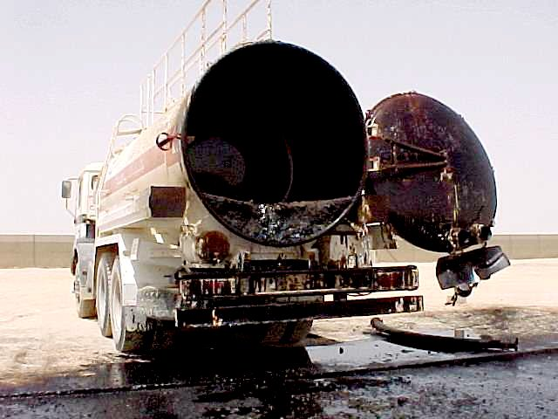 | 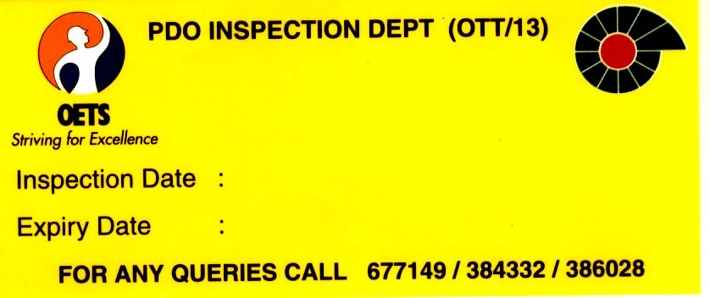  NO STICKER  =  NO USE
USING A VACUUM TANKER

Vacuum or suction tankers are used to suck up liquids and sludge for disposal. There are dangers in using this type of truck including hoses not being fitted correctly, personnel being injured by the rear door, injuries from wrongly using the hose, explosions and other associated health risks.

PLANNING INFORMATION | WORKING PRACTICE
All operations using vacuum tanks must be carefully planned. Many hazards of vacuum tanker operations are related to the material being carried (often hazardous or a health risk) or the site ( often hazardous).  Know the material and the site, and prepare the personal protective equipment.  Check whether the work requires a Permit-to-Work .  For general information, see the Task Sheet "Using a Truck". The Task Sheet "Storing and Transporting Hazardous Materials" must also be used when relevant.  Both these task sheets are included in the Transport Operations Manual: TOM, available from Logistics department (TLM) and CSM. | Always use the tank or tanker pump operating instructions and follow the instructions.  Attach earthing straps to the ground near the source of the material or to the container being emptied. Check the air pot and pump safety pot, and make sure the level gauge is clean.  Check that the multi-way cock is set to the correct position for the operation to be performed.  Check that the hose couplings are correctly fastened with safety lines attached between the hose and the coupling if unloading under pressure.  Always watch the pressure gauges while the tank is filling or discharging and “Do not stand behind the truck “.  Stop the machine immediately if there is excessive pressure or the gauge shows that the safety valve should have operated but has not.  Do not overfill the tank. Remember that there needs to be space for the contents of the suction hose.  Make sure that the system is not pressurised when fastening or unfastening couplings!
SUPERVISING PERSONNEL | Operating EQUIPMENT
Only allow experienced, specially trained personnel to operate vacuum tankers. Also Special training is needed if the driver has to use breathing apparatus.  Check that personnel know the rules including any rules regarding the Permit-to-Work system.  Regular checks should be made to observe the skill of vacuum tank operators, and especially their knowledge regarding working in hazardous areas.  NO STICKER  =  NO USE  February 2001, CSM/11 | “SP 1207 Specification For Vacuum Tankers” provides detailed specifications for vacuum trucks (issued early March 2001, downloadable from EDMS or CSM-WebSite). For further information or clarification contact OTT/13.  Make sure that all vacuum trucks involved in PDO operations have been inspected and issued with a certified sticker as per sample shown below.

