REVISED

SAFETY ALERT
Personnel Lifting Systems
Incident

The Gulf of Mexico Deepwater Production Business Unit suffered a fatality incident on August 16, 2000 when a contract drilling company employee fell from a full body harness boatswain’s chair while ascending to the derrick board on a hoisting system. The initial information from the investigation team indicates that the individual fell when he became detached from the self-locking grip latch hook similar to that depicted below. The latch on the hook depicted below opens outward.

Action

All Gulf of Mexico BP operating locations are required to immediately survey all personnel hoisting and fall arrest systems. Verify that all hook components are designed, manufactured and certified for personnel lifting. If there is a hook in your system, it must be self-locking and self-closing with an inward moving latch. Examples of such hooks are illustrated below.
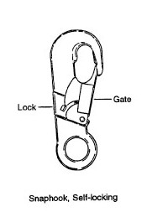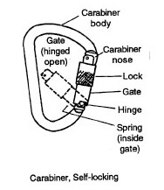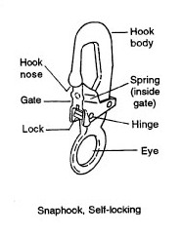

Should you have any questions, please contact your HSE representative.

Keith Elliott
Deepwater Production Delivery Manager
August 18, 2000

