BP SAFETY COMMUNICATION

Title: Fatal Accident on Dada Gorgud Rig Floor Business Unit: Azerbaijan Exploration BU
Country: Azerbaijan
Location of Incident: Dada Gorgud Semi-submersible Drilling Rig, Inam Contract Area, Caspian Sea
Date of Incident: 23rd February 2001
Contact Name and Phone Number: Hugh McDowell + 44 1932 759365; (99412) 979365

Brief Account of Incident: On February 23rd, 2001 at 04:30 hrs, following repetitive work involving breaking 348 pipe joints and laying singles on the pipe deck, a task to make up a cement stand was commenced. The made up stand was 1.5m higher than a normal drill pipe stand. Once made up, the cement stand was being racked back when the Driller lowered the traveling block. The top of the cement stand got caught on the underside of the gearbox of the traveling equipment causing the cement stand to be driven down into the drill floor (bird bath) where it bowed. Significant potential energy was stored in the cement stand before it whipped across the drill floor striking two men and fatally injuring them.
Actual or Potential Outcome: Two fatalities. Well operations shut down for over 7 days.
What Went Wrong:
- The upper and intermediate racking arms were not holding the stand vertically causing the top of the cement stand to be under the traveling equipment’s path of travel.
- The traveling block was lowered before the cement stand was clear of its line of travel.
- Work site rules were not being fully implemented at the work face

What Went Well:
- The initial emergency response on the rig was dignified and respectful of the two deceased men and Azeri custom.
- The onshore Emengency Response Team co-ordinated and effected excellent support to the rig site, the relatives of the deceased, and persons closely involvedwith the incident. All revevant Governmental agencies and media were kept fully informed throughout.
- A preliminary Incident Investigation team was dispatched immediately to the rig, vital evidence was recorded and the incident scene preserved. This greatly facilitated the subsequent work undertaken by the Major Incident Investigation Team.

Lessons Learned:
- The driller must never move the traveling block until positive confirmation is received that its travel path is clear
- Ensure that the driller has a good line of sight to the traveling equipment, that the traveling equipment is visible in the derrick (colour contrast) and that communication systems and signals are functioning properly and being used to maintain safe work.
- Changes to repetitive tasks should not be regarded as “routine”, and such changes should initiate the need for a time out, and pre task risk assessment to identify hazards associated with the new task.
- The continuous auditing by supervisors of the implementation of work site practices and rules at the work-face (“where the rubber hits the road”) is paramount in assuring the ability to deliver HSE performance.
Messages:
- Ensure that quality pre-task risk assessments are conducted at the work-face and that they are initiated when changes to repetitive tasks are made.
- Ensure that work site rules and practices are rigorously in force at the work-face, ensure continuous auditing and coaching by supervisors to reinforce the rules.
- While good HSE Management systems were in place they were not being fully implemented at the work face.
- Good safety track record is no guarantee that safety systems are being followed at the workface.

Picture-1: Looking upwards in Derrick - Top of cement stand caught on the underside of the traveling equipment gear box.

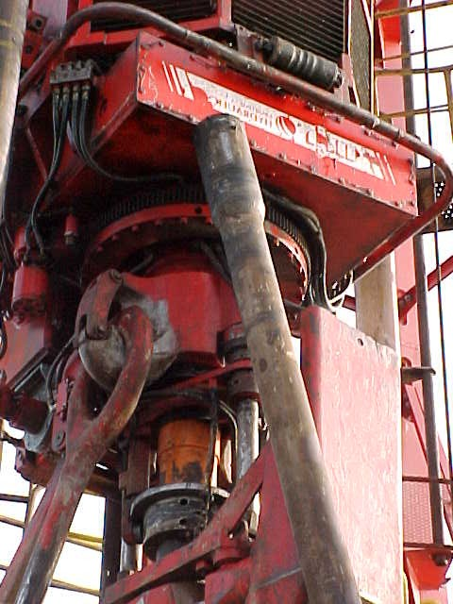

Picture-2: Looking downwards from Derrick to drill floor – shows bent cement stand (top right towards top center of picture and the “bird bath” from which it sprung (bottom right of picture). Original position of two men marked by chalk (top center).

