Mobile Radio and Emergencies

In emergencies, good communications are essential. In a recent incident, misuse of the radio prevented good emergency response.

This brief is issued to help radio users make better use of the system.

The PDO Mobile Radio system uses an “open channel”. This means that everyone can hear a conversation on a particular channel but only one user can speak at a time. If the system is misused by replaying music (or personal chatting) it cannot be used by others who may need it, possibly for emergency response.
Someone’s life may depend on this!
- If you hear a radio conversation about an emergency, please restrict your use of that channel to critical use only until the situation is cleared.
- If you have another emergency to report at the same time, be brief, specific and standby on the radio to give further information.
- Ensure your microphone is replaced on the hook provided, so that you do not transmit by mistake.
- If you see someone abusing or misusing the radio, report to Radio room or TCT/4.

Before you start any journey, test your radio!

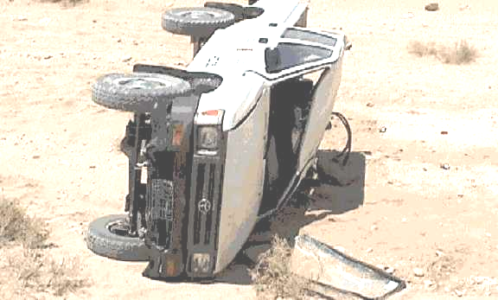 | The Life of the injured people in this vehicle depended on clear communication with LECC.  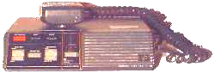  This could save your life,  so don’t misuse it!

