HSE alert
Number: 2002/06 |  | Seatbelts also in taxi and bus |  | July 2002

Again an alert on the subject of road safety, because traffic hazards are a major concern in our business. As most of us do a desk job in an office environment we encounter our major risks when we are on business trip and while commuting.

What happened:
An airport shuttle bus, on its way from a satellite parking, stopped very sharply at the airport terminal building. In the absence of seatbelts, most seated passengers grabbed something to hold on to. A woman and her child weren’t that fast and were thrown along the aisle of the shuttle. They were lucky and got away with slight injuries (scratches, bruises and some damaged clothing).

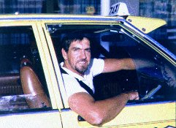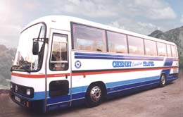

Key lessons:
- All too often we are happy with any bus, shuttle or taxi when we are waiting at the station.
- Using seatbelts is mandatory in increasing number of states and countries, also in public transport, also in rear seats.
- The protection provided by seatbelts is undisputed. They save lives on highways, in town, on short trips as well as long trips, in family cars, SUV’s, pickups, shuttles, taxi’s and buses.
- unnecessary

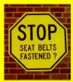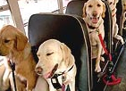

Recommendations:
- When boarding a taxi, check the seatbelts. If not present, switch to another cab.
- Always use the seatbelts, in front as well as when you are in the rear seat.
- Prior to hiring a bus, e.g. for business trip, excursion, off site event, make sure that seatbelts are installed at all seats.
- Pre-select taxi and bus companies that offer vehicles fulfilling our specifications, including seatbelts in all seats.
- All newcomers to fill-in and understand the HSE&S induction checklist with their sponsor (http://sww.siep.shell.com/induction_checklist/), the starting point for the induction program. Completed checklists must be stored with the team for 12 monthsAll newcomers to be assigned a mentor (usually the sponsor).

Contacts:
Rijswijk: Paul Gerlings  (+31) 70 311 6590
Houston: Willie Smith  (+1) 713 245 7933
SDS: Dick Twilhaar  (+1) 281 544 5303

