QARN ALAM HSE ALERT

FOG IS DANGEROUS

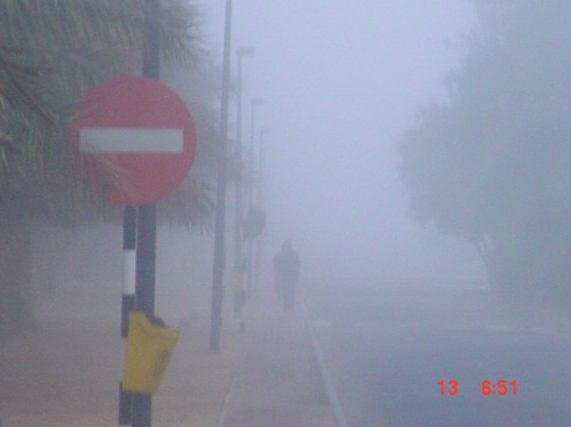
THE VISIBILITY IS POOR
THE ROAD IS SLIPPERY
THE WINDSCREEN IS MOISTURED

