
Hazard ID

18th December 2002: Marmul Yard - Personal Injury - MTC

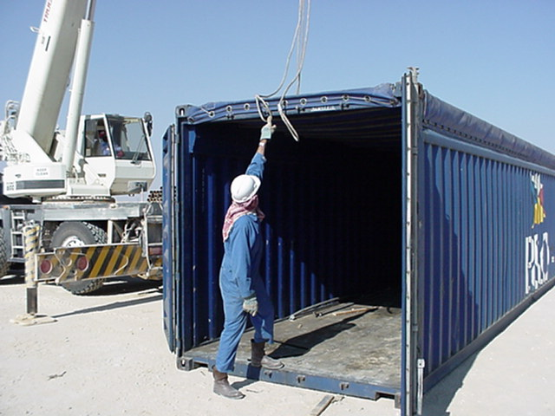

What Happened?
While attempting to free a wire rope sling which had become caught up on the canopy hook on top of a sea container, one of the yard crew injured his left index finger when it became trapped between the sling and the canopy hook. He was given first aid on the spot by the crew foreman, then taken to PDO Marmul clinic where his finger was treated for severe bruising.

Why did it Happen ?
The Foreman / banksman responsible for controlling the crane and supervising the crew’s work activity had positioned himself inside the container. From where he stood he could not see or direct the activity of the crane or control the work site.

Any Learning Value ?
This is the second incident we have had in this yard this year. Both incidents involved cranes and containers, and in both cases the foreman in charge of the work activity lost control of it. In the first incident one of the yard crew members was seriously injured (LTI) Obviously we learned very little from the experience !

