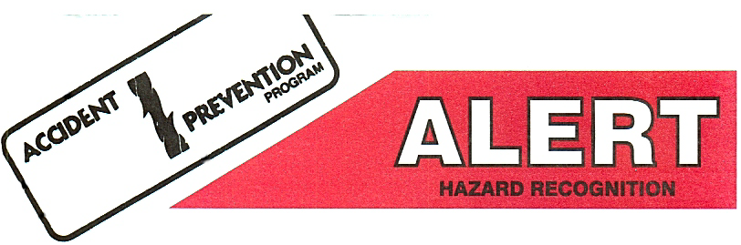

Crushed Between Stotler/Elevator

Date: 12/20/02
What Happened?
Crew completed running 3 1/2 tubing in the well and was in the process of stripping off the BOPE (Stotler). The crew stripped the BOP up off the wellhead and installed slips under the stotler. The stotler remained on the stup in the slips. Crew worker unlatched the tubing elevators and operator ran blocks to the tubing board with the tubing elevators at mid-point between the board and the floor. The operator latched down the brake handle using the ratchet latching mechanism instead of the chain. Crew worker then installed a sling on the stotler and held it in place on the flange bolt slots. The Crew Chief raised the stotler to collar height while waiting for the third crew worker to install a 4’ tubing sub in the rod tray to secure the stotler. The Crew Chief started to move the winch line and stotler, at this time the crew chief felt the brake handle strike him in the side as the ratchet latch released. The blocks came down being guided by the winch line striking the injured worker on the right middle finger between the tubing elevators and stotler flange.
Injuries/Property Damage:
The employee received two severe lacerations to the right middle finger requiring surgery.
Root Cause:
1. Improper hand placement
2. Failure to use the chain latching mechanism to secure brake handle.
3. Crew did not use a tag line.
4. No lifting eyes on stotler
Corrective Actions:
1. Crew will add to the JSP/JSA for the use of the tag line when handling equipment.
2. Equipment Manager is working with manufacturer to find a new location or design of the road latch mechanism.
3. Crew Chief will assure that the brake handle is secured by the chain except when roading.
4. Identify and install lifting eyes on all stotler style BOPE.

For More Information, Contact Clint Merrick at 661/201/2048
Approved By: Joe Deford
