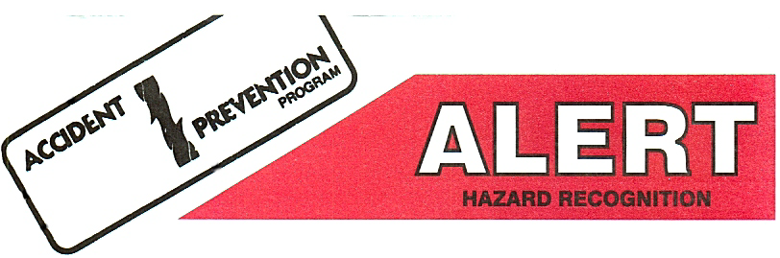

CARRIER POT INCIDENT

DATE: 12-23-02

WHAT HAPPENED:
A rig crew working in the Coalinga Aera field was preparing to install the polish rod onto a well.
The injured employee stabbed the stuffing box onto the stub (rod box) of the rod being held by the rod elevator. The injured employee and the derrick man lifted the carrier pot onto the top of the stuffing box by hand. (Wt. of carrier pot approx. 45 lbs.) As the derrick man went to grab the polish rod, the stuffing box moved toward the rig and the carrier pot fell towards the injured employee pinching his left thumb between the pot and the edge of the stuffing box.

INJURIES/PROPERTY DAMAGE:
The employee received multiple fractures to the tip of his left thumb and 15 to 20 stitches.

ROOT CAUSE:
- Improper hand placement
- Unsecured carrier pot on an elevated surface.
- Failure to use winch line to lift and secure carrier.

CORRECTIVE ACTIONS:
- Crew to produce a JSA on the installation of the carrier pot.
- Crew to utilize mechanical means to lift and secure carrier or install carrier and stuffing box onto the polish rod as described in the Job Safety Analysis.
- Safety department to generate alert.

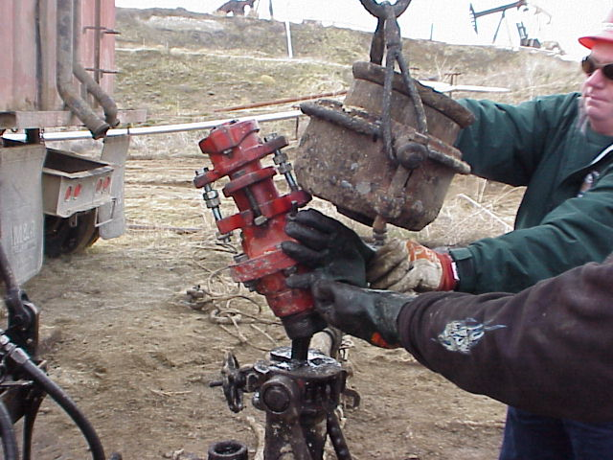
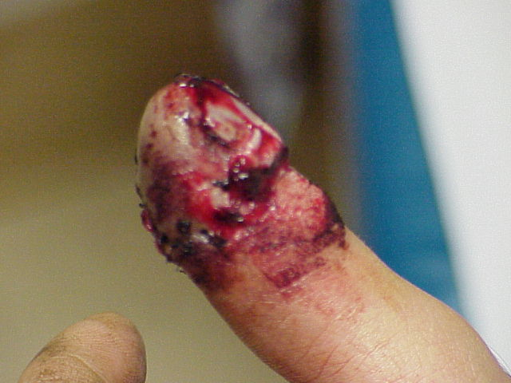

APPROVED BY: Joe Deford
FOR ADDITIONAL INFORMATION CONTACT:
Jerry Fernandez / Safety and Training Specialist
Pool Well Services Co.
661-201-6056

