KCA DEUTAG Drilling GmbH

SAFETY ALERT No. 02 – 2003

FLASH REPORT with upfront information

To: All slingshot rigs of the KCA DEUTAG Rig Fleet: T-45, T-46, T-47, T-48; T-57,
T-61, T-63, T-44.
KCA DEUTAG, Management Land Operations
Cc: KCA DEUTAG Ltd., Mgr. Techn. Support Services for information

From: HSE/ QA and Equipment Department, Germany.

TOPIC: Hazard in loosening of Rig Floor Plates on SLINGSHOT RIGS.

Key words: Floor plates; Rig move safety; lever arm of floor plates, plate support.

Incident Description:
This flash accident information is to notify all land operations of a potential hazard in loosening bolts of floor plates of the rig floor:

A tragic accident happened on one of our rigs Monday 5th May, where two bolts of the rear floor plate were removed from below the rig floor. At that time the stairs (see Fig.1) were still attached to this floor plate.
The supporting structure to hold the floor plate in place was not sufficient anymore and the weight of the stairs – sliding away – caused the plate to topple over.
This resulted in the stairs falling to the ground causing a worker, who was working at the grasshopper close by, being trapped and fatally injured.

Fig. 1: Rear stair attached to Rig Floor Plate.
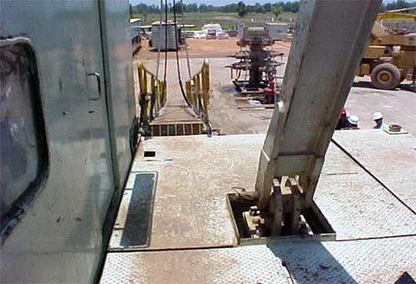

Fig. 2: Stairs connected to rig floor plate down to ground (sling shot was already lowered down)
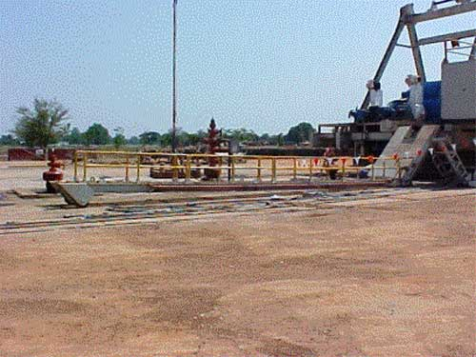

CORRECTIVE ACTIONS:
- The following procedure to rig down slingshot floor plates must at all times being followed: Before loosening any floor plate bolts, all attached equipment, such as stairs, must be removed before.
Action: Country Managers to communicate this procedure immediately and ensure that it is being followed and added to the rig up / rig down procedures of each of their rigs.

- All KCA DEUTAG slingshot rigs shall immediately check the support situation of all floor plates. Especially for the rear Rig Floor Plate with the stairs attached. A report with sketches or photographs must be submitted to the equipment department OT within one week.
Action: ensure sufficient support of Rig Floor Plates.

May 7th, 2003.

Helmuth Steckhan, Engineering Benjamin Langstein, HSE

