

SAFETY ALERT

Unrestrained Load

A large tipper truck (photographed near Qarn Alam) was loaded onto this semitrailer and improperly restrained by hand-tied frayed rope, broken webbing and two small rocks placed behind the rear tyres.
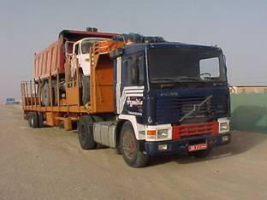
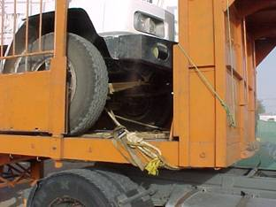

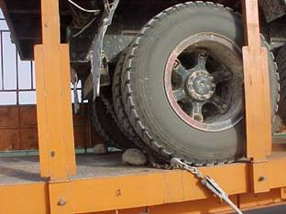
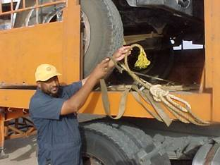

rocks !!! -use chocks frayed rope and broken webbing. Use chains.
Ensure all loads are restrained in accordance with SP2001

