Fall Protection

Operations Unit:
Gulf Division

Country:
USA

Location of Incident:
Gulf of Mexico Region

Date of Incident:
June 5, 2003

Brief Account of the Incident:
A contractor was working on the skimmer level of an offshore platform (approximately 35’ above the water) to wrap a light fixture in preparation of sandblasting operations. He was told by his supervisor in a Safety meeting that morning to use a spider (lifting device), Safety harness and work vest to get to the fixture that extended outward from a walkway. The contractor chose to lean out (see photographed re-enactment) from the walkway and through the handrails instead of using his PPE. While attempting to wrap plastic around the light, the fixture broke off of its’ pedestal. The contractor had the majority of his weight shifted outward and, therefore; fell, striking his head on the way down then entering the water unconscious.

Outcome:
The contractor was retrieved from the water and never regained consciousness.

Causes:
- Failure to use the Personal Protective Equipment available and required.

Lessons Learned:
- Never take shortcuts. When completing a job task, complete a Job Safety Analysis and understand the potential hazards.

Action:
- Review this Safety Alert in all Safety Meetings immediately and include in site orientations. Also, review the Fall Protection section of the EHS Handbook.

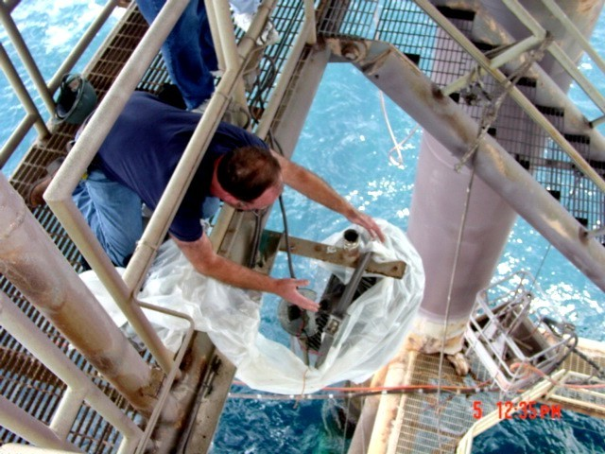

June 6, 2003

