
Onshore Pipelines, Spread 1C
HSE Lessons Learned

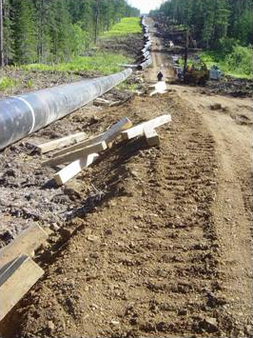
Incident Summary
On Sunday 11th July 2005, the SMU4 welding crew at KP26.9 suffered an LTI.
During preparation for stabbing of the 8th pipe length (7th joint) the hot pass welding crews were setting up.
Without warning the pipe string, around 77m shifted in a downhill direction and fell into the RoW, away from the access road.
The welder on the RoW side of the 6th joint was caught by the pipe and crushed beneath it. The side boom was used to free the welder and he was evacuated to hospital.
The welder suffered 4 broken ribs and multiple contusions. His relatively light injuries were due to the boggy ground conditions.

This incident had the potential to result in a fatality.

Investigation findings
The investigation found that the use of wooden skids without required crutches as pipe supports was inadequate in this case due to the inclination of the work area and the narrow width of the access road.
Contributing factors may have included the use of felled tree trunks as road base and insufficient compaction of the road surface.
On the ground supervisors appeared to be competent and aware of hazards posed by the activities underway.

Corrective Actions
- Access roads are to be a minimum of 8m wide.
- Update of method statements to recognise hazards and improved implementation at ground level.
- Excavator to be dedicated to welding crews to allow the use of earth berms as appropriate.
- The roles of Supervisors to be reiterated and commitment to HSE from contractor and sub-contractor management to be demonstrated through ongoing leadership.
- Development of method statements and risk assessments to include appropriate supervisory personnel.

