Loose Lifting Equipment– Safety Alert


Activity Location - All Locations

Alert Activity - Inspection of Loose Lifting Equipment

Activity Description

Faulty Chain Anchor Point
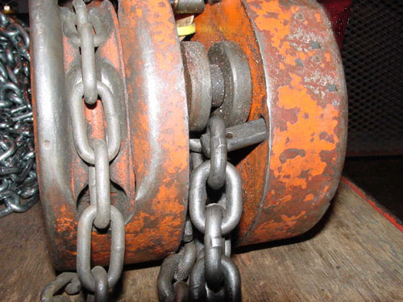
A load chain anchor pin became detached on a 1 tonne chain block. It had previously been inspected by a Lifting Gear Inspector as part of site 6 monthly routine inspection of portable lifting gear and had been used only once since the last inspection.
The block was correctly colour coded and certification was in order.
Following the incident, a check of all chain blocks on the location was carried out. No other chain blocks were found to be defective.

Alert Points
- Pre-use visual check on all lifting equipment should be carried out by a competent person (Rigger)
- ‘In Certification’ does not mean in ‘good condition’.

Lessons Learnt
- All users to be fully aware of the importance of checking all lifting gear before use.
- The colour coding tag alone should never be taken as an indication that the equipment is fit for use at the time it is required to carry out a lift, especially in the case of equipment that may deteriorate or be damaged in use.

Recommendations
  - All persons using lifting equipment should be competent to do so.
  - Visual inspection of lifting equipment should be undertaken before use.

Prepared By: Operational Safety Support Team

SEIC HSES

