Fire Alarms
Safety reminder on the importance of evacuating a building when the fire alarm sounds

The recent Corniche fire in Doha, which is currently under investigation by the authorities, highlights again the incredible speed with which a fire spreads through a building.

The time difference between these two pictures is less than 7 minutes

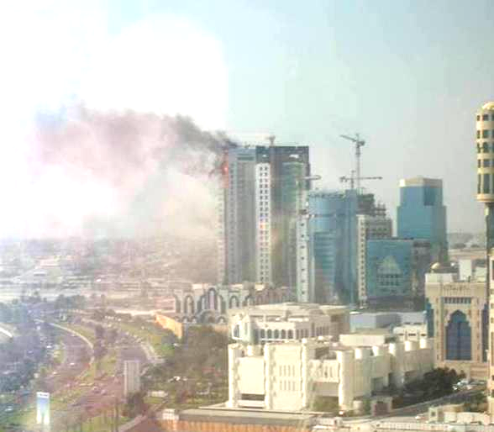
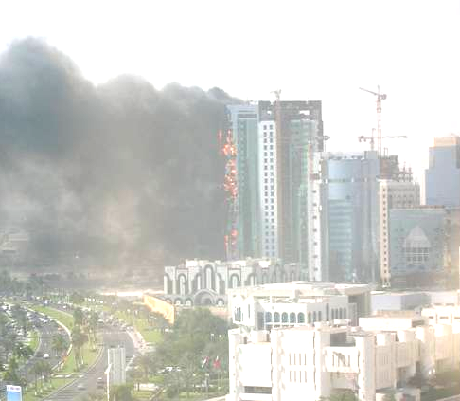
Fire first observed Building fully engulfed 7 minutes later

Actions to take when the alarm sounds
- Stop what you are doing
- Close your office door and place your dustbin in front of your door. (A rescue party will know that the occupant of that office has left the building. The fire warden then does not have to physically check all the offices, but only those which have no dustbin in front of the door.)
- Make your way to the nearest exit
- Make yourself known to the warden at the assembly point

Things not to do
- Don’t run – You may fall and hurt yourself which will make it more difficult to get out
- Don’t use the elevator – If the power fails you will be stuck inside an oven
- Don’t go back into a building that is already on fire – Fire spreads with phenomenal speed and the smoke may overcome you

Lastly – Never Ever Ignore a Fire Alarm
You only have precious seconds available to get out uninjured

