
02.04.01

Night Driving – Truck tip over, double LTI
The Incident:
A light canter truck, with a driver and a helper, was send from Muscat to Lekhwair to deliver most urgent oil production chemicals. Upon arrival at Fahud the Fahud-Lekhwair road was closed due to heavy rain. A decision was taken to re-route the truck via Ibri and a night driving permit and revised journey management plan were issued.

Somewhere between Ibri and Safah the driver hit a soft waterlogged spot on the road, lost control and the vehicle tipped over. The driver sustained neck injuries and the helper broke his arm. The vehicle cab was damaged and one chemical drum ruptured.

The Failures:
- Inadequate stock levels of chemicals (faulty reporting of stock).
- The driver had been on shift for 17 hours (with another 2 hrs of driving to go).
- Night driving on a water logged road.
- Passenger was NOT a helper/co-driver but an unauthorised “friend” of the driver.
- Journey management responsibility was taken over from truck owner/operator

The Lateral Learning:
- Before giving night driving approval is given carefully examine all possible risks such as total driving hours, driver's age and experience, current condition of the road, load on the truck and GSM coverage.
- Consider the need for an experienced co-driver on such journeys.
- Ad-Hoc transportation of “most urgent” deliveries are made by a TLM/Majan organized “Hot-Shot” service. Contact PDO logistics department for these services.
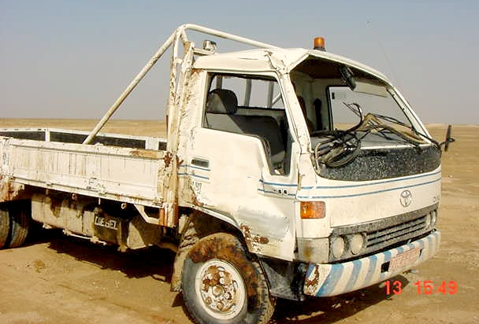

HSE Incident Lateral Learning
No: 2002-01
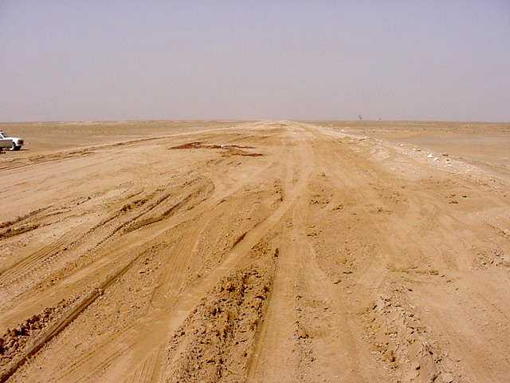
The truck
The road (by day)

