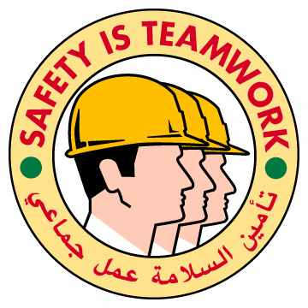
Staff working on a drill machine breaks arm
The Incident:
A sub-contractor plumber was tasked by his supervisor to drill a steel bar (3mm thickness) using an electric pedestal drilling machine. Whilst drilling, the bar suddenly slipped from the self fabricated jig (clamp assembly). The plumber tried to hold it. As a result, his glove was caught by the drilling bit, twisting his hand causing an open fracture of both forearm bones.

The Failures:
- Metal bar was not properly secured on the machine (self-made clamp).
- Excessive tool pressure was applied on the metal piece as the drill bit was not sharp.
- Plumber was assigned drill machine job. There was no formal assessment of his skills.

The Lateral Learning:
- Ensure that Contractor/ Sub-contractor personnel are competent to carry out jobs on the machines. What systems do you have in place for this?
- Maintain list of trained and authorised staff with respect to each machine operation.
- Provide appropriate warning signs on hazardous areas/machines.

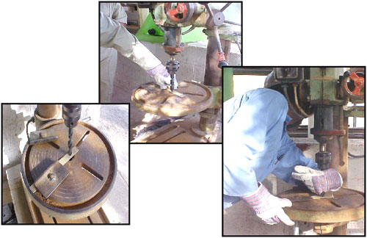

HSE Incident Lateral Learning
No: 2002-04

