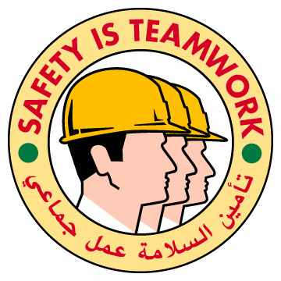
02.04.01

Getting out of a truck: the wrong way and the correct way

HSE Incident Lateral Learning No: 2002-08

The Incident:
A helper came out of an oilfield truck cabin facing forwards instead of backwards. He lost his footing on the first step of the ladder an fell down to the floor hitting hurting his back.

The Failures:
- Incorrect way to come out of a truck
- The helper was in a hurry to get out
- The helper did not see this as a specifically hazardous activity and did therefor not pay attention to what he was doing

The Lateral Learning:
- Even minor activities like mounting/dismounting trucks can cause serious injuries.
- You can break bones and hurt yourself coming when working at heights as low as this.
- Always come down a truck facing backwards towards the truck.
- Always follow the procedures- assess the hazards/effects of your activity.

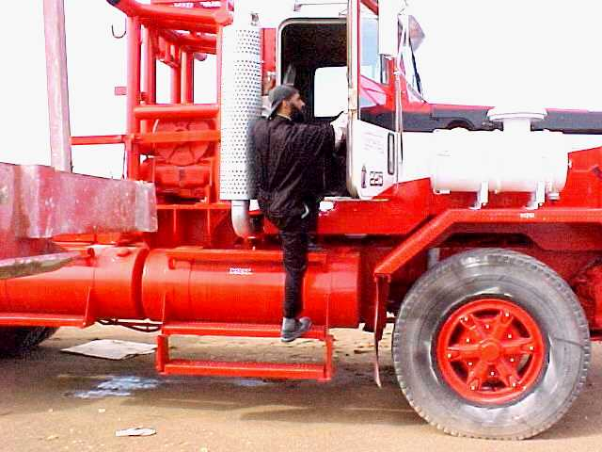
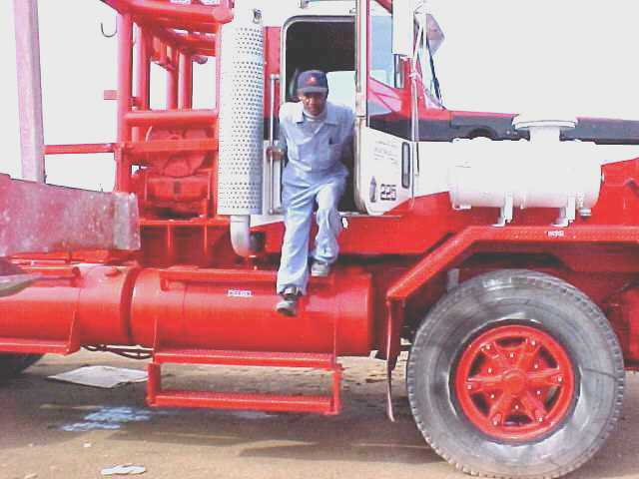

The wrong way The correct way

