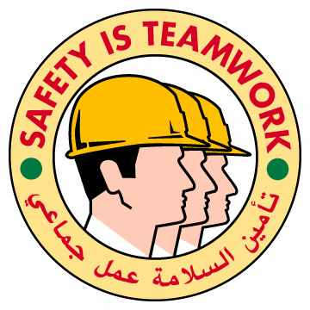
The Prime mover after recovery
Prime Mover and Trailer during recovery
02.04.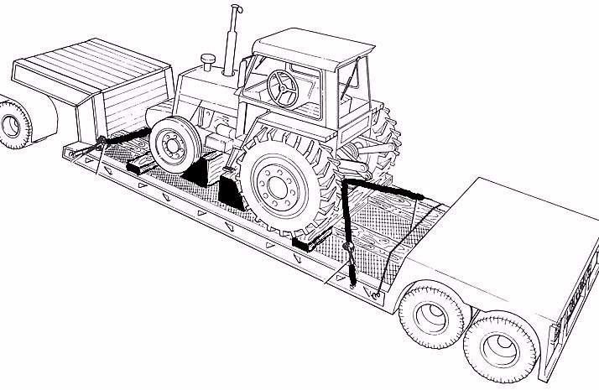01

High Potential Road Traffic Accident

HSE Incident Lateral Learning

No: 2002 - 09
The Incident:
On 28th June 2002, a loaded prime mover/trailer combination was climbing the Salalah jebel road, when the air braking system on the prime mover failed causing only the prime mover air brakes to apply, (fail to safe). The prime mover brakes alone were insufficient to hold the prime mover and loaded trailer on the hill. The result was that the combined weight of the unit, load and the slope caused the vehicle to roll back down the hill. To avert a more serious accident the driver steered the prime mover so that the back of the trailer hit the jebel wall. The trailer turned upside down and came to rest on the load, and the prime mover rolled over onto the driver's side of the cab. The driver was unhurt and escaped from the cab via the passenger side door.

The Failures:
- Failure by the driver to switch off the engine and engage first gear when stopping on a slope.
- No proper wheel chocks readily available on the vehicle.
- No “fail to safe” braking system on the trailer (not a requirement).

The Lateral Learning:
- Apply the handbrake.
- Switch off the engine and engage first gear when stopping on a slope.
- Apply the "Mechanical" braking system on the trailer.
- Ensure proper wheel chocks are readily available on the vehicle and place behind the tyres when stopped on a slope.

