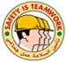

HSE Incident Lateral Learning No: 2002-10

Lost Time Injury: Man lift incident (Bucket Truck)

The Incident:
During the 6 monthly preventive maintenance of beam pump (well 263), the technician (IP), had ascent to approximately between 3 m to 4 m to carry out Preparation work to clean saddle bearing before greasing when the bucket suddenly descended (DROPPED) to its resting position, while the technician was inside the bucket cell resulting in fracture of 9 ribs.

The Failures:

Unsatisfactory certification process of truck and manlifter
- Lack of QA/QC on Contract’s execution and adherence to contract’s requirements.

Procedures for lifting operation were not followed
- Lack of maintenance and Inspection.
- Sheared-off hydraulic connector nipple downstream of NRV
- The hydraulic system was not fail safe.

The Lateral Learning:
- Adhere to maintenance requirements of lifting equipment and trucks as per PDO’s specs and procedures
- Both truck and lifting equipment must be certified by competent 3rd party and verified by PDO before putting them into use
- No Modification and haphazardly fixes on both truck and manlifter are allowed without manufacturer recommendation
- Review operating procedure and daily checklist for operation of man lift and retain the records
- Maintenance/Services of man lift and bucket truck to be done as per the manufacturer recommendations and record should be maintained
- Train crew on maintenance and operations aspects of the bucket truck and manlifter
- This incident and injury could have been eliminated had the supervision been adequate enough
- PLEASE Exercise STOP- You will save lives and some one from serious injuries

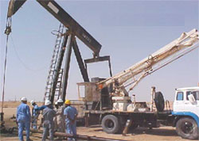
The actual scene of the incident

