

HSE Incident Lateral Learning No: 19-Jan-2002
CONTRACTOR MAN LOST INCIDENT ON 18th SEPTEMBER 2002
Incident Summary:
A two man inspection crew, their task completed, set out from a Rig at Hawqa North bound for Nimr driving a 4WD pick up. They took a short cut track not approved or shown on the J.M road map, following a Bedu, who (his vehicle not having a speed limiter fitted) quickly drove out of sight! They then took a wrong turning off the “main” track and their vehicle became bogged in sand approximately 6km south east of the short cut track. After walking back to the “main” track they were picked up by a passing seismic vehicle working in the area, which helped to pull their vehicle free of the sand. They were returned to their departure point at the rig some seven hours after leaving.
Their Journey Manager at the coast failed to raise the alert despite receiving no check-in calls and being fully aware that he had not heard from his crew. The weather was cool and cloudy and they had adequate water for the conditions. Had this incident taken place in the full heat of summer, the outcome may have been very different.
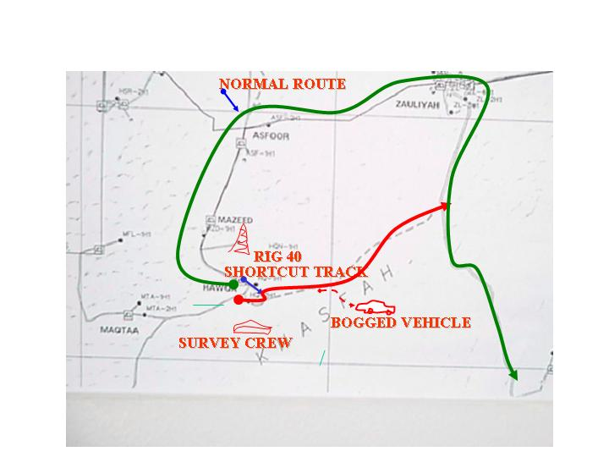
The Failures:
- Driver did not follow the approved Journey Plan and took an unauthorized short cut.
- Failure of the Journey Manager to raise “Man-Lost Alarm” despite the long passage of time with no check-in calls

Learning Points:

- DO NOT TAKE SHORT CUTS—stay to the approved route per the journey plan.
- Ensure adequate controls in place to manage Journey Manager’s activities.
- Journey managers must be aware of and clearly understand their role –RAISE THE MAN LOST ALERT per the requirements of the Safe Journey Management procedure.
http://sww1.pdo.shell.om/dept/cd/csm/dts/default.htm
Contact: Habib Al-Maamari CSM/151

