Hazard
ID



DANGERS IN THE HOME

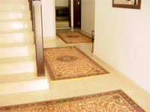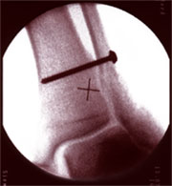

STEPPING ON THIS MATT CAUSED THIS

What Happened?
A senior member of Truckoman stepped on a matt in his own home, a normal activity and something he had done hundreds of times before but unfortunately in this instance the matt moved causing the individual to fall. The injuries sustained were a broken and dislocated leg just above the ankle.

Why did it Happen?
The floor surface was polished marble, the back of the matt although rough in texture was not sufficiently adherent enough to grip the smooth surface of the floor. Consequently when the matt was stepped on at a certain angle it slipped causing the accident to occur.

Is There any Learning Value?
Although the matt had been stepped on many times before it only takes one occurrence of catching the wrong angle to result in an accident as described above. No significant movement of the matt was previously noticed although the firm contact of the matt with the polished floor was obviously inadequate. This hazard had gone unnoticed and possibly ignored until the incident.

The accident could have been worse it could have been the individuals wife carrying the baby

Any matt of this nature which is suspect in the home should be secured with strong double-sided tape or removed completely.

STATISTICS PROVE THAT THE MAJORITY OF ACCIDENTS HAPPEN IN THE HOME

