PDO Office HSE Checklist
Item |  | Findings
 | Is equipment stored on cupboards
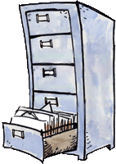 | Are shelves / cabinets filled with heaviest material at the bottom
 | If equipment is stored high up are there steps
 | Are floor tiles loose, are there trip hazards
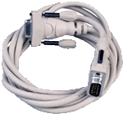 | Are cables properly stored
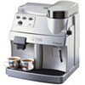 | Are coffee machines placed to prevent spills onto electrical equipment
 | Is the office tidy
 | Only one mobile pedestal per workstation
 | Are AC vents clean
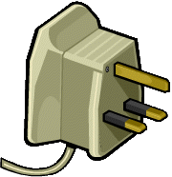 | Are electrical connections in good condition
 | Who do I report unsafe acts to
 | Escape routes, Assembly point known
 | First aiders and fire wardens known
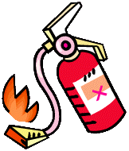 | Fire extinguisher locations known?
 | HSE Focal Point known?
 | Are VDU's positioned appropriately?
 | Are chairs positioned correctly?
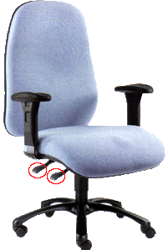 | Do staff know how to adjust chairs/tables
 | Do staff know when to take breaks
 | Do staff know how to reduce RSI
 | Are corridors, escape routes free of obstacles
Comments:

