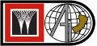 | HSE ALERT  WorleyParsons Arabian Industries JV  EMC- SOUTH [PDO/C-31/606] | 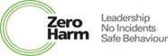
RTA 16KM FROM BAHJA CAMP ON BAHJA T JUNCTION ON MUSCAT-SALALAH ROAD [MARCH 31, 2007]
OVERSPEEDING & OVERTAKING IN THE WRONG LANE
Why Were They There
Mukhaizna Trading Company bus returning to their Camp from a Sadad road resheeting activity.
What Happened
The Bus was taking a left turn to enter the road to Bahja. A third party vehicle (Maxima) tried to overtake.
The Incident
The Car collided with the MTC bus. The front of the car hit the left rear side body & tyre of the bus. Both vehicles were extensively damaged; the car caught fire (after the driver was pulled out).
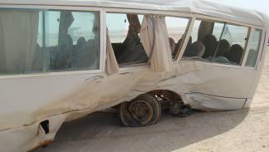
The Result
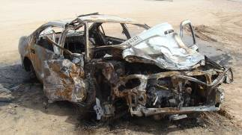
- Severe injuries to SEVEN bus passengers.
- Severe injuries to Car driver who escaped sure DEATH purely by timely rescue.
- Extensive damage to both vehicles.
Learning Points
- Seat Belts: Use of Seat belts undoubtedly saves lives. It was proved in this case again.
- Turning left: Do not assume that if the road is clear ahead than it is safe to turn.

- Blind-spot: Checking both the rear view mirror and over the left shoulder to double check that the road is clear before proceeding to turn.
LIFE IS ALMIGHTY’S BEST GIFT. RESPECT IT. TREASURE IT.

