Unloading Skid Leads to a FALL and Lost Time Incident

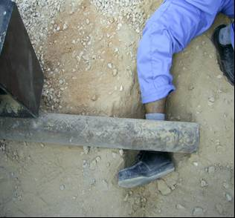 | .What HAPPENED?  De-stuffing of a 40 foot container containing a beam pump base frame and counterweight attachments was in progress. Sub-contractor was using Fork lift and web belts to pullout the load using pipes as roller on the uneven ground. The Rigger (Injured Person-IP) was in the close vicinity of the roller pipe. The load moved quickly after getting stuck and the roller pipe hit the IP’s lower leg causing him to fall and trapping his foot. The IP sustained a laceration wound and compound fracture to the right lower leg (tibia).  Unfortunately, this is MEDCO’s First Loss Time Incident reported after successfully completing one Year of Operation.

Key Lessons:

Personal Factor:

The IP failed to pay attention on his position close to the load although warned.

Lack of Arrangements for Safe Work

Poor/ uneven ground condition, pipes longer than necessary, lack of Hazard assessment, Safe working procedure & awareness of risk.

Lack of Supervision:

Supervisor did not recognize the unsafe condition in the work areas and at the time of the Incident the Supervisor was away from the area of operation.

DO’s

- Develop and document HEMP for individual task and ensure effective communication to workforce.
- Engage only trained & experienced personnel for high risk / unconventional activities.
- Ensure appropriate arrangements for safe execution of the work e.g. Workplace, tools & equipment.
- Ensure personnel are clear of the load movement area specifically during rigging/skidding gear use.
- In the event of crew change, risks and control measures are communicated to the new members.
- Empower the personnel to “STOP” activity when it is immediately dangerous to Life & Health (IDLH).
- Ensure in absence of supervisor either Job is stopped or supervised by equally competent Person.
- Stop the activity when not safe & reassess safety arrangements prior commencement of the activity.

DonT’s

- Use “uncontrolled/non routine” rigging methods.
- Start the activity unless the hazards identified and controls are well communicated & understood.
- Allow external parties to influence the job.

Personnel Empowerment is a Key to Stop Unsafe Condition & Practices

