1. | Open Flame Cutting, Welding and Burning
Hazards |  | Fire.  Explosion. | Hot spot re-ignition.  Skin and eye damage
Controls and precautions to be observed during this work

- Hot Work Permit and Gas Test documentation to be at worksite if area requires
- Clear Area Of combustible materials
- Equipment to be operated by competent person only
- Competent Fire watcher to be appointed (two if work on bulkhead/floor/deck head
- Equipment to be inspected and fit for purpose
- Flashback arresters to be fitted and functional
- Equipment liable to spark or spatter damage to be covered.
- Fire extinguisher to be at work site
- Gas bottles not to be placed in confined spaces.
- Gas bottles to be secured upright and away from hot site
- Hoses to be clear of walkways
- Bottle key to be attached to Gas bottle by chain.
- Correct eye, ear and Body protection to be worn during work.
- Worksite to be inspected by firewatcher 30 minutes after hot work ceases.

Open Flame Cutting,Welding and Burning

2. | Electric Arc Cutting and Welding.
Hazards |  | Fire.  Explosion.  Electric shock | Hot spot re-ignition.  Skin and eye damage Tripping
Controls and precautions to be observed during this work
- Hot work Permit and Gas Test documentation to be at worksite if area requires.
- Equipment to be operated by competent person only
- Electrical supplies to inspected and to be fit for purpose
- Welding sets and transformers to be correctly earthed.
- Equipment to be inspected, labelled and in date for use
- Competent Fire watcher to be appointed (two if work on bulkhead/floor/deck head
- Clear Area Of combustible materials
- Equipment liable to spark or weld spatter damage to be covered.
- Barriers and warning signs to be posted
- Fire extinguisher to be at work site
- Electrical supply leads to be run so as not to provide a trip or fouling hazard
- Correct eye and Body protection to be worn during work.
- Eye line Glare shields for adjacent walkways to be erected.
- Worksite to be inspected by firewatcher 30 minutes after hot work ceases.

Electric Arc Cutting and Welding

3. | Grinding and Buffing Using Rotary wheel Tools.
Hazards |  | Fire-.Explosion.  Electrical Shock Hot spot igniting. | Vibration  Skin and eye damage  Wheel Fragmentation
Controls and precautions to be observed during this work

- Authorised Hot work Permit and Gas Test documentation to be at worksite as appropriate to Area
- Clear Area Of combustible materials
- Rotary wheels to be inspected as fit for use and for correct speed grading
- Grinding wheels to be changed by trained operatives only
- Equipment liable to spark damage to be covered.
- Sensitive equipment to be protected to prevent damage.
- Competent Fire watcher/s to be appointed
- Electrical and air Drive equipment to be in date for test
- Fire extinguisher to be at work site
- Electrical supply cables and air hoses to be inspected for damage and be fit for purpose
- Cables and hoses to be run so as not to present a trip hazard
- Correct eye, ear and Body protection to be worn during work. (Shatter proof eye protection)
- Respiratory protection to be worn where applicable
- Worksite to be inspected by firewatcher 30 minutes after hot work ceases.

Grinding and Buffing Using Rotary Wheel Tools

4 | Spray Painting
Hazards |  | Paint Ingestion  Eye/skin damage | Flash fire
Controls and precautions to be observed during this work

- Barriers and signs to be posted around Worksite.
- Safety lookout Man to be posted
- Air compressor equipment to be tested and fully functional
- Air Hoses to be properly connected with whip checks
- Full protective clothing to be worn whilst spraying
- Breathing masks to be worn
- Ignition sources to be kept out of worksite
- Sensitive equipment to be masked to prevent damage.
- Lances not to be directed at people
- Hot surfaces are not to be sprayed
- Lances are not to be directed within 1m of Air vent inlets/exhaust outlets
- Spray Painting equipment and lances to be positively grounded against static spark in gas zones.

Spray Painting

5. | Work At Height
Hazards |  | Falling | Dropped objects
Controls and precautions to be observed during this work

- Only Authorised people to go aloft
- Ladders scaffolds and platforms to be properly erected and certified
- Hard points Established for fall arrester and safety line anchor points
- Fall Arresters and Harnesses inspected for defects / damage before each use
- Fall arrester and harness to be worn and secured prior to commencement of operations at height.
- Barriers and signs posted to keep people out from Drop Zone
- Area lookout Safety Man appointed
- Other PPE appropriate to task to be worn
- Tools for use are attached to lanyards and secured
- Area below worksite inspected for conflicting activities
- Appropriate precautions taken for adverse wind/weather.

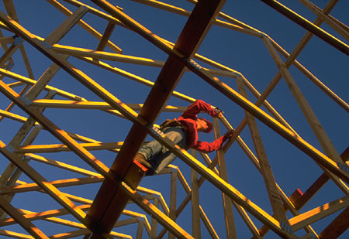
Work At Height

6. | Crane Operations and Lifting
Hazards |  | Dropped objects  Crushing | Trapping  Moving machinery
Controls and precautions to be observed during this work

- Hazard assessment to be conducted for all heavy (75%crane capacity) or unusual movements
- Every lift to be supervised by competent controller
- Weight of lift to be known
- Lift brief to be held on site
- All lifting gear to be in date
- Lifting equipment to be correct colour code.
- Lifting gear to be inspected fit for purpose each time of use
- Only Authorised Crane Driver to operate Crane
- Banks man to be trained and wear identifying clothing
- Enough men to control load to be at site
- Tag lines to be fitted and used at all times
- Area under lift and immediate vicinity to be vacated.
- Overhead and jib swing hazards and obstructions to be noted and clearly marked where applicable
- Crane operating lift limits to be observe
- Gear to be inspected and stored after lift

7. | Excavation
Hazards |  | Falling Trapping | Crushing Burial
Controls and precautions to be observed during this work
- Ground survey before any work commences
- Location of all ground services to be marked before digging
- Competent supervisor to be at site.
- Only competent persons to operated Motorised excavation equipment.
- Safety lookout man to be present when ever men are in hole
- Barriers and signage to be in place.
- Vehicle exclusion area established.
- Either graded sides or Appropriate side supports to be in place
- Spoil heaps away from excavation
- Pumps and drainage provided as necessary
- Air sampling available as appropriate
- Portable engines not to be run in or near vicinity of excavation
- Only Hand digging to be carried out in vicinity of underground services.
- Bump blocks to be provided when vehicles need to approach excavation
- Ladder or ramp access to excavation to be provided
- Overhead hazards to be identified
- Exposed services (pipes/cables) to be supported
Excavation

8. | Worksite Housekeeping
Hazards |  | Slips trips falls
- Access Egress and emergency routes are not to be obstructed
- All Waste to be removed sorted and placed in authorised storage/sort bins.
- Wires and cables to be secured to avoid tripping hazard, and/or provide walkway clearance
- All electrical system connections to be secured off ground and protected from rainfall
- Structure and scaffold projections to be signposted and masked when possible.
- Holes and ground/floor openings to be barrier’d and signposted.
- Fluid spills to be cleared as they occur
- Hoses and cables crossing roadways/paths to be protected with suitable covers.
- Tools to be returned to store after use
- Materials to be stored in correct locations
- Flammable materials are not to be left unattended at worksite.

- Worksite Houskeeping

9. | Entry into Culverts/Sewers/closed Tunnels and sealed Areas  (confined Spaces)
Hazards |  | Asphyxiation | Trapping  Illness
Controls and precautions to be observed during this work

- No person is to enter a closed Tunnel, Sewer, Culvert or sealed underground area unless authorised to do so.
- A hazard assessment will be required for this type of activity
- A Permit to work will be required for this activity.
- A competent Confined space Supervisor must be in attendance outside the workspace
- Location to be vacated if supervisor leaves the location
- Air sampling must be conducted by an authorised person until air proven sweet prior to commencement of activity
- Ventilation/air circulation may be required.
- Correct PPE to be worn.
- BA to be worn and tended by trained operatives only
- Harness and Safety lines to be worn
- Where appropriate weather forecast to be taken
- Wash down all personnel and equipment on exiting site.
- A rescue plan must be in place
Entry into Culverts/Sewers/closed Tunnels and sealed Areas (confined Spaces)

10. | Temporary Electrical Systems Equipment and Circuits
Hazards |  | Electrocution  Fires | Trips and falls
Controls and precautions to be observed during this work
- Only 110v Tools to be used on site
- . Risk assessments and RCD, s are to be used when higher voltages must be used
- Only competent trained personal are to work on or adjust or modify electrical equipments
- Site first Aider to be trained in electric shock recovery procedure
- Temporary electrical cables are to be secured above ground where possible
- Temporary electrical cables are to be routed over walkways and roads to provide headroom clearance
- Overhead cables must be supported not hung free
- High voltage cables must be routed clear of possible obstruction/fouling and clearly signposted.
- All portable electrical equipment must be in date for test
- Temporary electrical systems are to be inspected regularly for damage/integrity.
- RCD, s are to be tested daily
- Cables and plug boxes are to be clear of ground water and protected from rain/spray
Temporary Electrical Systems, Equipment and Circuits

11 | Man Handling Loads
Hazards |  | Sprains Straines | Ruptures
Controls and precautions to be observed during this work

- Know the weight of the object to be lifted.
- Conduct manual handling assessment
- Keep back straight
- Use strength of legs.
- Avoid twisting and reaching
- Wear back brace if available
- Only lift within capability.
- Don’t be proud get help.
- Use lifting hoists and trolleys when available
- If you have to strain its too heavy for you.
- When carrying a load ensure you can see your pathway
- Be aware of trapping hands/fingers when releasing load
- Do not climb to reach stuff on shelves and racks
- Do not carry loads on stairways unless you have a free hand for the handrail
- If its more than 20 kg get help

Man Handling Loads

12 | Work on Ladders
Hazards |  | Falling | Dropped object
Controls and precautions to be observed during this work

- Is there another way to do the Job without using a ladder?
- Check ladder is fit for purpose, inspection in date.
- Ensure ladder can sit with both feet firmly on ground/platform
- Ensure base of ladder cannot slip. Peg or block if possible
- Ensure ladder angle is not too steep (1 out for 4 up)
- Ensure that the top of ladder is resting on a firm structure?
- Ensure that the ladder protrudes 1m beyond working height.
- Ensure that the ladder is tied off and restrained from moving sideways or away from the structure?
- Ensure that the Safety man is in attendance
- Ensure ladders do not foul or strike overhead services
- Are tools and materials raised and lowered in a carry bag
- Ensure that the ladder is positioned to avoid body stretching and leaning?
- Is the man comfortable working on ladders?

Work on Ladders

13 | PPE
Hazards |  | Harm to body, lungs and sensors, (ears eyes)
Controls and precautions to be observed during this work

Always To Be Worn In Designated Work Areas
- Eye protection
- Hard Hats.
- Overalls.
- Hard toe boots/shoes

The Following Work Situations Generally Require A Hazard Assessment which will identify the extra PPE requirements.

To Be Worn When Near Noisy Activities.
- Hearing protection where designated

To Be Worn When 2m+Above Ground Or Platform
- Fall arrester and Harness. Safety Line

To Be Worn When There Is A Danger Of Falling Into Water
- Life jacket or life preserver safety vest

To Be Worn When Using Power Tools
- Shatter proof eye protection

To Be Worn When Working In Dusty Locations
- Breathing mask appropriate to situation.
Personal Protective Equipment

14 | Boat Work
Hazards |  | Drowning, Illness, Injury to hands/feet
Controls and precautions to be observed during this work

- Self righting Life preserver to be worn at all times afloat
- Boat passengers must have swimming test or dispensation
- Boat passengers must attend the Boats safety induction
- All instructions by skipper or crew to be obeyed
- Keep clear of mooring lines and ropes at all times
- Do not allow body parts to get between boats and boats and jetties/pontoons
- Do not board or land from boats until told to do so by the crew.
- Have both hands free during transfer
- Observe the relative motions of the vessels before transferring
- Avoid transfer when engines running if possible
- Whilst boat is underway stay seated.
- If you fall in try not to swallow water
- If you fall in do not try to swim or struggle if not in danger. Let the life preserver do the work.
- Fishing is not permitted from working or duty boats
- Observe all safety signs in particular no smoking

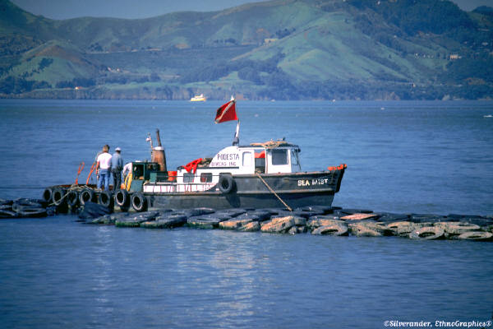
Boat work

15 | Vehicles on site
Hazards |  | Trapping Crushing collision.
Controls and precautions to be observed during this work

- Vehicle pass to be obtained on entry to site.
- Only authorised vehicles allowed on work site
- Only qualified and authorised drivers to operate vehicles
- Vehicles to keep to directed routes.
- Speeds to be appropriate to site
- Reversing warning tone to be operational
- Banks man to be present when vehicles are reversing.
- Only authorised maintainers to work on vehicles whilst on site.
- Seat belts where fitted are to be worn by drivers and passengers.
- Passengers in vehicles only allowed in fitted seats, no riding.
- Vehicles are not to be overloaded.
- Wide or high loads are to be escorted whilst moving on site.
- Vehicles are only to be used for designed purpose.
- Vehicle and auxiliary engines are to be stopped when refuelling.
- Engines to be stopped and keys are to be removed when vehicles are left unattended
Vehicles on site

16 | Work on or with Scaffolds
Hazards |  | Falling. Dropped objects.
Controls and precautions to be observed during this work

- Only trained scaffolders are to erect, modify or dismantle scaffold structures.
- Scaffolds are not to be used unless properly inspected and certified with a current scaftag.
- Only authorised people to be on scaffolds
- Scaffolds are not to be overloaded with materials or MEN.
- Access ladders are to be secured to scaffold structure.
- Scaffolds must be tied into the parent structure to provide stability.
- Toe boards and guardrails must be fitted.
- Intermediate stage boarding to be provided for access ladders
- Dropped object catchment netting to be provided as appropriate
- Walkways under scaffolding to be bridged by hard barriers
Work on or with Scaffolds

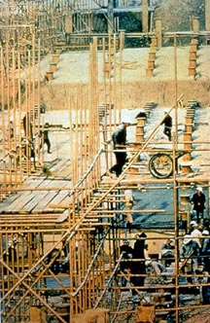

17 | Vibration and Noise
Hazards |  | Harm to hearing, long term harm to muscle tone, joints
Controls and precautions to be observed during this work
Try not to use Vibrating or noisy tools. Try to find another way to do the job.
When working/adjacent to High Noise Zones.
- If you have to shout to be heard at 2m then ear defenders are to be worn.
- High noise areas are to be barriered and signposted with warning signs.
- Where alarms are in place-Visual alarms systems are to be provided in high noise areas?

When Working With Vibrating Mechanisms
- Do not use blunt tools – keep tools sharp and use the right tool for the job
- Always let the work equipment do the work for you. Grip the handle as lightly as possible whilst ensuring sufficient grip is maintained for safety.
- Be aware of dulling of senses of touch and stop work when this occurs
- Regular breaks to be taken to prevent white finger.

Vibration and Noise

18 | Hazardous Substances and Materials
Hazards |  | Harm to skin lungs and eyes.  Environmental contamination

Controls and precautions to be observed during this work

- Never use a chemical or substance that is not fully identified. No Label- do not use.
- Always refer to the ”chemical data sheet” before commencing activity.
- Check Protective clothing is in usable condition and not damaged before use
- Breathing masks and equipment where required must be fully functional and used by trained operatives.
- Personnel involved in the use of substances must be medically fit with all abrasions treated and covered.
- Personnel involved in the use of substances must be fully briefed on the nature and hazards of the substance.
- Spill kits must be available before activity commences.
- Eyewash and hygiene stations must be available to workers employed with hazardous substances.
- Cleansing and changing space must be provided to prevent area contamination from clothing
- Tins, bags, sacks and wrappings from hazardous substances must be contained and disposed of in an appropriate manner.
- Do not store hazardous materials above head height

Hazardous Substances and Materials

19 | Shot Blasting
Hazards |  | Dust Ingestion  Eye/skin damage | Damage to equipment
Controls and precautions to be observed during this work

- Barriers and signs to be posted around Worksite.
- Air compressor equipment to be tested and fully functional
- Air Hoses to be properly connected with whip checks
- Full specialist protective clothing to be worn whilst Blasting
- Breathing masks to be worn
- Safety Man to be posted
- Sensitive equipment to be masked to prevent damage.
- Lances not to be directed at people
- Used by trained operatives only
- Shot and spoil to be cleaned away after each work period.
Shot Blasting

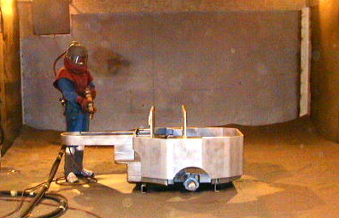

20 | Working with Asbestos.
Hazards |  | Respiratory illness and fatalities.
Controls and precautions to be observed during this work
Site manager to comply with the Asbestos regulations
- Only properly trained and authorised personnel are to undertake this work.
- Personnel not involved in the asbestos activity are to be removed from the work area.
- All work on asbestos materials must be the subject of a risk assessment.
- All operatives involved with Asbestos working must wear fully functional PPE.
- Removal and demolition of asbestos structures and materials must be planned to prevent unnecessary breakage of material.
- Keeping material damped down will help prevent asbestos dust.
- All asbestos arising must be properly handled and bagged for disposal
- Storage and disposal of asbestos products must be in accordance with local regulations.
- Personnel working with asbestos must be provided with appropriate washing and changing facilities adjacent to the worksite.
Working with Asbestos.

21 | In The Office
Hazards
Controls and precautions to be observed during this work

- Know your emergency evacuation route
- Keep safety equipment and walkways unobstructed
- Report faulty electrical equipment
- Only authorised equipment maintainers are to repair/ service office machinery/equipment.
- Observe the no smoking rules.
- Do not lift objects beyond your personal capacity. If it is too heavy for you, save your back and get help
- Use any personal protective equipment required for designated tasks.
- Do not use chairs etc for reaching high objects-use authorised step-ups/ladders.
- Do not stack boxes / objects above eye height on cabinets.
- Lock away sensitive information when not in use
- Switch off electrical equipment before you leave
- Tidy your workstation before you leave
- Do not sit all day behind your VDU, take periodic breaks
In The Office

22 | Pollution Control
Hazards |  | Damage to environment and water courses
Controls and precautions to be observed during this work
- Always use hazardous substances with care, ensuring they are suitably stored and empty containers are properly disposed of.
- Oil and fuel cans, etc, should be stored and used so that leakages /spillages can be contained consider hard standings, bunding, spill trays, spillsorbs, etc
- Do not run plant or equipment when not in use
- Ensure all plant and equipment is well maintained to ensure it is running efficiently-no smoke, oil leaks etc
- Do not waste Water by using leaking hoses or running taps unnecessarily
- Reduce dust by damping down materials, roads, truck loads
- Be aware if your site borders any watercourse. Do not allow dumping near banks. Water can carry pollutants over significant distances, and can contaminate local drinking supplies
- Never pour any contaminants down storm drains or gullies.
- Never use watercourses for cleaning tools, etc, and never store hazardous substances nearby.
- Store potential contaminants in authorised stowages and do not take more than is required to the worksite.
- Keep secure storage facilities locked with appropriate key control.

Pollution Control

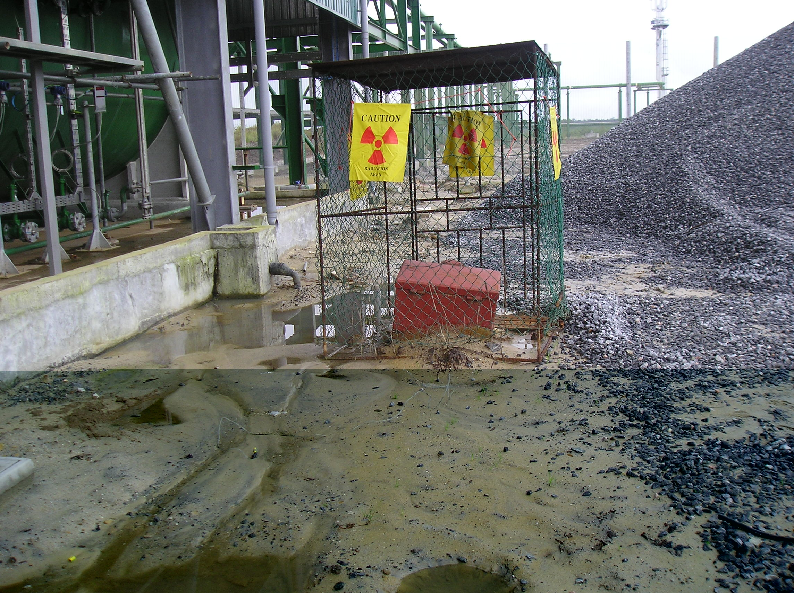

23 | Guidance to Banks Men
Controls and precautions to be observed during this work
- Any banksmen/slingers must be competent, i.e. must have received formal training
- All lifting operations should be suitably planned prior to commencing
- Ensure effective communications are in place
- When a crane is in operation, banksmen must not become distracted, and on no account leave the area unless relieved by another competent person.
- Use guide ropes to steady loads where applicable
- Visually inspect all lifting gear daily – if in doubt do not use
- Ensure you are aware of all relevant hazards on site including overhead power lines, excavations
- When using signals then stand where you can clearly see the load, the crane operator can clearly see you, and make your signs clear and distinct using only the approved codes.
- Ensure loads are lifted off the ground, are free, and are correctly slung before hoisting
- Ensure safe working loads (SWL’s) are always complied with
- Establish communications with the crane driver where applicable – if you can’t see him then use radios
- Always wear a safety helmet and hi-visibility vest
- Always ensure crane hooks are centrally located over loads to reduce swinging when raised If the crane is travelling, ensure you warn the driver of obstructions, sharp corners, etc

Guidance to Banks Men

24 | Concrete work
Hazards |  | - Chemical Burn. Trapped by Moving Machinery.  - Dust inhalation. Falling from height.

Controls and precautions to be observed during this work
- Formwork and shuttering is to be soundly constructed and supported, tied and footed.
- Climbing on formwork and shuttering is not permissible. Access Ladders and platforms are to be provided.
- All bracing must be in place before loading and before pouring walls and columns.
- PPE including gloves to be worn when working wet material
- Re-enforcing materials are to be handled with care to prevent dropping or heavy personal lifting.
- Banks men are to control bucket movement and pouring to prevent third party injury
- A shuttering breakout plan is to be held prior to dismantling.
- Dust masks to be worn when opening and mixing silica powders (cement)
Concrete work

25 | Use of Chain Saws
Hazards |  | Amputation of limbs. Severe operator/assistant lacerations
Controls and precautions to be observed during this work
- All chainsaw operators should have received formal training
- Before using a chainsaw carry out the following checks:
a. Check guards are in place, in good condition and secure.
b. Check chain brake operation (if fitted)
d. Check throttle and interlock for serviceability.
- Ensure you have the required PPE and that it is serviceable. This must include leggings
- Always engage the chain brake and place saw on a secure surface clear of any obstructions before starting.
- Never make adjustments to the chainsaw whilst it is running
- Never place any part of your body in the saw’s line of cut
- Before moving with the chainsaw, switch it off, (apply the chain brake), and fit the scabbard over the chain. Carry by front handle with chain facing rearwards
- Maintain a firm grip, using both hands, on the chainsaw when in operation.
- Stop saw motor before fuelling
- Check for fuel leakage and ensure fuel cap is correctly replaced
- Refuel chainsaws in well-ventilated areas and at least 3 metres away from where you are going to use the chainsaw

Use of Chain Saws

