 | 
 | Fire Incident in Condensate Export Pump at Cawthorne Channel Gas Plant
 | SPDC/ALFI/2008/05/02 | Exploration and Production (SPDC) |  | Fountain #145769 | Issue Date: May 2008
Purpose To focus attention on potential impacts of deviations from manufacturers’ design specifications.  Target audience All  Facts At about 22:45hrs on 8th November 2007, Cawthorne Channel Gas Plant shut down on ESD due to flame detection on sensors CC74-XZA-328 & CC74-XZA-329. The field operator on duty observed incipient-stage fire on the condensate export pump (P4303A) skid. Nearest fire extinguisher was used to extinguish the fire and situation brought under control. The plant was restarted at 11:40hrs on 9th November 2007.  There was damage to the pump and no injury to personnel.  Key findings during investigation include the following:  - The fire incident occurred on a reciprocating triplex plunger pump (P4303A), used for condensate export service.  - The pump, as designed, is always started under load, contrary to manufacturer specification. No bypass line (for start-up) is in place due to design oversight.  - The connecting rod and bolts of the pump’s outboard plunger sheared and broke-off from the crankshaft due to fatigue.  - Pumping operation continued for 20 minutes after the outboard plunger broke-off.  - The shearing-off of the pump connecting rod caused misalignment of plunger strokes, ineffective plunger system lubrication, and increased friction due to rubbing of metal surfaces, heat build-up and ignition.  - The CCGP fire detection system operated as designed and the field operator extinguished the fire using nearest available extinguisher.  - CCGP operators and attendants have had fire-fighting training.  - The field operator was not within the vicinity of the pump export skid during the incident, and there was heavy rainfall/thunderstorm.  - The pump’s maintenance plan / MJR is NOT in SAP; consequently no (manufacturer recommended) PM is being done.  - There was a conscious decision by Major Projects & Asset team leadership to continue operating CCGP (post-June 2006 militant attack), whilst outstanding design, commissioning and handover issues are being tackled.  Learning Points:  - Need for Project, Maintenance and OR&A teams to adhere to manufacturers’ recommendation on equipment design, installation and maintenance.  - Need for all Cat 0 & 1 equipment to be fully captured in SAP-PM, with approved MJRs and Maintenance plan in place prior to handover/continuous operations.  - Need for conducting periodic integrity/reliability checks to assure proper functioning of equipment and HSE gadgets  - Need for fire-fighting training to be conducted for all frontline operations staff and station attendants.  For More information Contact: akuro.adoki@shell.com |  |  | 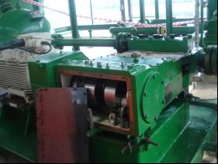  Condensate Export Pump Skid  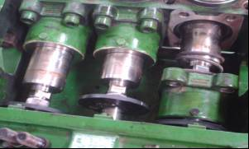  Scoured Plunger surface  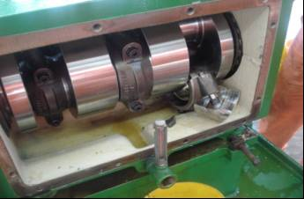  Broken & Sheared-off Parts  Recommended Actions:  - Implement manufacturer’s recommendation on pump installation.  Action Party: Ajayi R, (TPE) ECD: 30/9/2008.  - Complete ongoing CCIP CMMS activities and update SAP.  Action Party: Joel, O. (PECR) ECD: 31/7/2008  - Review CCIP Project recompletion team workscope for completeness (e.g. pumps drain connections, DCS historian, etc).  Action Party: Joel, O (PECR) 31/7/2008.  - Provide alternative means/flexibility for evacuating CCGP condensate to flowstation.  Action Party: Oputa, B (TEEM) ECD: 31/12/2008

