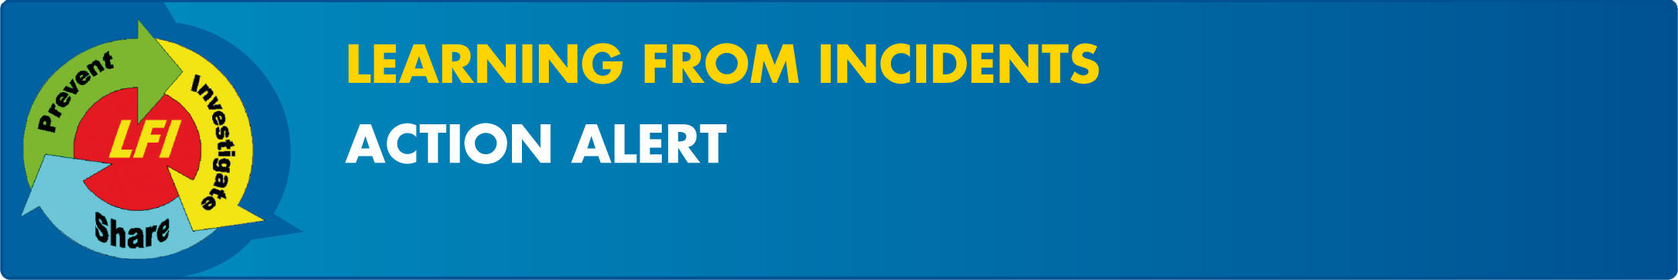

Worker Struck by Dropped Object
EP/AA/2009/10-02 | Action Alert - Fatality | October 2009
What Happened?
On April 6, 2009, at a contract-drilling rig in South Texas, two crewmembers were in the process of retrieving drill collar slips from a storage box with a forklift. They had previously completed a JSA and performed a pre-use inspection on the forklift. The forklift operator retrieved the forklift attachment. Neither crewmember attached the tie back cable. The forklift operator and injured party (IP) installed a lifting sling. They retrieved two sets of drill collar slips and were in the process of attaching a third. At some point, the operator tilted the forks down. The IP connected the third set of drill collar slips and signalled the forklift operator to lift the slips. The forklift operator raised the boom to lift the load. The lifting device slid off the forks and fell, striking the IP. He was standing inside the of the 15ft buffer zone. The IP was immediately transferred via ambulance to a local hospital for medical attention. Several days later, the IP passed away.
Tie Back Cable- Properly Attached
Key Findings:
Standard/Procedures
Group Personal Safety Manual - Lifting and Hoisting
- Key Lifting and Hoisting / Safety requirements were not followed:
    - Neither crewmember visually confirmed tie back cable was installed.
    - The lifting device tie back cable was not secured.
    - The IP did not stay 15 feet away from the load as per JSA (to ensure he was safeguarded from entering the path of the load).
    - JSA was not fully executed.
    - There was a previous incident of inadvertent tilting of forks, which was not reported.
- Crewmembers inconsistently executed and supervisors inconsistently validated safety procedures and practices mentioned above.
- The model of forklift being used at the time of the incident was similar to but not exactly the same as the one regularly used. The controls were different. The familiarity of the operator with the replacement forklift was not verified.
Actions required:
- All facilities utilizing forklift/loader attachments and accessories used for lifting and hoisting MUST develop and utilize an installation procedure, clearly indicating safety precautions for installation and use, including certification of the equipment /tool and identification of accountable parties that are responsible for ensuring the check list is utilized. If this cannot be accomplished for any reason, remove the lifting device from service. Action Party: OIMs, OMs, Well delivery Managers, Construction Managers / Due Date: November 30, 2009.
- All Shell leaders with operational responsibilities shall hold a session with their teams to review the learnings of this incident (using provided Learning Pack). Action Party: Asset Managers and OIMs, OMs, Well delivery Managers, Construction Managers / Due Date: November 30, 2009.
- VPs shall set expectations that their supervisors are spot-checking execution of work against Job Safety Analyses (JSA’s, HTA’s) and Work Permits to confirm work is executed in accordance with documentation. Action Party: VPs. Due Date: November 30, 2009.
- All facilities to verify user competence for forklifts and other power lifting trucks including operator training and proof of competency for use with the available accessories. Also, confirm that there is a process in place to identify hazards associated with the introduction of new/different equipment to the work site (e.g. similar equipment with different controls). Action Party: OIMs, OMs, Well delivery Managers, Construction Managers / Due Date: November 30, 2009.
For more information: contact Gordon Graham VP Wells HSE (mailto:gordon.graham@shell.com)

