

Hazards of working with Rotating Equipment
EP/AA/2009/10-03 | EP - Fatality | October 2009
Purpose: This alert highlights the risks where exposure to equipment with rotating parts is not prevented by hardware barriers. Machine – human interface is an important part of worksite hazard management. Rotating equipment constitutes a danger for people working around it if there are no safety barriers in place. Please review this action alert with your team and follow through on the actions prescribed below.
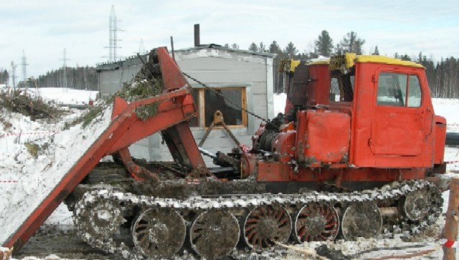

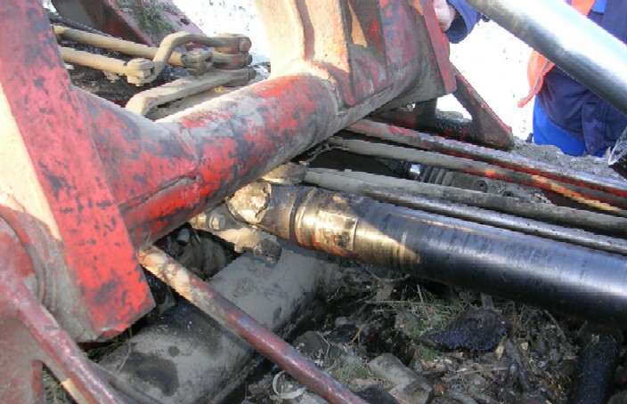
Target audience: Asset managers, departments HSE personnel.
What happened? On 27 of February 2009 around 9.00am a contractor working for Salym Petroleum Development (SPD) was involved in a fatal accident. The contractor and his crew were preparing to move their tree removal equipment to another worksite upon the completion of the deforestation activities for a pipeline right-of-way. The crewmembers were briefly resting in a nearby cabin when the contractor began to prepare the skidder vehicle for the move on his own. The engine of the skidder was not turned off when the contractor commenced this activity. He was in the process of removing tree limbs and other debris from in between the chassis and the drive shaft when his clothing was caught in the rotating prop shaft. He was pulled against the hydraulic ram and died immediately as a result of his injuries.
Learnings:
- During normal activity, the vehicle accumulates debris that needs to be removed. The vehicle has a poor design which makes it time consuming to be shutdown and restarted when needing to clear the material, which resulted in complacency to the Shell procedure for working around rotating equipment.
- The crew did not intervene in the unsafe work.
- The deceased was wearing clothing with baggy/bulky sleeves that contributed to the incident and is against Shell PPE Standards.
Since the incident, SPD has inventoried and any equipment that have exposed rotating parts have been taken out of work for the interim period. The equipment will not be restarted until there has been a formal risk assessment with similar equipment carrying out the same operation, and all identified precautions implemented.
Actions to be completed by Dec. 31, 2009:
- Contract holders and facility owners are required to make an inventory of any activities that expose staff to equipment with potentially exposed rotating parts.
- Conduct a risk assessment to confirm that appropriate controls are in place to operate and maintain the equipment safely. Where the assessment shows gaps in the controls stop operating any identified equipment using the lock out / tag out procedure and put a corrective action plan in place to address the deficiencies.
For more information, please contact Koos Koole.

