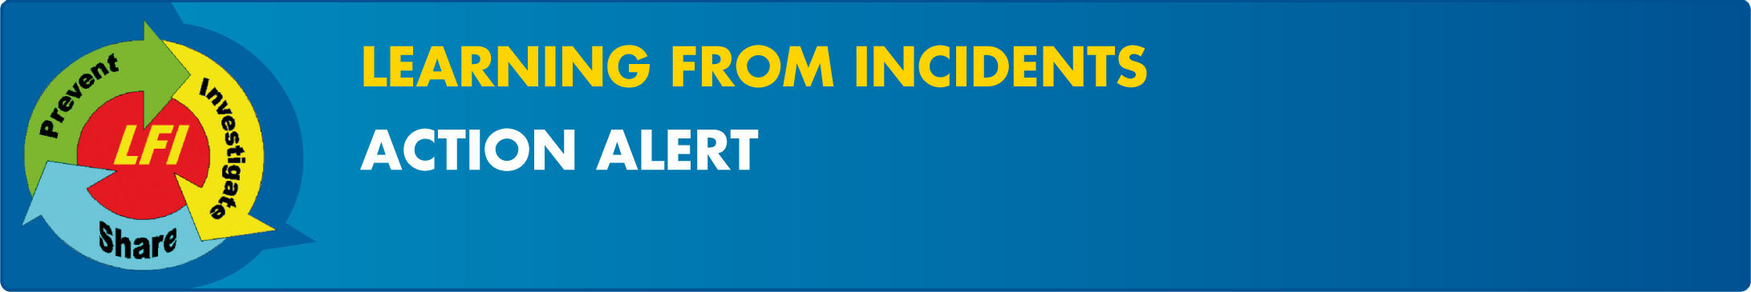

Operating Cranes near Overhead Power Cables – Reducing the Risk and Increasing Awareness
EP/AA/2009/10-01 | High Risk Incident | FIM# 339804 | Oct 2009
Purpose: To re emphasise the dangers and reduce the risks associated with operating cranes and other tall mobile equipment near overhead power lines. Please share and discuss this alert and Learning Pack from a 2006 fatal incident with your line management and all crane operators.
Target Audience: Plant and site managers, logistics managers, crane supervisors and operators.
What happened? On March 10th 2009, a 70-ton RT Grove crane was dispatched from the Logistics Heavy fleet workshop to load line pipe on to a third party truck in the SPDC Industrial Area car park. During transport, the crane made contact with a live 33KV high-tension cable while passing under overhead power lines, leaving the cable dangling (Picture 1). Fortunately, there was no injury to the crane operator or any other person.
Similar incidents have occurred in the past: One fatal SPDC incident (Picture 2) and one high-risk incident occurred in 2006 in Nigeria. Another high-risk incident involving power lines in SPDC occurred in 2007 (Picture 3). More information on these incidents can be found at the following links Overhead cable incident at Afam VI and Bulldozer pulls down PHCN high-tension pole at Afam.
Lessons Learned:
Standard/Procedures
- EP2005 0264-ST Manage Logistics - Lifting and Hoisting
These incidents highlight the risks from power lines to mobile equipment, particularly to cranes, mobile towers, hoists and forklift trucks. As such, sites where high equipment is used should be free of overhead power lines. Where sites have power lines that restrict access and movement, they should be removed by rerouting or burial. Where this is not possible, restrictions shall be placed on the movement of such equipment by appropriate road marking, barriers and signage. These requirements are outlined in the Manage Logistics – Lifting and Hoisting Standard. Crane operators. Banksmen also need to be continually aware of risks presented by overhead cables.
Actions Required -
Plant and site managers, logistics managers - to be completed by December 31, 2009
- Identify permanent industrial sites with overhead power lines and where high vehicles such as cranes and forklifts are in use.
- Investigate the rerouting, removal or burial of these overhead power lines.
- Where overhead power lines cannot be removed or on sites that are not permanent or industrial, clearly designate those areas where crane and high vehicle access is not allowed.
Managers responsible for crane operations – November 30, 2009
- Communicate the risks associated with overhead power lines to crane operators and supervisors and that the planning and execution of crane operations near overhead lines and cables is treated as non routine and covered by a dedicated lift plan reviewed by a qualified electrical engineer. This is outlined in the EP2005 0264 Lifting and Hoisting Standard.
SGSI have developed a good guideline for Avoidance of danger from overhead electric power lines. It is recommended that this guideline be used when planning and completing these actions. For more information on these incidents, please contact Akuro Adoki.
Please take a few minutes to provide us your FEEDBACK

