IMPORTANT ROAD SAFETY NOTICE
TRAFFIC RESTRICTIONS IN MUSCAT FOR
40 th ANNIVERSARY CELEBRATIONS
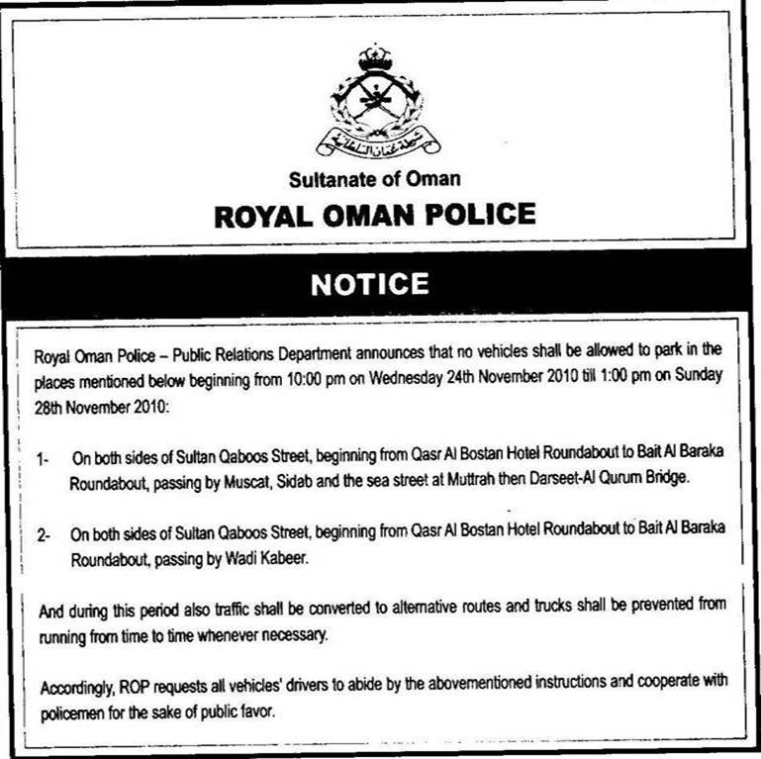
Please find below parking restrictions from the ROP. Note that the main highway will be closed from time to time to allow the passage of dignatories.
Chris Evans MSE13

