I Value My Safety



Important Driver information on how IVMS works

Version 1: January 2011

To all PDO drivers,
PDO is happy to advise you that the vehicle you are now using is safer due to the fact it has an IVMS Travel Buddy installed.
The Travel Buddy gives you as the driver an alarm to inform you of problems with your driving and any rule breaking that has the potential to cause an accident and injure yourself or others.
It is very important for you to know how it all works:
The Driver Green Key:
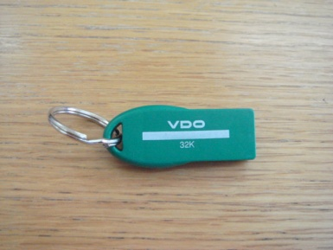
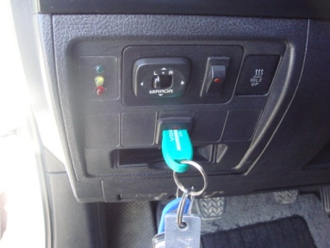
The Travel Buddy needs to know who will be driving the vehicle and so you have your own driver green key which you need to insert into the IVMS slot in the dash and wait for it to beep. This is the Travel Buddy telling you it knows who you are and it then allows you to start the vehicles engine with the normal engine ignition key
This ensures that any learning about your driving are communicated to your line manager so he can help you to continually improve.

Emergency Button:
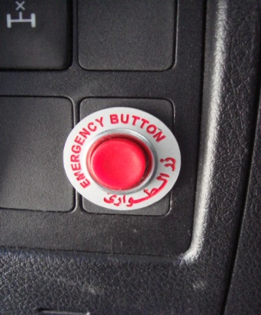
IVMS in your vehicle is equipped with emergency button to use in cases that you are in need to contact the IVMS center but you have no other means (out of radio range, no GSM, …etc)
This needs you to press the button for over 5 seconds. It is configured with a delay to avoid any accidental pressing and any false message. If you are in a GSM area, then help will be sent to rescue you.

Flammable Area GSM Transmission- Off Switch:
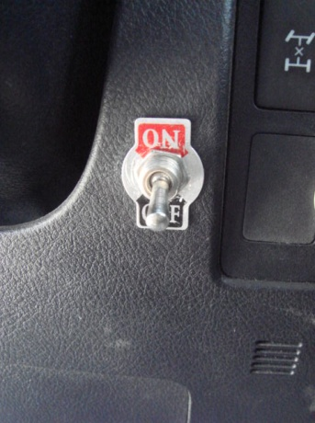
Each Travel Buddy communicates via the GPRS network. If you are entering a flammable area or area sensitive to GPRS waves, then the Travel Buddy GPRS system communication switch must be switched to ON to delay the GPRS communications until after you exit the sensitive area. Outside of these sensitive areas the switch should be in the OFF position. It will not stop the communication of data to the server, it only delays when it is sent as the information is constantly stored on the Travel Buddy itself.
Driving in such sensitive areas is high risk and so speed should be kept to a minimum. If you leave the area and forget to switch the IVMS switch to OFF then the Travel Buddy will sound a constant alarm to the driver after you exceed a speed of 40 km/hr.
IVMS Sleeping mode:
The Travel Buddy goes to sleep if the vehicle is not driven for 72 hrs to save the vehicle’s battery. You can recognize when this has happened when the flashing of the device stops. In such cases the Travel Buddy will not respond to the green key being inserted and you have to turn the ignition key first and then insert the green key so the Travel Buddy will wake up.
Waking-up time is only 6~8 seconds then the device will flash normally and will respond to green key inserting to start vehicle.

Events Recorded BY IVMS:
IVMS is configured to monitor and record below listed events:
- Vehicle’s battery disconnection
- IVMS device power disconnection (power or earth lines)
- Over speeding (tolerance window: 15sec)
- Harsh braking
- Harsh acceleration (tolerance window: 3sec)
- Driver seat belt is not fasten at speeds more than 10 km/h (tolerance window: 10sec)
- Emergency button pressing (tolerance window: 5sec)
- Driving for more than 2hrs without rest
- Data transmission shut-off
- Data transmission shut-off during driving (working when vehicle’s speed is more than 40km/h)
IVMS’s primary purpose is not to track and report driver’s driving errors to the management and so there is a tolerance time-window within which the Travel Buddy alerts the driver with an alarm to draw the drivers attention to the driving error. If the error is corrected within the tolerance window then only the driver and the Travel Buddy know.
The alarm will be played for the whole tolerance time-window and the event is only recorded and communicated after the tolerance time has been exceeded.

Help and advise
If you have any problems relating to your IVMS then contact your IVMS focal point or the IVMS help desk by calling 99310613. This number is also located on the IVMS sticker on your door sill.

